Media Release
Hall A2
Stand A2-2217
Oerlikon HRSflow at Fakuma 2021:
HRScool Evo: Non-cooled hydraulic cylinder now for extended process window
San Polo di Piave/Italy and Friedrichshafen/Germany, 12 October 2021 - With HRScool Evo, Oerlikon HRSflow presents a further development of the HRScool hydraulic cylinder system for hot runner injection moulding, which, thanks to its sophisticated temperature management, does not require active liquid cooling of the actuation unit. Thanks to a further reduction in the heat flow between the hot runner and the mould plate, HRScool Evo version can now be used at higher mould temperatures than its predecessor system HRScool, which was presented in 2019.
Oerlikon HRSflow has constructively optimised the heat balance of the cylinder. As a result, this advantageous technology, which is mainly used in the production of interior and exterior automotive parts, is now also available for previously temperature-critical applications. Despite the significantly improved heat transfer, HRScool Evo – in both the basic and the damped version – fits into the mould cut-outs of the fully compatible hot runner systems of the P, M, G and A series from Oerlikon HRSflow.
HRSCool Evo allows to reducing the heat transfer from the manifold heaters to the oil of the actuator thanks to the geometry optimization of the contact elements between manifold and cylinder. In contrast, the highly efficient heat dissipation to the cold clamping platen takes place via a cover whose large, flat surface is made of a material with very high thermal conductivity that works as thermal bridge. An integrated height adaptability ensures maximum efficiency even without accurate seat tolerances.
HRScool Evo enables savings in costs and maintenance, because the elimination of liquid cooling reduces the number of components. The connection of cooling circuits is equally eliminated, as is the problem of clogged cooling ducts or the degradation of hydraulic fluids. The effort required to install and remove this uncooled system is also reduced, because thanks to the special lock, the needles can remain in the nozzle during mounting and dismantling. And the sophisticated insulation concept, which ensures an optimally uniform temperature distribution along the entire hot runner system, supports the production of components with particularly high quality.
About Oerlikon HRSflow
Oerlikon HRSflow (www.hrsflow.com), part of the Swiss technology group Oerlikon and its Polymer Processing Solutions Division, is based in San Polo di Piave/Italy and specialises in the development and production of advanced and innovative hot runner systems for the injection molding industry. The business unit employs about 1,000 people and is present in all major global markets. Oerlikon HRSflow manufactures hot runner systems at its European headquarters in San Polo di Piave, Italy, its Asian headquarters in Hangzhou, China, and its Byron Center facility near Grand Rapids, MI, USA.
Your contact at Fakuma
Grit Reifer
Marketing Manager Oerlikon HRSflow D-A-CH
HRSflow GmbH, Frankfurt/M.
Mobile: +49 160 7407058
Grit.reifer@oerlikon.com
www.oerlikon.com/hrsflow
For further information, please contact:
Chiara Montagner  Marketing & Communication Manager  Oerlikon HRSflow  Tel: +39 0422 750 127  Fax: +39 0422 750 303  chiara.montagner@oerlikon.com  www.oerlikon.com/hrsflow | Erica Gaggiato  Marketing & Communication Specialist  Oerlikon HRSflow  Tel: +39 0422 750 120  Fax: +39 0422 750 303  erica.gaggiato@oerlikon.com  www.oerlikon.com/hrsflow
Please send voucher copies to:
Dr.-Ing. Jörg Wolters
Konsens PR GmbH & Co. KG
Im Kühlen Grund 10, D-64823 Groß-Umstadt, Germany
Tel: +49 6078 9363 0,
mail@konsens.de
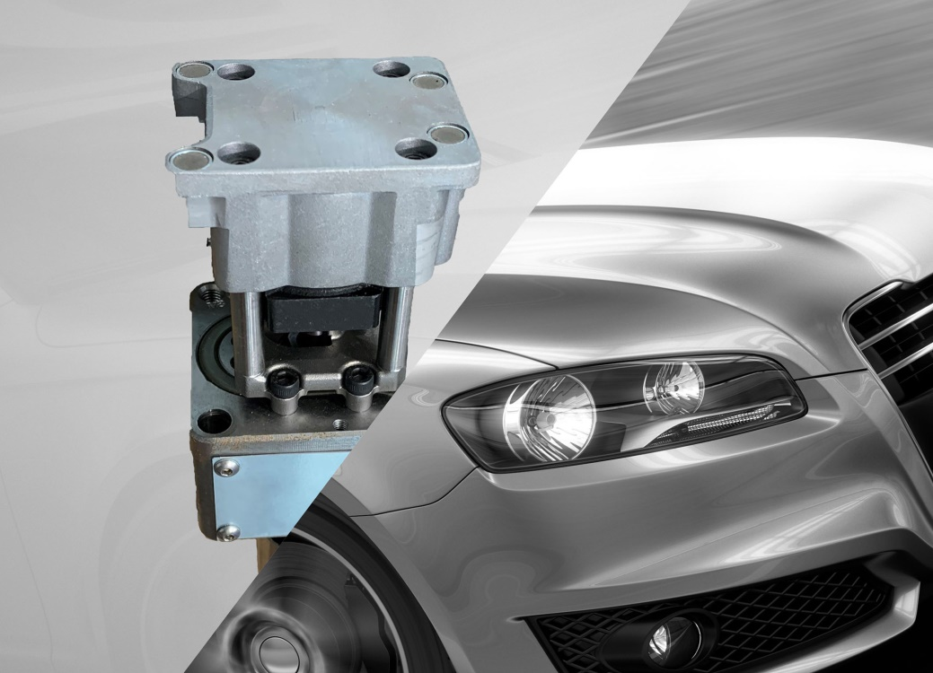
The design optimisation of the uncooled HRScool Evo hydraulic cylinders from Oerlikon HRSflow extends their process window to higher processing temperatures. © Oerlikon HRSflow

Text and image of this press release are available for download at https://www.konsens.de/hrsflow

