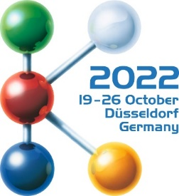
Hall 1
Stand D10

Press Release
Oerlikon HRSflow at K 2022:

Oerlikon HRSflow hot runner systems in action: live molding demo at K2022
San Polo di Piave, Italy and Düsseldorf: October 19, 2022 - Intricate applications of Oerlikon HRSflow hot runner systems produced in cooperation with project partners in the fields of polymer materials, mold making and machine manufacturing, will be presented at the upcoming K Show. The live molding demonstrations will be available at the partners’ booths.
Thin-walled 150ml IML Yogurt cup: the evolution towards a fully recyclable packaging
At NETSTAL booth (Hall 15, Booth D24), the ELIOS 4500 Injection Molding Machine will produce a thin-walled 150ml IML yogurt cup (6.4 g) from a certified renewable PP polymer by SABIC®, highlighting the importance of human and environmental health. The material is based on tall oil, a waste product from paper production. The powerful and energy efficient NETSTAL injection molding machine compensates for the slightly thicker label in the injection molding process with a correspondingly thinner wall thickness of the cup. Wall thickness of the 5.4 g cup without label measures only 0.32 mm. This high-performance application runs with a fast 3.9 s cycle time.
The new Xp nozzle Series from Oerlikon HRSflow, specifically engineered for thin wall packaging, ensures a reliable process and an increased productivity at the lowest cost per unit. The result is a low thickness component (0.4 mm) injected with ambitious cycle times and decorated with a new generation label: the NextCycle IML™ from MCC Verstraete. The NextCycle IML labels allow that a fully decorated PP IML package can be recycled without any impact of the label on the RPP material. These labels will also feature digital watermarks from the Holy Grail 2.0 initiative. The project was developed in cooperation with Netstal, IML Solutions, MCC Verstraete, Sabic, Oerlikon HRSflow.
Eco-friendly fruit box: maximum precision combined with sustainability
Haitian (Hall 15, Booth A57) will showcase the injection molding of an eco-friendly fruit box which marks a key step in Oerlikon HRSflow’s approach to Circular Economy. The selected hot runner configuration is specifically designed to process APS PE compound with recycled TETRA PAK® carton package Alu Foil. The 4 drop FLEXflow servo-driven valve gate system, running on a Haitian Jupiter Series (JU4500III), ensures the production of a flawless part with the complete filling of all the ribs and walls and a high process repeatability. For an optimal gate vestige quality, Oerlikon HRSflow’s new patent pending TTC cooling bushing avoids pin’s sticking issues even with fast cycle times. Project partners are Haitian, Mundimold, Tetra Pak®, APS, Oerlikon HRSflow.

Sustainable tool case: complex shapes made masterfully
Arburg will present at its stand (A13, hall 13) the injection molding of a complex tool case requiring the use of 4 hot runner systems from Oerlikon HRSflow. For the manufacturing of the two covers from a PC/ABS blend in a family mold, a 2 drops screwed-in system are used. Moreover a 3D Design Film is overmolded on the covers. Particular attention will be also given to the inner tray, the handle as well as the lateral latches made of PET RECOPOUND® by KURZ. The result is a stable and robust end product with illimited possibilities of decorations. Project partners are Arburg, Hofmann, LEONHARD KURZ, Oerlikon HRSflow.
2K Rear-Panel: futuristic smart automotive surfaces
ENGEL (Hall 15, Booth C58) will present the injection molding of a smart 2K rear panel composed by a PC+ABS frame overmolded with PMMA or alternative PC. During the first injection phase a hydraulic 2 drops system from Oerlikon HRSflow will be used while for the second one a Single nozzle from Ga Series will be employed. The part will be finally decorated with a capacitive and aesthetic film directly in the mold for an innovative result. To implement such complex requirements, exact rheological analysis calculations were necessary. Project partners: ENGEL, Schöfer, LEONHARD KURZ, Röhm, Oerlikon HRSflow.
3 component coffee-to-go cup: hot runner solutions for 100% recyclable parts
At Booth C06, Hall 15, Wittmann Battenfeld will show the manufacturing of a 3-component coffee-to-go cup with a lid. The rotational mold with 3 separate injection units is equipped with three different single nozzle systems by Oerlikon HRSflow optimized to process the 100% recyclable PP Bornewables™ (non-petroleum-based feedstock) from Borealis.The Bornewables™ - made of renewable raw materials derived from waste and residue streams - perfectly meet the functional requirements of the molded part without compromise in terms of quality and sustainability standards. The cup, with a thickness of 2 mm, is produced in clear optic in the first cavity and over-molded in the second cavity with an insulated shell. The insulating effect is obtained by foaming the melt through the special Cellmould® technology which enables the production of lightweight, rigid parts without sink marks. Project partners are Wittmann Battenfeld, Haidlmair, Borealis and Oerlikon HRSflow.
Garden tool: 2K irrigation connector
Additionally at K show, Oerlikon HRSflow will showcase at Billion’s booth (Hall 15, Booth B24) the injection molding of a garden tool, specifically an irrigation connector. The part will be produced through a 2K tool equipped with two different hot runner systems with one nozzle. During the first phase, a face-to-face torpedo system is used to inject styrenic compounds (ASA polymer), while for the second phase, a screwed-in cylindrical valve gate system is employed to inject elastomer compounds (SEBS). During the second phase, the molded part can be easily customized thanks to the marking operations directly embedded in the tool cycle process. Among the special features the automatic and quick change of the mold version enabling the production of the three different components – in this case the coupling diameters - without disassembling the tool or stopping the manufacturing activities. Project partners are Billion, Groupe Pernoud, Actemium, Sepro Group, Resinex, Lifocolor and DeViris, Oerlikon HRSflow.
High Gloss B Pillar: accurate injection, perfect appearance
The Injection Molding Machine manufacturer Tederic (Hall 15 Booth D40) will showcase the production of a high gloss B pillar. The molded part is obtained through a 2K hot runner system developed by Oerlikon HRSflow. The hot runner solution enables the perfect appearance of the component thanks to a gentle, low-stress injection. During first phase a 2 drops conical valve gate hydraulic system combined with ICM Technology are used to inject PMMA polymer, while for the second one (ABS material) a 6 drops system is developed. The project was conceived in cooperation with Tederic, Yuyao Skymold, Piovan and Technotrans Solutions GmbH, Oerlikon HRSflow.

About Oerlikon HRSflow
Oerlikon HRSflow (www.hrsflow.com), part of the Swiss technology group Oerlikon and its Polymer Processing Solutions Division, is based in San Polo di Piave/Italy and specializes in the development and production of advanced and innovative hot runner systems for the injection molding industry. The business line employs about 1,000 people and is present in all major global markets. Oerlikon HRSflow manufactures hot runner systems at its European headquarters in San Polo di Piave, Italy, its Asian headquarters in Hangzhou, China, and its Byron Center facility near Grand Rapids, MI, USA.
For further information, please contact:
Chiara Montagner  Marketing & Communication Manager  Oerlikon HRSflow  Tel: +39 0422 750 127  Fax: +39 0422 750 303  chiara.montagner@oerlikon.com  www.oerlikon.com/hrsflow | Erica Gaggiato  Marketing & Communication Specialist  Oerlikon HRSflow  Tel: +39 0422 750 120  Fax: +39 0422 750 303  erica.gaggiato@oerlikon.com  www.oerlikon.com/hrsflow
Editorial contact and please send voucher copies to:
Dr.-Ing. Jörg Wolters
Konsens PR GmbH & Co. KG
Im Kühlen Grund 10, D-64823 Groß-Umstadt, Germany
Tel: +49 6078 9363 13
mail@konsens.de

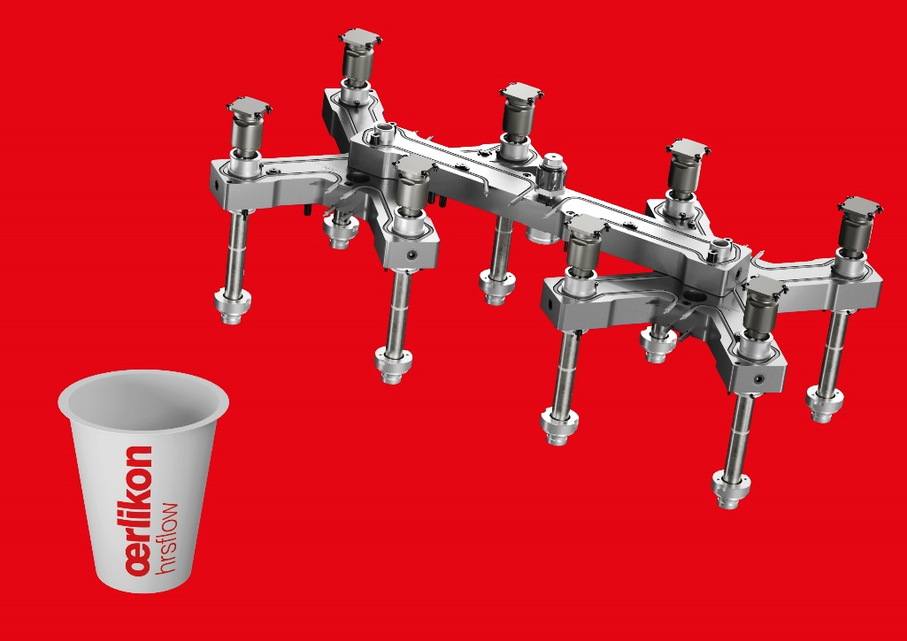
Available at NETSTAL booth the live molding demonstration of a thin-walled 150ml IML yogurt cup (6.4 g) from a certified renewable PP polymer by SABIC®. This high-performance application runs with a fast 3,9 s cycle time. © Oerlikon HRSflow
Text and image of this press release are available for download at https://www.konsens.de/hrsflow

