Tailor-made hot runner solutions for planar components
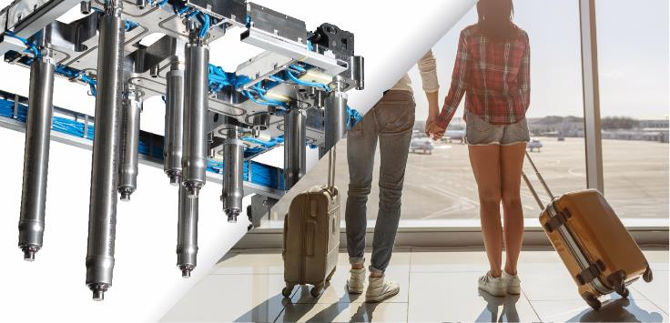
Tailor-made hot runner solutions enable the production of demanding planar components, including suitcase shells, a collapsible bath box, and a laptop cover. © HRSflow
San Polo di Piave/Italy, December 2018 – Complex, high-quality planar parts underline the synergies generated from the combination of HRSflow’s universal hot runner systems and their expertise in the CAE simulation of injection molding processes. Examples range from a sizeable, thin-walled suitcase shell and a collapsible two-material bath box to a laptop cover with a top-class surface; the latter produced using HRSflow’s FLEXflow technology of electric servo-driven valve gate systems.
Large, thin-walled, deformation-resistant suitcase shell
Despite its low mean wall thickness of only 1.8 mm, the shell for a lightweight 1.9 kg suitcase made of polypropylene has particularly high structural performance. The manufacturer traditionally fills the cavity for the approx. 490 mm x 290 mm x 690 mm parts via a single injection gate with a diameter of 5 mm positioned centrally on the outer surface. HRSflow performed extensive computer simulations of the flow behavior and the pressure conditions arising during the process. The solution is a customized axial single-nozzle solution, in which a hydraulically operated hot runner needle valve nozzle serves as an extension of the machine nozzle. Despite the long flow paths, this design ensures – unlike the original configuration – warp-free parts with high class surfaces, free of flow lines or visible weld lines. A brand emblem is clipped on to cover the gating point. Furthermore, the HRSflow nozzle enables, thanks to an optimized internal geometry with minimized dead spots, a fast color change between the 15 available shell colors.
Collapsible Box in 2 K-Technology
A collapsible box measuring 660 mm x 240 mm x 300 mm, used for bathing babies or small children, has been designed so that it can be folded away to save space. Made by two-component injection molding, the manufacturer combines a polypropylene (for the 2.5 mm thick side parts) with a thermoplastic elastomer that joins the PP parts flexibly to one another. To fill the cavities for the wall elements, use is made of a 10-drop hot runner system from HRSflow with valve gate nozzles of the Ma series, which are designed for medium shot weights. A cascade control system ensures that all the differently sized parts are perfectly filled at the same time. The second operation comprises the injection of the flexible component into the long but tight cavities for the hinges. This is done using a 4-drop hot runner system with valve gate nozzles of the Pa series, which are designed for lower shot weights.
In the project phase, HRSflow optimized all the functions with the help of extensive CAE flow simulations. This has resulted in evenly filled 2K parts without visible weld lines or entrapped air. The flexible components continue to connect the wall elements reliably for a long period of time and even after a large number of folding processes. In production, the system allows fast color changes to be completed within just a few cycles.
Superior appearance
A project that has been developed together with the heating and cooling specialist Roctool, KraussMaffei and the toolmaker Flex is a cover, only 1.5 mm thick, for a 14" laptop. The part is produced by sequential injection molding using a five-drop FLEXflow hot runner system with induction heating and cooling technology from Roctool. It is made from a highly glass fiber-reinforced polycarbonate (up to 50% by weight). The two technologies make it possible for the part to satisfy the very highest demands in terms of appearance and functionality. A visible surface combining high gloss and matte areas is produced in a single shot with a cost-efficient cycle time of around 50 seconds and a minimum of production scrap.
Here, HRSflow's FLEXflow technology proves to be the ideal solution because the integrated servo-electric pin drive offers a variety of possibilities for setting the process parameters. For example, the individual valve pins of the hot runner system can be controlled independently of one another with regard to their position (stroke), velocity and acceleration. This means that users can individually control the pressures and flow rates during the entire mold-filling process at every individual gate and thus optimize the quality of their injection moldings. This results in parts with a streak-free Class A surface and minimized warpage combined with low maintenance requirement and high user friendliness of the hot runner system.
HRSflow (www.hrsflow.com) is a division of INglass S.p.A. (www.inglass.it), headquartered in San Polo di Piave/Italy. It is specialized in the development and production of advanced and innovative hot runner systems for the injection molding industry. The group of companies has more than 1,100 employees and is present on all the major global markets. HRSflow produces hot runner systems at its European headquarters in San Polo di Piave/Italy, in Asia at its plant in Hangzhou/China and at its facility in Byron Center near Grand Rapids, MI, USA.
Contact and further information
HRSflow, Via Piave 4, 31020 San Polo di Piave (TV), Italy
Phone: +39 0422 750 111, Email: info@hrsflow.com, www.hrsflow.com
Erica Gaggiato, Communication Dept.
Phone: +39 0422 750 120, Email: erica.gaggiato@inglass.it
Editorial contact and voucher copies
Dr.-Ing. Jörg Wolters, Konsens PR GmbH & Co. KG,
Hans-Kudlich-Straße 25, D-64823 Groß-Umstadt, Germany – www.konsens.de
Tel.: +49 (0) 60 78 / 93 63 0, Email: mail@konsens.de
Press releases from HRSflow with text as well as pictures in print-ready resolution are available to download from: www.konsens.de/hrsflow.html

