Media Release
Hall A2
Stand A2-2217
Oerlikon HRSflow at Fakuma 2021:
New S series hot runner system for small injection moulded parts
San Polo di Piave/Italy, August 2021 – At Fakuma 2021, Oerlikon HRSflow will be presenting the new, particularly small hot runner systems of the S series with their low space requirement in the mould. The main field of application is the production of small-format technical components.
Depending on the application, the new S series can be equipped with screwed-in or non-screwed-in (face-to-face) nozzles. The inner bore size can be selected according to the shot weight. The design allows a compact mould structure with a minimum nozzle pitch of 37 mm. In the valve gate version, the S series is combined with either a compact cylinder 62 mm high or, in the version with adjustable needle position, with a 70 mm high cylinder. Extensive internal laboratory tests have ensured an optimal sealing and thermal profile along the whole nozzle. In addition, a special channel geometry enables fast colour changes.
The new S series is suitable for low shot weights, multi-cavity moulds and thin-walled components. Typical applications include consumer goods, technical and electronic components as well as small automotive parts such as emblems, interior switches, knobs for sound systems or air conditioning components.
At Fakuma, Oerlikon HRSflow will showcase the application of the new S series for a so-called Hydration Reminder made of polypropylene (PP). Attached to bottles or glasses, it reminds the user by signal to drink regularly. The S series made it possible to meet the requirements for a low part weight with a wall thickness of only 1 mm as well as for quick colour changes.
About Oerlikon HRSflow
Oerlikon HRSflow (www.oerlikon.com/hrsflow), part of the Swiss technology group Oerlikon and its Polymer Processing Solutions Division, is based in San Polo di Piave/Italy and specialises in the development and production of advanced and innovative hot runner systems for the injection molding industry. The business unit employs about 1,000 people and is present in all major global markets. Oerlikon HRSflow manufactures hot runner systems at its European headquarters in San Polo di Piave, Italy, its Asian headquarters in Hangzhou, China, and its Byron Center facility near Grand Rapids, MI, USA.

For further information, please contact:
Chiara Montagner  Marketing & Communication Manager  Oerlikon HRSflow  Tel: +39 0422 750 127  Fax: +39 0422 750 303  chiara.montagner@oerlikon.com  www.oerlikon.com/hrsflow | Erica Gaggiato  Marketing & Communication Specialist  Oerlikon HRSflow  Tel: +39 0422 750 120  Fax: +39 0422 750 303  erica.gaggiato@oerlikon.com  www.oerlikon.com/hrsflow
Editorial contact and please send voucher copies to:
Dr.-Ing. Jörg Wolters
Konsens PR GmbH & Co. KG
Im Kühlen Grund 10, D-64823 Groß-Umstadt, Germany
Tel: +49 6078 9363 0,
mail@konsens.de
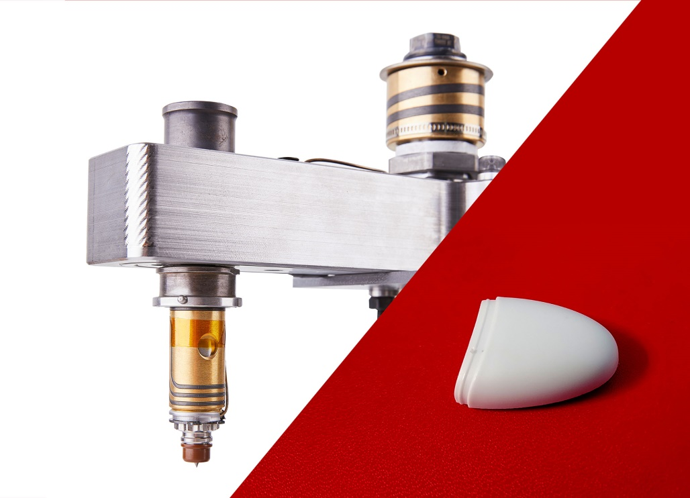
Typical applications of Oerlikon HRSflow’s new S series hot runner line include small technical parts such as the housing for a smart device called Hydration Reminder. © Oerlikon HRSflow

Text and image of this press release are available for download at https://www.konsens.de/hrsflow

