Media Release
Hot runner systems from Oerlikon HRSflow
Innovative mechanical stroke regulator for hydraulic driven valve gate systems avoids surface defects
San Polo di Piave/Italy, July 2021 – Oerlikon HRSflow has developed a Mechanical Stroke Regulator (MSR) for hydraulic driven valve gate systems that makes it easy to individually preset the opening positions of the pins in hot runner systems. Via a graduate scale adjusting screw the user specifies the individual oil volume, which the valve gate system then uses to bring the needles into the intended positions. In this way, the pressure drop for each nozzle can be set independently, and the pressure distribution during the packaging phase can be controlled.
Oerlikon HRSflow supplies its new MSR ready-to-install on all of the company's existing hydraulic cylinder series equipped with electrovalves. Installation can be limited to individual nozzles of a system to save costs. It only takes around 10 minutes and can be done without dismantling the mold. Modifications to the existing hot runner cutout are not required. Combined with Oerlikon HRSflow's FLEXspeed system, the speed of the pin can also be adjusted.
First users unanimously confirm the very good suitability of the new MSR for balancing the melt flow in cascade molding and thus avoiding surface defects by simple means. Numerous trials have also demonstrated its successful use in family molds.
Stephan Berz, Vice President Sales at Oerlikon HRSflow, comments: "We have recognized that numerous quality problems on parts that occur during the injection process can be positively affected by the management and correct positioning of the pin. The new MSR is the result of our developments to make the pressure drop proportional to the opening stroke of the pin. It allows for easy pin adjustment even with hydraulic actuation."
About Oerlikon HRSflow
Oerlikon HRSflow (www.oerlikon.com/hrsflow), part of the Swiss technology group Oerlikon and its Polymer Processing Solutions Division, is based in San Polo di Piave/Italy and specializes in the development and production of advanced and innovative hot runner systems for the injection molding industry. The business unit employs about 1,000 people and is present in all major global markets. Oerlikon HRSflow manufactures hot runner systems at its European headquarters in San Polo di Piave, Italy, its Asian headquarters in Hangzhou, China, and its Byron Center facility near Grand Rapids, MI, USA.
For further information, please contact:
Chiara Montagner  Marketing & Communication Manager  Oerlikon HRSflow  Tel: +39 0422 750 127  Fax: +39 0422 750 303  chiara.montagner@oerlikon.com  www.oerlikon.com/hrsflow | Erica Gaggiato  Marketing & Communication Specialist  Oerlikon HRSflow  Tel: +39 0422 750 120  Fax: +39 0422 750 303  erica.gaggiato@oerlikon.com  www.oerlikon.com/hrsflow
Editorial contact and please send voucher copies to:
Dr.-Ing. Jörg Wolters
Konsens PR GmbH & Co. KG
Im Kühlen Grund 10, D-64823 Groß-Umstadt, Germany
Tel: +49 6078 9363 0,
mail@konsens.de

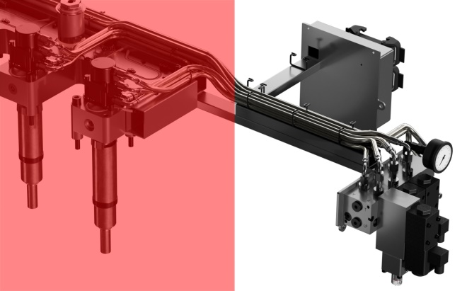
Oerlikon HRSflow's new Mechanical Stroke Regulator (MSR) for hydraulic driven valve gate systems provides an easy-to-use way to adjust and balance melt flow at different gating points.
© Oerlikon HRSflow

Text and image of this press release are available for download at https://www.konsens.de/hrsflow

