NPE2018: an unmissable opportunity to experience FLEXflow Technology. Live molding demonstrations on site
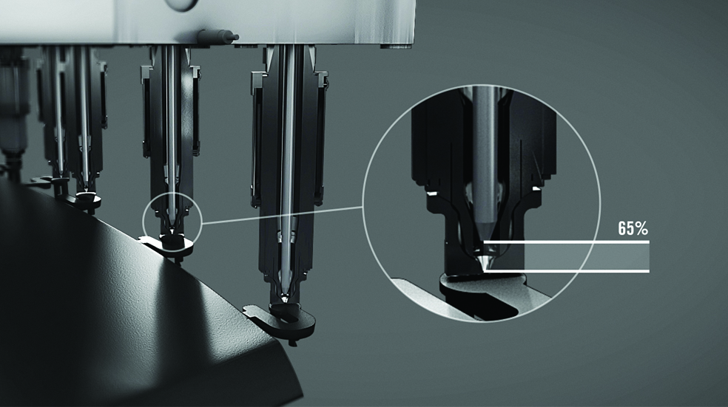
Electrical servo driven valve gate technology: accurate pin open/close control. © HRSflow
San Polo di Piave, Italy, March 2018 – Only a few months are left before the beginning of NPE 2018 and Italian hot runner specialist HRSflow is excited to share the following news. For the occasion of the upcoming exhibition, 4 FLEXflow live molding demonstrations will be held in cooperation with HRSflow project partners including materials suppliers, mold makers and injection molding machine manufacturers. An unmissable opportunity to experience our new range of product, FLEXflow Family: the electrically driven valve gate solutions for automotive and non-automotive premium parts.
FLEXflow applications: live demonstrations not to be missed
At NPE2018, Italian hot runner specialist HRSflow will focus its presentation on hot runner solutions tailored to the injection molding of complex, large-format parts with demanding quality requirements. Practical examples will feature the state-of-the-art FLEXflow technology: the servo driven valve gate system developed by HRSflow for a 360° flow control and monitoring.
Partners’ booths to visit:
- Wittmann Battenfeld (booth W3742): superior solution for automotive exterior components requiring high quality surfaces. The production of an automotive spoiler utilizing a FLEXflow 5-drop hot runner system. Special features of the part: excellent flow and pressure distribution during processing, elimination of pressure and hesitation lines, and optimization for color change.

- Yizumi (booth W3343): premium technical parts. The production of a tool case utilizing a 3-drop FLEXflow servo driven valve gate system. Special features of the part: MuCell® technology, back injection, lightweighting.

- KraussMaffei (booth W403): technology for next generation lightweight vehicles. The realization of a lightweight center console armrest in cooperation with ProperTooling. Special features of the part: TPV overmolding, lightweighting, multicomponent (2+3) drop FLEXflow systems.
- ENGEL (booth W3303): interior parts for the best touch and feel experience. The injection molding of a high-quality grained interior trim component, realized with the In Mold Graining technology together with the back injection of PP in MuCell® foaming process through 5-drop FLEXflow system and DecoJEct foils of Benecke Kaliko.
FLEXflow Family: The Electrical Future With Benefits Beyond Your Expectations
Simple, safe and clean. At the upcoming NPE2018, HRSflow will showcase its FLEXflow Family: the new range of product including the servo driven valve gate systems, FLEXflow and FLEXflow One.
Today’s automotive manufacturing environment is moving in a new direction: design complexity, e-car development, digitalization, autonomy driving and car sharing. Vehicles will become more and more lightweight, autonomous and connected. To face these new challenges and obtain the next-generation high quality parts, Tier1 and OEM customers will need increasingly flexible flow control.
The electric servo technology by HRSflow is designed for the independent adjustment of each valve pin with precise control of stroke, velocity and force during opening and closing phases. This solution assures accurate, easy to operate, flexible control of pressures and flow rates at each individual gate during the injection process.
To discover all the benefits of HRSflow servo driven valve gate technologies, the appointment will be at HRSflow’s Booth: W991, West Hall Level 2.
HRSflow (www.hrsflow.com) is a division of INglass S.p.A. (www.inglass.it), headquartered in San Polo di Piave/Italy. It is specialized in the development and production of advanced and innovative hot runner systems for the injection molding industry. The group of companies has more than 1,100 employees and is present on all the major global markets. HRSflow produces hot runner systems at its European headquarters in San Polo di Piave/Italy, in Asia at its plant in Hangzhou/China and at its facility in Byron Center near Grand Rapids, MI, USA.
Contact and further information
HRSflow, Via Piave 4, 31020 San Polo di Piave (TV), Italy
Phone: +39 0422 750 111, Email: info@hrsflow.com, www.hrsflow.com
Erica Gaggiato, Communication Dept.
Phone: +39 0422 750 120, Email: erica.gaggiato@inglass.it
Editorial contact and voucher copies
Dr.-Ing. Jörg Wolters, Konsens PR GmbH & Co. KG,
Hans-Kudlich-Straße 25, D-64823 Groß-Umstadt, Germany – www.konsens.de
Tel.: +49 (0) 60 78 / 93 63 0, Email: mail@konsens.de

Press releases from HRSflow with text (German and English) as well as pictures in print-ready resolution are available to download from: www.konsens.de/hrsflow.html

