Hall 1
Stand D10

Press Release
Oerlikon HRSflow at K 2022:
New hot runner nozzles increase efficiency in thin wall packaging and multi-cavity molds
San Polo di Piave/Italy and Düsseldorf, October 19, 2022 - Oerlikon HRSflow has expanded its extensive portfolio of valve gate nozzles for hot runner systems. The new Xp series is specifically tailored to the requirements of injection molding thin-walled packaging and is available as both a single-face and stack mold solution. Also new is the Vf series, which the company has optimized for use in multi-cavity molds for caps and closures. Both new introductions help reduce energy consumption in plastics processing, enabling more sustainable production.
For thin-walled packaging applications
The new Xp valve gate nozzles are designed for high injection pressures of up to 2,200 bar. They enable very fast injection and cycle times in a stable process with high part-to-part weight consistency and without compromising quality and surface finish. Despite the compactness of the overall system, they allow extremely simplified assembly and maintenance with a plug-and-play solution for fast production start-up.
Hot runner systems equipped with this solution enable the energy-saving use of smaller injection molding machines. Suitable for hot half thicknesses of up to 240 mm, it can supply perfectly symmetrical systems with up to 8 plus 8 drops, with a minimum drop-to-drop pitch distance between cavities of 65 mm and 120 mm between nozzle and inlet.
Specific solutions for caps and closures
With special solutions, the Vf nozzles of the new multicavity line from Oerlikon HRSflow are suitable for caps and closures with very high requirements for fast cycles with weights from 0.95 g to 2.4 g. In any case, they stand for reliably consistent processes and product qualities, fast color changes and system restarts, and particularly short cycle times of less than two seconds. Based on its broad experience, also with large systems up to 96 cavities, the hot runner specialist Oerlikon HRSflow has designed them in such a way that even such complex systems can be optimally tuned without much effort.
A special nozzle tip enables optimum control in the gate area and improves cycle time. The separate replaceability of the nozzle tip point makes maintenance particularly fast and cost-effective. Rheologically optimized hot runner geometries ensure significantly increased reactivity and thus effectiveness of the system. Special inserts minimize the time required for color changes while keeping reject rates low, which contributes to the sustainability of production even with particularly critical colors.
About Oerlikon HRSflow
Oerlikon HRSflow (www.hrsflow.com), part of the Swiss technology group Oerlikon and its Polymer Processing Solutions Division, is based in San Polo di Piave/Italy and specializes in the development and production of advanced and innovative hot runner systems for the injection molding industry. The business line employs about 1,000 people and is present in all major global markets. Oerlikon HRSflow manufactures hot runner systems at its European headquarters in San Polo di Piave, Italy, its Asian headquarters in Hangzhou, China, and its Byron Center facility near Grand Rapids, MI, USA.
For further information, please contact:
Chiara Montagner  Marketing & Communication Manager  Oerlikon HRSflow  Tel: +39 0422 750 127  Fax: +39 0422 750 303  chiara.montagner@oerlikon.com  www.oerlikon.com/hrsflow | Erica Gaggiato  Marketing & Communication Specialist  Oerlikon HRSflow  Tel: +39 0422 750 120  Fax: +39 0422 750 303  erica.gaggiato@oerlikon.com  www.oerlikon.com/hrsflow
Editorial contact and please send voucher copies to:
Dr.-Ing. Jörg Wolters
Konsens PR GmbH & Co. KG
Im Kühlen Grund 10, D-64823 Groß-Umstadt, Germany
Tel: +49 6078 9363 13
mail@konsens.de
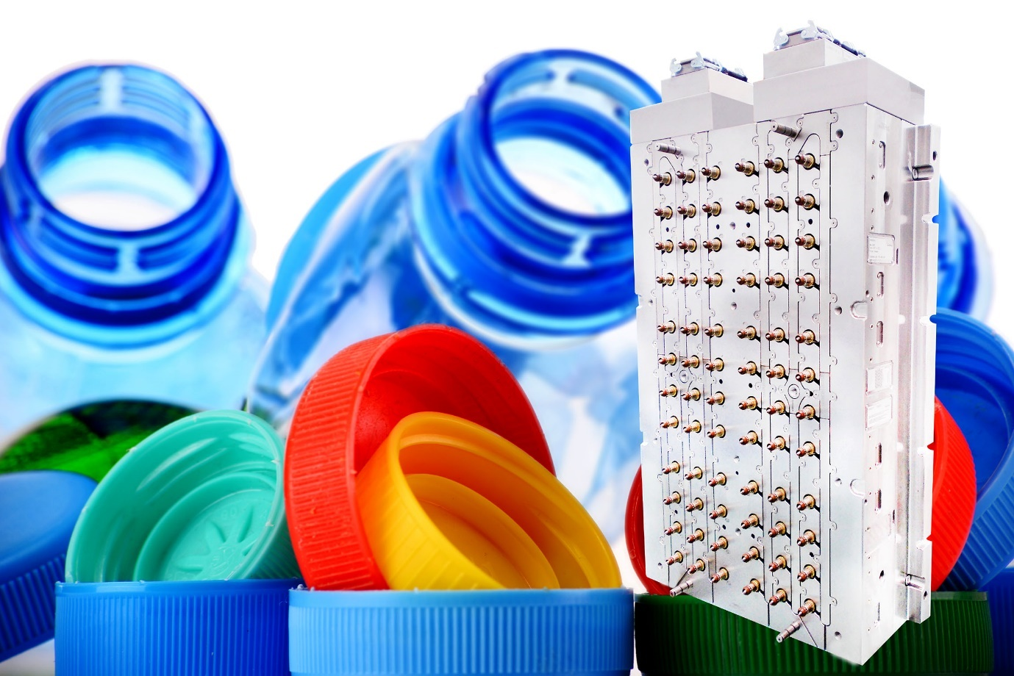
The Vf nozzles of Oerlikon HRSflow's new Low Weight Shot system line are suitable for multi-cavity molds for the production of molded parts such as caps and closures with weights from 0.95 g to 2.4 g. © Oerlikon HRSflow
Text and image of this press release are available for download at https://www.konsens.de/hrsflow

