News Release

Oerlikon HRSflow hot runner systems combine cost-efficient production with a precise process control

Hot runner technology for superior surface quality in the automotive industry

San Polo di Piave/Italy – April 2023 – Hot runner technology enables injection molded parts with the highest surface quality, as required in particular by the automotive industry. In many applications, systems from Oerlikon HRSflow support cost-efficient, material-saving production with highly precise process control. Examples include a "smart" car rear panel in 2K technology as well as injection-molded light guide elements for which the new, patent-pending CTC gate insert is used. Beyond, the advantages of the company's FLEXflow technology with servo-controlled needle positioning are demonstrated by the cascade injection molding of headlight covers and the back molding of films in a lightweight construction application.

“Smart“ automotive rear panel
The supporting element of a "smart" car rear panel using 2K technology is a frame made of PC/ABS. In the first step, this is injection molded using a hydraulic 2-drop hot runner system from Oerlikon HRSflow. In the second step, the part is overmolded with PMMA or alternatively PC using a single nozzle from the Ga series. Finally, the part is decorated directly in the mold with a capacitive yet aesthetically pleasing film. In addition to Oerlikon HRSflow, Kurz, ENGEL and Schöfer also contributed to the success of this innovative project, which required, among other things, extensive rheological calculations due to the complex requirements.

Light Guide element
For the injection molding of an automotive light guide element, Oerlikon HRSflow’s new patent-pending CTC gate insert provides optimum properties. It is made of steel with superior mechanical properties and wear resistance. In addition, flash formation is completely avoided thanks to optimum thermal control in the gate area in conjunction with a cylindrical shut-off. Both factors help optimize productivity in the manufacture of the light guide element. Forgiving dimensional requirements simplify machining of the nozzle seat, and a smart solution that allows the gate opening to be renewed with minimal effort facilitates maintenance work. In general, injection molded parts that require a wide process window due to difficult conditions such as low shot volumes, long packing times and high holding pressure values are among the typical applications for the new CTC.

Headlight Bar
LED headlight bars made of crystal-clear polycarbonate (PC) are a proven application of Oerlikon HRSflow's FLEXflow technology. The systems' servo motors enable synchronized needle movements for precisely controlled flow front progression during sequential injection molding. Sudden pressure drops that occur when additional gates are opened are perfectly damped, so that the cavities are filled evenly and residual stresses in the molded part are minimized. There is also a high degree of flexibility during the holding pressure phase because the needle closing profile (speed and stroke) can be adapted to meet product dimensional requirements.

Lightweight construction by back-injection molding
The possibilities of hot runner technology in the design of future cockpits are illustrated by a joint project between the Koller Group, Dietfurt, and Oerlikon HRSflow using the example of a laptop housing demonstrator part. A prefabricated and preformed film is back-injection molded with PC using the FIM (Film Insert Molding) process. Mold development was carried out jointly with Koller Formenbau, while the back molding process was developed with the automotive lightweight specialist Koller Kunststofftechnik. While the film was initially displaced below the injection point, this washout effect could be reliably avoided by using and optimizing Oerlikon HRSflow’s electrically controllable FLEXflow hot runner system.

About Oerlikon Polymer Processing Solutions Division
Oerlikon is a leading provider of comprehensive polymer processing plant solutions and high-precision flow control component equipment. Oerlikon HRSflow, part of Polymer Processing Solutions Division, develops and produces advanced and innovative hot runner systems and multi-cavity solutions for the injection molding industry. Business sectors include automotive, logistics and environmental, domestic appliances, mobility, houseware and gardening, technical applications, medical, beverage and home, thin wall packaging, beauty and personal care markets. The division provides in addition polycondensation and extrusion lines, manmade fiber filament spinning solutions, texturing machines, BCF and staple fiber lines and nonwoven production systems. Its engineering competence leads to sustainable and energy-efficient solutions for the entire textile value added chain with a circular economy approach. Moreover, Oerlikon develops and produces customized gear metering pumps for the textile, automotive, chemical, dyes and lacquers industries.

The division serves customers through its technology brands – Oerlikon Barmag, Oerlikon Neumag, Oerlikon Nonwoven and Oerlikon HRSflow - in around 120 countries with production, sales, distribution and service organizations.

The division is part of the publicly listed Oerlikon Group, headquartered in Switzerland, which has 12 000 employees and generated CHF 2.65 billion in revenue in 2021.

For further information: www.hrsflow.com

For further information, please contact:
Chiara Montagner  Marketing & Communication Manager  Oerlikon HRSflow  Tel: +39 0422 750 127  Fax: +39 0422 750 303  chiara.montagner@oerlikon.com  www.oerlikon.com/hrsflow | Erica Gaggiato  Marketing & Communication Specialist  Oerlikon HRSflow  Tel: +39 0422 750 120  Fax: +39 0422 750 303  erica.gaggiato@oerlikon.com  www.oerlikon.com/hrsflow

Editorial contact and please send voucher copies to:
Dr.-Ing. Jörg Wolters
Konsens PR GmbH & Co. KG
NEW: Hans-Böckler-Str. 20, D-63811 Stockstadt, Germany
Tel: +49 99005 13
mail@konsens.de www.konsens.de
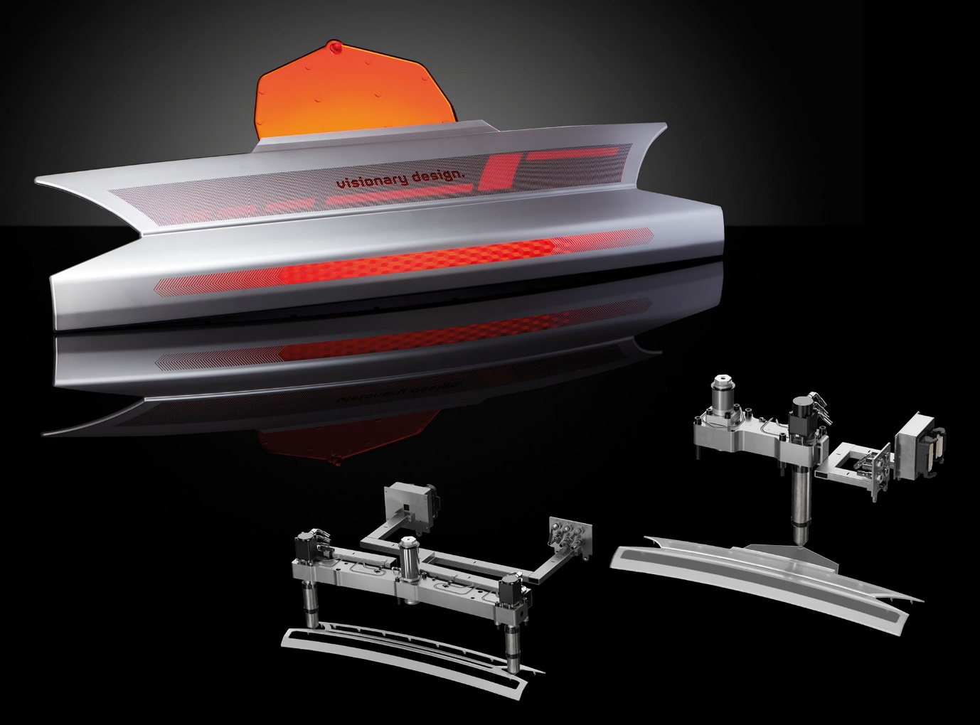 A "smart" automotive rear panel in 2K technology, consisting of a PC/ABS frame overmolded with PMMA or PC, is injection molded in the first phase using a hydraulic 2-drops system from Oerlikon HRSflow and then overmolded using a single nozzle from the Ga series. © Oerlikon HRSflow
Text and image of this press release are available for download at https://www.konsens.de/hrsflow

