Press Release
Simultaneous to the digital process twin
Mold Sampling during Flow Simulation
San Polo di Piave/Italy, and Raunheim/Germany, September 2022 – Flow simulation data can significantly reduce the time until the real sampling of a tool, and avoid expensive tool modifications. The prerequisite is that the development partners work on the project in a centralised, simultaneous workflow instead of sequentially and contribute their know-how simultaneously. This is the result of a joint project in which Borealis, Oerlikon HRSflow and ENGEL used the example of a demanding mould to show how successfully injection moulding parameters can be optimised in the simulation and transferred directly to the machine as an initial setting proposal, provided that all relevant data of the injection moulding machine, the processed material as well as the hot runner system and other components are available. The experience gained from this close cooperation, the precision of the spot landing achieved with it and possible consequences for practice are presented by the partners in the context of a documentation that can be accessed online and will be presented at K2022.
The simulation was carried out with the aid of Moldflow®, using the example of a family mould with three cavities and a weight difference of 1:11 from the smallest to the largest component. ENGEL provided a duo injection moulding machine, detailed values, for example on the geometries of the nozzle used, as well as the sim link data interface for the direct connection of Moldflow® to the CC300 control unit of the injection moulding machine. Borealis provided the comprehensive, very precise data on the flow behaviour of the Daplen™ EE001AI polypropylene, and Oerlikon HRSflow contributed a servo-driven 8-cavity hot runner system that allows the volume flow to be controlled and thus each cavity to be filled individually.
In the traditional process, the parties involved do not discuss possible causes of faults and remedial measures until after sampling has been completed. In the project described here, optimisation with regard to temperature control, injection characteristics and all other pressure and time-related injection moulding parameters started jointly and immediately at the beginning of the simulation. The parameters determined in several iteration steps were then transferred to the machine via sim link. This data exchange between simulation software and injection moulding machine can take place in both directions. It thus also enables the analysis of process data, which in turn provides potential for process optimisation. Access to sensitive design data is not necessary.
The real production start-up underlined the high precision of the settings found via Moldflow®. The real filling behaviour and the positioning of the weld lines matched the simulation 100 %. The warpage behaviour of the largest part, the door trim measuring around 600 mm x 400 mm, was predicted to within ±2 mm, and the dimensions across the diagonal of over 650 mm were maintained with maximum deviations of only 0.04 %. After a few optimisation steps and without major manual readjustment, all three moulded parts met the quality requirements.
This joint project has not only shown that real production has run almost identically to the simulation, but the result also opens up potential for more sustainable production. For example, it is possible to see in the design phase whether a machine is suitable for the intended product or whether energy can be saved and production efficiency increased by using a smaller machine. In addition, the setting data suggestion developed in the simulation reduces the number of necessary setting cycles. This leads to fewer rejects and lower energy consumption during sampling.
Markus Kralicek, Business Development Manager at Borealis, Michael Fischer, Head of Business Development Automotive Technologies at ENGEL, and Stephan Berz, Vice President Sales at Oerlikon HRSflow and General Manager DACH, will report on the project itself and many additional details in a free, off-line webinar at https://www.hrsflow.com/ww/en/events/borealis-engel-oerlikon-hrsflow-webinar. In addition, the speakers will present the results during K 2022 at the Oerlikon HRSflow stand (Hall 1, Stand D10) on Thursday, 20.10.2022 at 4.30 p.m. and on Tuesday, 25.10.2022 at 4.00 p.m.
About Oerlikon HRSflow
Oerlikon HRSflow (www.hrsflow.com), part of the Swiss technology group Oerlikon and its Polymer Processing Solutions Division, is based in San Polo di Piave/Italy and specializes in the development and production of advanced and innovative hot runner systems for the injection molding industry. The business line employs about 1,000 people and is present in all major global markets. Oerlikon HRSflow manufactures hot runner systems at its European headquarters in San Polo di Piave, Italy, its Asian headquarters in Hangzhou, China, and its Byron Center facility near Grand Rapids, MI, USA.
For further information, please contact:
Grit Reifer  Marketing Manager Oerlikon HRSflow D-A-CH  HRSflow GmbH  Am Prime-Parc 2A, D-65479 Raunheim  Mobil: +49 160 7407058  grit.reifer@oerlikon.com  www.oerlikon.com/hrsflow | Erica Gaggiato  Marketing & Communication Specialist  Oerlikon HRSflow  Tel: +39 0422 750 120  Fax: +39 0422 750 303  erica.gaggiato@oerlikon.com  www.oerlikon.com/hrsflow
Editorial contact and please send voucher copies to:
Dr.-Ing. Jörg Wolters
Konsens PR GmbH & Co. KG
Im Kühlen Grund 10, D-64823 Groß-Umstadt, Germany
Tel: +49 6078 9363 13
mail@konsens.de
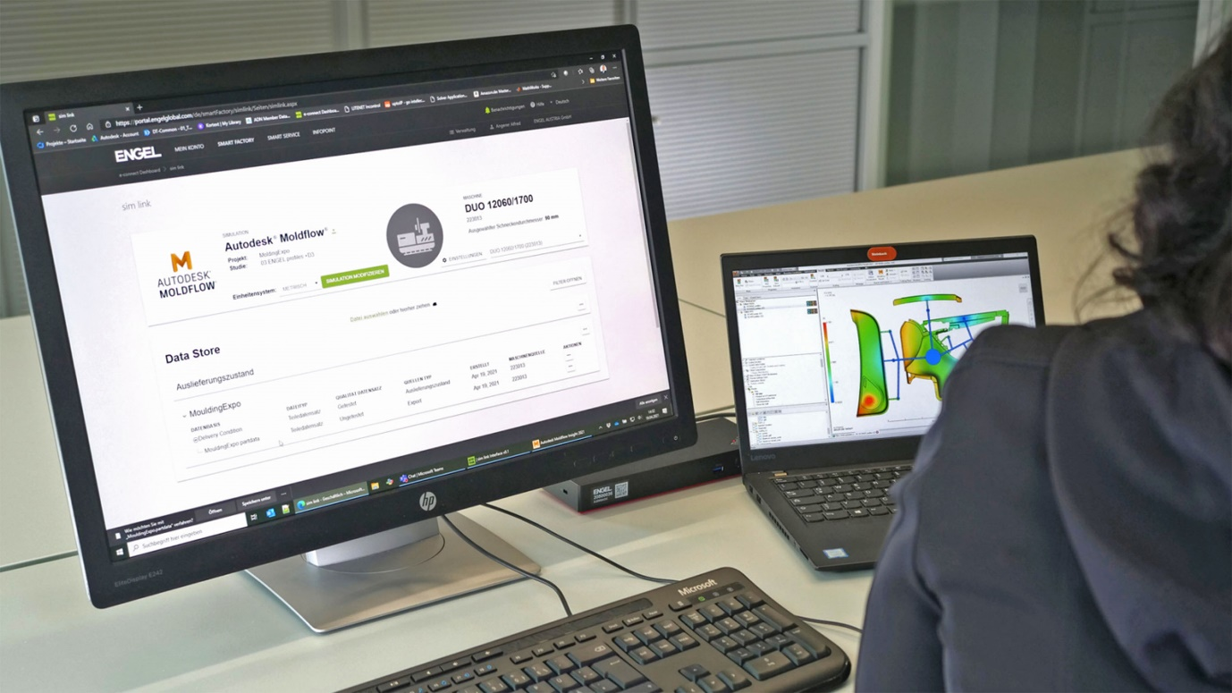
Simulation and practice match almost one hundred percent. © Oerlikon HRSflow
Text and image of this press release are available for download at https://www.konsens.de/hrsflow

