“Follow your job every time, everywhere”

HRSflow even closer to its customers with the new MyHRS Portal
The new online area allows HRSflow customers to follow their jobs every time and everywhere in just a few clicks.
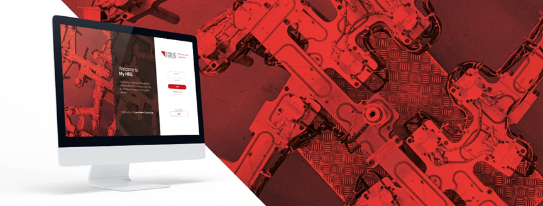
© HRSflow
San Polo di Piave (Italy) / May, 2021 – Covid-19 pandemic has been leading millions of employees to work remotely. Efficiency, collaboration and responsiveness are now more important than ever. Aware that the way we work and interact will never be the same, the hot runner manufacturer HRSflow launches MyHRS Portal: the online area that allows customers to follow their jobs from quotation to system delivery in an innovative way.
Easy and intuitive, the new working space enables HRSflow customers to gain a complete visibility and control over their orders with a tailored made dashboard. HRSflow offers a single point of access to monitor all activities. It just takes few clicks to open a new Request for Quotation (RFQ), track the status of all jobs, access the relevant and latest information and check the delivery information of the system. Built with a customer-oriented approach, through MyHRS everything can be managed in a simple and fast way, minimizing emails related to the order process.
Thanks to the new portal, information will be accessible anywhere, by logging in with a laptop. Customers will be able to recognize intuitively the main tasks to be performed, and on the other side what HRSflow is doing. All the documents related to a specific job request, will be saved in a digital format facilitating the information sharing among the different parties involved. In addition, the contact details of HRSflow representatives - such as the dedicated Salesman, Sales Support Engineer and Sales Assistant - will be available, on the left side of the dashboard.
Customers will be able to add other members of their own staff creating multiple accounts with different functions. The “team management” feature permits to inform in real time all the players involved in the process, even if they don’t share the same office space.
HRSflow Project Manager Marco Bettin states: “The main concept behind MyHRS is to create a new platform which is smart, easy-to-use and custom built to meet our customer needs. Thanks to the Value Stream Mapping (VSM), the powerful Lean Methodology tool, we mapped the entire process flow: from the request for quotation to the delivery of the system. This also gave us the opportunity to enhance our value added activities.
MyHRS reflects our belief that a high-quality service should be shown especially in the tools provided to the customers. Born from the suggestions of our Sales force, always focused on the customers’ voice, MyHRS is a platform at the cutting-edge of customer experience offering an innovative channel of communication. We can now shout it loud: it’s online.”
MyHRS will be available first in Europe, then in America and Asia. The authorization to access the customer area will be supplied by the HRSflow team. Once received, opening hrsflow.com and clicking on “MyHRS” on the right will start the journey. All the information you need will be at your fingertips, wherever you are.
HRSflow (www.hrsflow.com), recently acquired by the Swiss Group Oerlikon, is based in San Polo di Piave/Italy and specializes in the development and production of advanced and innovative hot runner systems for the injection molding industry. The group of companies employs about 1,000 people and is present in all major global markets. HRSflow manufactures hot runner systems at its European headquarters in San Polo di Piave, Italy, its Asian headquarters in Hangzhou, China, and its Byron Center facility near Grand Rapids, MI, USA.
Contact and further information:
HRSflow, Via Piave 4, 31020 San Polo di Piave (TV), Italy
Phone: +39 0422 750 111, Email: info@hrsflow.com, www.hrsflow.com
Erica Gaggiato, Communication Dept.
Phone: +39 0422 750 120, Email: erica.gaggiato@inglass.it
Chiara Montagner, Marketing Dept.
Phone: +39 0422 750 127, Email: chiara.montagner@inglass.it
Editorial contact and please send voucher copies to:
Dr.-Ing. Jörg Wolters, Konsens PR GmbH & Co. KG,
Im Kühlen Grund 10, D-64823 Groß-Umstadt, Germany – www.konsens.de
Phone: +49 6078 9363 0, Email: mail@konsens.de
Press releases from HRSflow with docx-text files and print-ready images are available for download at https://www.konsens.de/hrsflow

