New in hot runner technology – precise control for hydraulic needle drive, wear-resistant design for abrasive plastics, high quality film injection molding
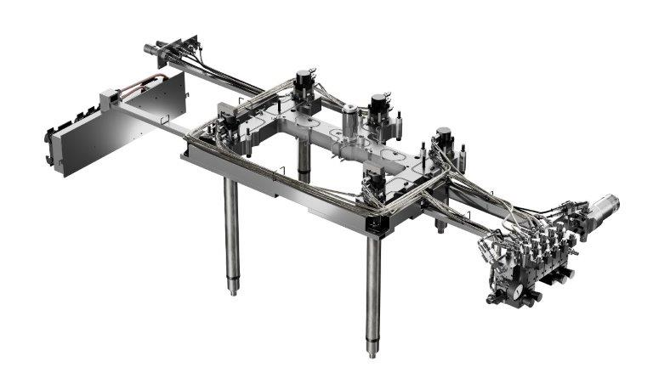
HyFlow, the recently introduced development to control the needles’ opening and closing speeds in hydraulically actuated cylinders, is available as complete or – when applied to selected actuators only – as hybrid version. © HRSflow
San Polo di Piave/Italy, September 2020 --- New and advanced developments around HRSflow’s hot runner systems are specially designed to increase product quality in cascade injection molding. This includes the only recently launched HyFlow technology developed for applications with hydraulically actuated cylinders, in which the opening and closing speeds and the positioning of each individual pin can be precisely adjusted via the oil flow rate. Now also available in the market is the Hyper-GF series for processing abrasive thermoplastics. On the application side, HRSflow uses a current pilot project with a customer, to show how FLEXflow Evo, the recently presented advancement of the FLEXflow technology for servo-electrically driven valve gate systems, can be used to achieve outstanding results when back-molding sensitive films.
HyFlow uses a controller with a user-friendly interface to set the lock position of each individual pin. The opening and closing speed for each nozzle can be set by a manual adjustment mechanism. This allows for controlling the melt flow rate in a way that cascade injection molding results in a uniform mold filling process without sudden pressure drops and the associated surface defects. The positioning of the pin also allows for optimal balancing of the pressure distribution in the cavity during the entire injection process.
The new Hyper-GF series, available for HRSflow’s Ga and Aa nozzles, is designed to improve the long term performance of the hot runner system when processing highly abrasive materials such as glass fiber reinforced materials. It supports extended service lives even in injection molding processes with very high productivity. Contributing factors include the use of special steels and an optimized flow channel design.
The possibilities offered by the FLEXflow Evo hot runner system for film insert molding (FIM) are demonstrated in a joint project with the film manufacturer Kurz, Fürth/Germany. This pioneering technology enables, for example, the integration of capacitive films for sensors or touch control panels in combination with backlit decorative films. This provides a previously unknown design and functional flexibility, especially for automotive interior applications. In cooperation with Kurz, a film featuring functional capacitive elements for touch operation and decorative elements was back-injected with a crystal clear polycarbonate (PC) in a single step, enabling backlighting in the area of the operating elements. The servo driven valve gate technology produced results of a quality level that would not be achievable with conventional concepts. In particular, after back-injection with the FLEXflow Evo technology, the thin functional and decorative elements do not show internal stress as in conventional cascade injection molding, thanks to the evenly and low-pressure spreading melt flow front, whilst any damage to the film was reliably avoided.
HRSflow (www.hrsflow.com) is a division of INglass S.p.A. (www.inglass.it) based in San Polo di Piave/Italy and specializes in the development and production of advanced and innovative hot runner systems for the injection molding industry. The group of companies employs about 1,000 people and is present in all major global markets. HRSflow manufactures hot runner systems at its European headquarters in San Polo di Piave, Italy, its Asian headquarters in Hangzhou, China, and its Byron Center facility near Grand Rapids, MI, USA.
Contact and further information:
HRSflow, Via Piave 4, 31020 San Polo di Piave (TV), Italy
Phone: +39 0422 750 111, Email: info@hrsflow.com, www.hrsflow.com
Erica Gaggiato, Communication Dept.
Phone: +39 0422 750 120, Email: erica.gaggiato@inglass.it
Chiara Montagner, Marketing Dept.
Phone: +39 0422 750 127, Email: chiara.montagner@inglass.it
Editorial contact and please send voucher copies to:
Dr.-Ing. Jörg Wolters, Konsens PR GmbH & Co. KG,
Im Kühlen Grund 10, D-64823 Groß-Umstadt, Germany – www.konsens.de
Phone: +49 6078 9363 0, Email: mail@konsens.de
Press releases from HRSflow with docx-text files and print-ready images are available for download at https://www.konsens.de/hrsflow

