New FLEXflow Evo facilitates use of servo-controlled valve gate systems
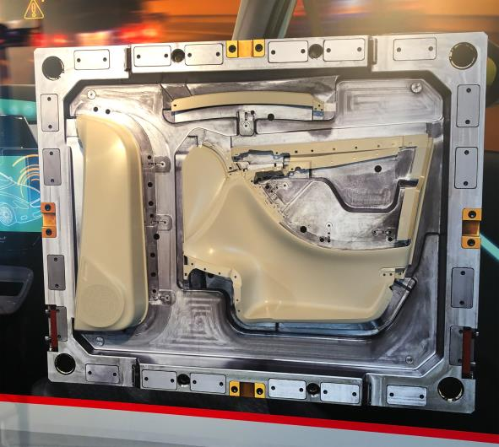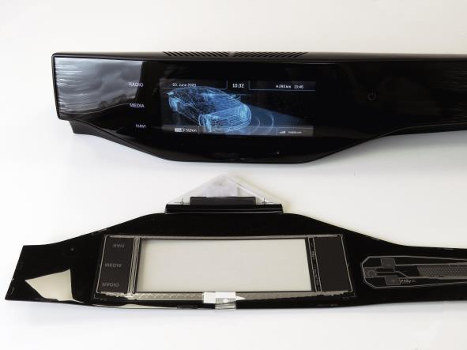 | The most promising application trends for FLEXflow EVO include cost-efficient family molds (above) and back-injection of films, here using the example of a demonstrator cover with backlight functions and integrated capacitive sensor
San Polo di Piave/Italy, May 2020 --- Introduced in early 2020, FLEXflow Evo is an advancement of the FLEXflow technology for servo-electrically driven valve gate systems from HRSflow, which had revolutionized sequential injection molding. With actuators directly fixed on the manifold, the result is a ready-to-install system for quick and safe installation on the mold. The updated software simplifies the operator's work and can be easily retrofitted to all existing control units. The new controller is even more responsive thanks to an optimization of the data transfer.
FLEXflow Evo is complemented by the FLEXflow Evo One valve gate system, which is also servo-motor driven. Instead of the usual control system, a simply designed driver module coupled to each individual nozzle takes over the task of controlling the melt flow in order to produce molded parts with reproducibly high quality.
Currently, the most promising application trends for the FLEXflow Evo technology include family molds and back-injection of films. Companies using family molds for the simultaneous production of different parts in a single shot benefit from significant cost savings compared to separate production of the individual components. What’s more, FLEXflow Evo also allows for producing parts with significant differences in geometry and weight in one mold. Film back-injection with capacitive films is a forward-looking technology that is only just beginning to develop. It enables, for example, the integration of functional elements with a low thickness, such as lights, sensors or touch switches, and thus provides a previously unknown level of design flexibility, especially for automotive interior and exterior applications with grained or high-gloss Class A surfaces.
HRSflow (www.hrsflow.com) is a division of INglass S.p.A. (www.inglass.it), headquartered in San Polo di Piave/Italy. It is specialized in the development and production of advanced and innovative hot runner systems for the injection molding industry. The group of companies has more than 1,100 employees and is present on all the major global markets. HRSflow produces hot runner systems at its European headquarters in San Polo di Piave/Italy, in Asia at its plant in Hangzhou/China and at its facility in Byron Center near Grand Rapids, MI, USA.
Contact and further information:
HRSflow, Via Piave 4, 31020 San Polo di Piave (TV), Italy
Phone: +39 0422 750 111, Email: info@hrsflow.com, www.hrsflow.com
Chiara Montagner, Marketing Dept.
Phone: +39 0422 750 127, Email: chiara.montagner@inglass.it
Editorial contact and please send voucher copies to:
Dr.-Ing. Jörg Wolters, Konsens PR GmbH & Co. KG,
Im Kühlen Grund 10, D-64823 Groß-Umstadt, Germany – www.konsens.de
Tel.: +49 6078 9363 0, Email: mail@konsens.de
Press releases from HRSflow with text as well as pictures in print-ready resolution are available to download from: https://www.konsens.de/hrsflow

