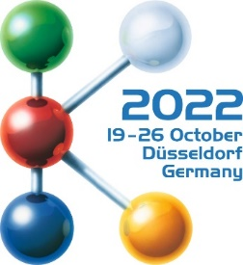
Hall 1
Booth D10

Press Release
Hot runner solutions from Oerlikon HRSflow at K 2022:
Advanced Hot runner solutions increase flexibility and sustainability in injection moulding
San Polo di Piave/Italy, July 2022 - At K 2022, which will take place in Düsseldorf from 19 to 26 October, Oerlikon HRSflow will focus on an extensive range of hot runners tailored to small shot weights and the new Xp nozzle series for use in thin-wall injection moulding. Both support the trend towards greater sustainability by helping to reduce energy consumption in plastics processing. Applications of Oerlikon FLEXflow's hot runner technology and other advanced hot runner solutions specifically designed for PCR materials and biopolymers will be on display on the stands of several partner companies. In addition, the company, together with ENGEL and Borealis, will show in a presentation that a lot of time can be saved if all partners involved in a development proceed simultaneously and make full use of the possibilities of simulation.
Reduced dimensions for low shot weights
Hot runner specialist Oerlikon HRSflow has expanded its portfolio to include components for injection molding of demanding parts with small shot weights in stable and reliable processes. The manufacturer now offers complete systems for this market segment, which require tight nozzle pitch solutions. These include nozzles with small dimensions in all designs, from thermal gate to valve gate, as well as the associated manifolds and actuation mechanisms. For multi-cavity applications, a multi-valve plate (MVP) provides perfectly synchronized control of the injection channel across all cavities for high part-to-part weight consistency. Oerlikon HRSflow systems offer optimal colour change performance and easy system restart, reducing waste and increasing efficiency and sustainability.
With unique solutions, the new low shot weight system line covers market segments such as medical technology, thin-walled packaging, beverages, and home goods, e.g. caps produced in multi-cavity moulds, as well as beauty and personal care and technical applications. The latest version of the system is highly reliable for processing even biopolymers and PCR compounds. A version with a specially coated nozzle tip is available for processing highly corrosive polymers including flame retardant compounds. For demanding applications, Oerlikon HRSflow uses its in-house additive manufacturing process SLM (Selective Laser Melting) technology to produce cooling circuits for all market segments. Thanks to the joint experience with sister brand Oerlikon Balzers, Oerlikon HRSflow also offers innovative surface protection for all moulded part surfaces to increase their corrosion resistance.
For thin-wall injection moulding and stack moulds
The new Xp series of valve gate nozzles from Oerlikon HRSflow is designed to withstand high filling pressures up to 2200 bar and enables fast injection and cycle times in a stable process with high part weight consistency. An innovative, patent-pending solution for stack systems in thin-wall injection moulding has been developed. Assembly is extremely simplified and highly efficient thanks to a plug-and-play installation. This hot runner system, which enables the use of smaller injection moulding machines, fits a maximum plate thickness of 240 mm. This allows perfectly symmetrical systems with up to 8 plus 8 drops to be supplied, with a minimum pitch between cavities of 65 mm and between nozzle and inlet of 120 mm.
Trendsetting for automotive applications
A trend in automotive interiors are interactive panels controlled by touch sensors, whose elements and information only become visible when there is activity. For their production in the IMD process (In-Mold-Decoration), the FLEXflow hot runner technology from Oerlikon HRSflow with its servo-electric needle positioning is increasingly proving to be the tool of choice, because it enables precisely controlled, gentle and low-warpage overmoulding of the sensitive electronic components with high-quality surfaces at the same time.
The cost- and energy-efficient applicability of FLEXflow for perfectly balanced family moulds, even with extremely different part volumes, ensures additional acceptance in this industry. This also applies to HRScool, Oerlikon HRSflow’s solution for hot runner injection moulding, which eliminates the need for water cooling of the associated actuators.
Both technologies help to reduce the environmental footprint of the injection moulding process. This starts with the lower energy consumption of the servo-electric system compared to the hydraulic system and includes the ability to use smaller injection moulding machines and family moulds, reduce wall thicknesses and reduce scrap thanks to better process repeatability.
Oerlikon HRSflow has recently made the operating software for controlling the FLEXflow hot runner systems even more intuitive and convenient. With the thoroughly revised Human Machine Interface (HMI) 4.0, systems with different nozzle types can be integrated and several parameter sets can be stored per mould. Extended possibilities exist for the individual control of the respective servo motors for nozzle needle positioning and for monitoring process stability. In addition, specific user accounts for individual access authorisations can now be set up and managed. Thanks to the web connection, access to the control unit is possible regardless of location.
Turnkey Molding Solutions
In close cooperation with sister company Oerlikon Balzers, innovative coating protection for perfect molded part surfaces can also be offered. One current application is BMW's iXe all-electric SUV, which uses Oerlikon Balzer's ePD™ technology (embedded PVD for Design parts). This forward-looking, environmentally friendly coating process can be used wherever high-quality, metallic-looking surfaces on plastic parts with intelligent functionality are required.
Systems from Oerlikon HRSflow in action
Systems from Oerlikon HRSflow can be experienced live on the exhibition stands of ENGEL (Hall 15, Booth C58, door panel and smart rear panel), Tederic (Hall 15, Booth D40, 2K High Gloss B pillar), Arburg (Hall 13 / Booth A13 – B13, multi-component tool box made of PC+ABS and RECOPOUND® – the recycled compound based on PET by LEONHARD KURZ), Haitian (Hall 15, Booth A57, fruit box made of PE plus Tetra Pak recycled shredded flakes), Wittmann-Battenfeld (Hall 15, Booth C06, 3K coffee cup), Billion (Hall 15, Booth B24, garden tool), and Netstal (Hall 15, Booth D24 R-PP thin-wall cup).
Presentation: On the way to the digital process twin
During the show, Oerlikon HRSflow, ENGEL and Borealis will report at Oerlikon’s booth D10 in hall 1 on a jointly realized project which, using a family mould with three different cavities, shows how close simulation and reality can be when the partners each contribute a maximum of know-how. Instead of the usual sequential approach, the participants accompanied the development steps simultaneously and provided all relevant data of the injection molding machine, the valve gate hot runner system and the processed material for a perfect flow simulation. The parameters determined there were finally transferred to the injection moulding machine's control system. Compared to conventional sequential cooperation, the time until the initial sampling of the mould and for the commissioning itself could thus be significantly reduced.
About Oerlikon HRSflow
Oerlikon HRSflow (www.hrsflow.com), part of the Swiss technology group Oerlikon and its Polymer Processing Solutions Division, is based in San Polo di Piave/Italy and specializes in the development and production of advanced and innovative hot runner systems for the injection molding industry. The business line employs about 1,000 people and is present in all major global markets. Oerlikon HRSflow manufactures hot runner systems at its European headquarters in San Polo di Piave, Italy, its Asian headquarters in Hangzhou, China, and its Byron Center facility near Grand Rapids, MI, USA.
For further information, please contact:
Chiara Montagner  Marketing & Communication Manager  Oerlikon HRSflow  Tel: +39 0422 750 127  Fax: +39 0422 750 303  chiara.montagner@oerlikon.com  www.oerlikon.com/hrsflow | Erica Gaggiato  Marketing & Communication Specialist  Oerlikon HRSflow  Tel: +39 0422 750 120  Fax: +39 0422 750 303  erica.gaggiato@oerlikon.com  www.oerlikon.com/hrsflow
Editorial contact and please send voucher copies to:
Dr.-Ing. Jörg Wolters
Konsens PR GmbH & Co. KG
Im Kühlen Grund 10, D-64823 Groß-Umstadt, Germany
Tel: +49 6078 9363 13
mail@konsens.de
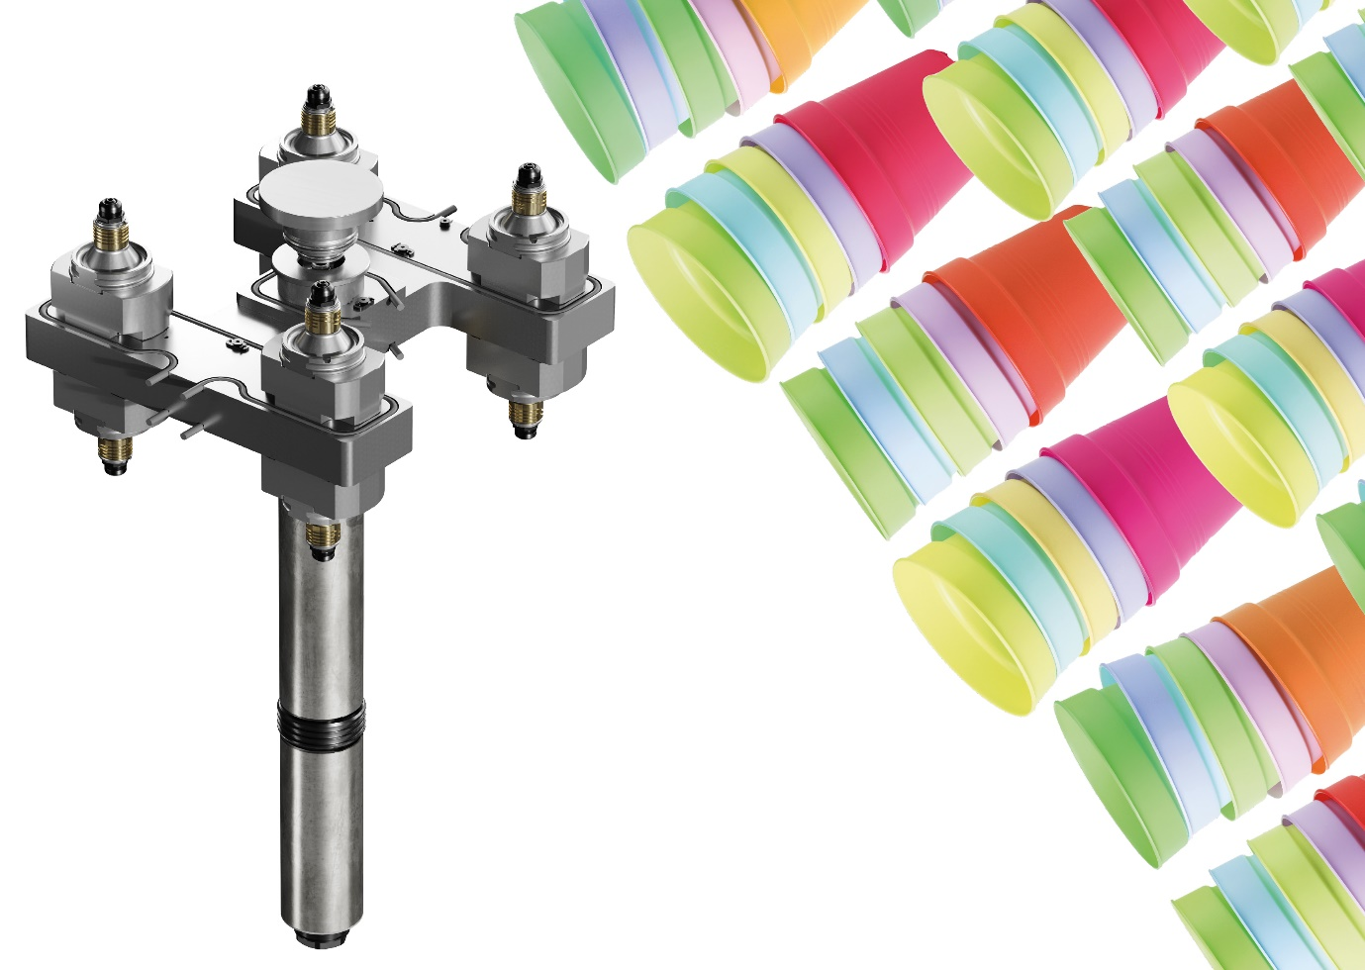
The new Xp nozzle series from Oerlikon HRSflow enables face-to-face assembly in compact stack moulds. © Oerlikon HRSflow
Text and image of this press release are available for download at https://www.konsens.de/hrsflow

