New valve gate solution:
HPgate from HRSflow enlarges process window and improves quality of the molded part
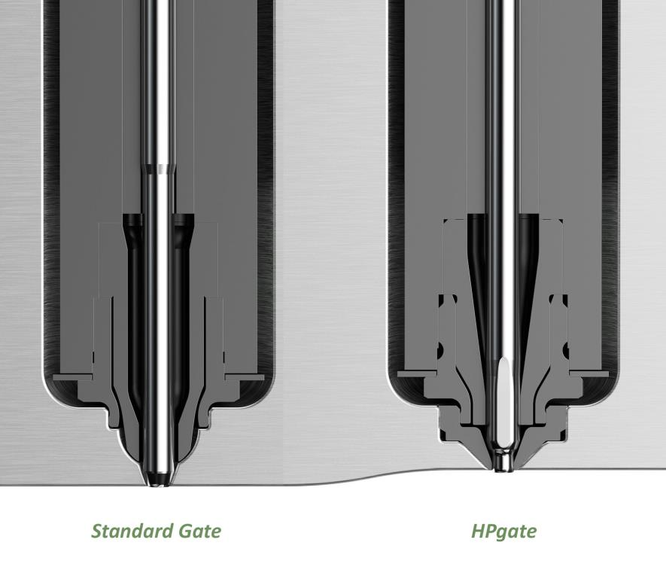
The main characteristic of the new HPgate concept from HRSflow (right) is the introduction of a hard metal insert screwed into the mold, in which a conical-cylindrical gate is machined. If it becomes worn, the optimal closure can be easily restored without any of the usual cost-intensive work on the mold.
© HRSflow
San Polo di Piave/Italy, November 2017 --- With its HPgate, Italian hot runner specialist HRSflow (www.hrsflow.com) presents a new, quality-enhancing, cost-saving valve gate solution for manufacture of high-quality parts without flash. Compared to the conventional versions, the gate is machined on an hardened metal insert produced by HRSflow itself. This insert is simply screwed into the mold, so it’s very easy to replace it in the event of wear.
This innovative solution saves the moldmaker the time-consuming and complex machining of the standard cylindrical gate. Infact with the gate geometry already being machined on the insert, the HPgate from HRSflow eliminates the difficulties connected with the cylindrical configuration including narrow tolerances, large and variable depths and providing coaxiality between needle and gate. Equally beneficial for the moldmaker is the outstanding hardness of the insert, because of which a less hard steel could also be chosen for the mold plates.
Another advantage comes from the special needle geometry in which the conical contact surface allows a better thermal control of the needle temperature, whilst the precisely aligned cylindrical needle closure assumes the task of sealing. With the conventional conical configuration, when the valve closes there is always the formation of the typical plastic layer at the gating point. When the mold opens this layer is torn off from the part and it could lead to flash formation. In order to get a good detachment, so avoiding flash, frequently a very fine adjustment of the process conditions is required. Through the elimination of the layer due to the cylindrical needle closure, the HPgate solution reduces the time required to optimize the respective process parameters. Excellent molding quality is attained much faster, which is basically equivalent to enlarging the process window.
An even higher gate quality can be obtained by combining the HPgate technology with HRSflow's FLEXflow technology. Here, the needle position can be precisely controlled, thereby reducing even further the influence of the process conditions. The result is high-quality reproducible parts with optimum gate aesthetics.
HRSflow (www.hrsflow.com) is a division of INglass S.p.A. (www.inglass.it), headquartered in San Polo di Piave/Italy. It is specialized in the development and production of advanced and innovative hot runner systems for the injection molding industry. The group of companies has more than 1,100 employees and is present on all the major global markets. HRSflow produces hot runner systems at its European headquarters in San Polo di Piave/Italy, in Asia at its plant in Hangzhou/China and at its facility in Byron Center near Grand Rapids, MI, USA.
Contact and further information
HRSflow, Via Piave 4, 31020 San Polo di Piave (TV), Italy
Phone: +39 0422 750 111, Email: info@hrsflow.com, www.hrsflow.com
Erica Gaggiato, Communication Dept.
Phone: +39 0422 750 120, Email: erica.gaggiato@inglass.it
Editorial contact and voucher copies
Dr.-Ing. Jörg Wolters, Konsens PR GmbH & Co. KG,
Hans-Kudlich-Straße 25, D-64823 Groß-Umstadt, Germany – www.konsens.de
Tel.: +49 (0) 60 78 / 93 63 0, Email: mail@konsens.de
Dear Colleagues, Press releases from HRSflow with text (German and English)
as well as pictures in print-ready resolution are available to download from:
www.konsens.de/hrsflow.html

