Press Release
Two days of connection, insight and inspiration for the injection molding industry
FLOW BEYOND 2026: the summit shaping the future of injection molding
San Polo di Piave, Italy, June 2026 – On September 8 and 10, Oerlikon HRSflow will open its doors to innovation with FLOW BEYOND 2026 – Shaping the Future of Plastic Injection, an international event bringing together key players in injection molding and experts from the plastics industry.

Technical sessions. Company tour. Live demonstrations.
The two-day event will begin with in-depth technical sessions covering emerging market trends, sustainability, the application of artificial intelligence in manufacturing and the latest PPWR regulatory updates.
Participants will also have the opportunity to visit Oerlikon HRSflow’s production departments and R&D center, and attend live molding demonstrations showcasing cutting-edge technologies.
This educational summit, structured across two days - each dedicated to specific application areas - will take place at Oerlikon HRSflow’s Italian headquarters in San Polo di Piave (Treviso), in the charming Prosecco region, offering valuable opportunities for professional development, exchange and networking.
Attendance is free. Places are limited.
Next-generation Automotive Day: Advanced solutions for part excellence
On September 8, the spotlight will be on the automotive sector, highlighting market trends and innovations in flawless surface finishing.
The event will feature contributions from industry experts such as ams OSRAM, with a focus on lighting technologies, and DVN, a technology observatory specializing in automotive Lighting and Interior topics.
Significant attention will also be given to production efficiency and molding technologies - such as In-Mold Color - that enable high-quality visible automotive surfaces to be produced directly from the mold, reducing the need for post-processing. Featured solutions will include innovative films developed by the DNP Group.
The summit will also include contributions from ENGEL, presenting AI applications in production processes, Oerlikon Balzers with advanced coating technologies and MAIP with insights into high-performance compounds.

Live demonstrations will showcase lighting applications, the production of an exterior spoiler using STARgate HRS™ technology, the GLOW HRS solution and challenging technical components.
Advanced Applications Day: Packaging, Medical, Technical and Consumer Goods
On September 10, the focus will shift to the Advanced Applications Day - High Performance in Packaging, Technical, Medical and Consumer Goods.
Among the speakers, PETCORE Europe will address the impact of PPWR on packaging design and regulatory compliance, while MADE 4.0 will explore how innovation across the plastics value chain drives digital and sustainable transformation.
Partners for the second day will also include Oerlikon Balzers, ENGEL and GUZTEC Polymers, focusing respectively on coating and surface technologies, injection molding machines, and advanced engineering polymers.
Live demonstrations will feature a technical-medical Luer-lock component produced using the TECHflow HRS Line, with a mold by C.P. Stampi and a next-generation medical-grade PBT derived from chemically recycled PET supplied by GUZTEC Polymers. A 100% recycled PP bucket will also be presented, showcasing the potential of STARgate HRS™ technology.

Useful information
Attendance is free. Places are limited.
For info & registration, please write to: marketing.hrsflow@oerlikon.com
September 8 and 10, 2026
Oerlikon HRSflow Headquarters - Via Piave, 4 - San Polo di Piave, Treviso (Italia)
September 8, 2026: Next Generation Automotive Day September 8
September 10, 2026: Advanced Applications Day September 10th

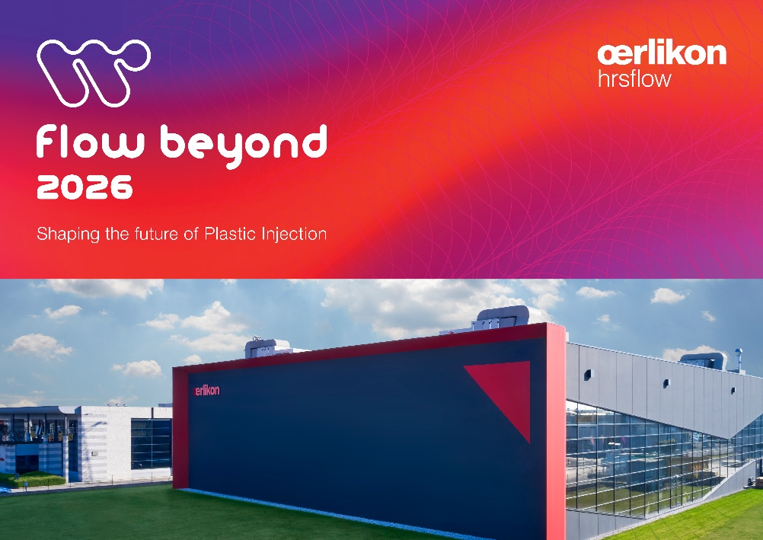
FLOW BEYOND 2026 - Shaping the Future of Plastic Injection - is an international event bringing together key players in injection molding and experts from across the plastics industry. © Oerlikon HRSflow

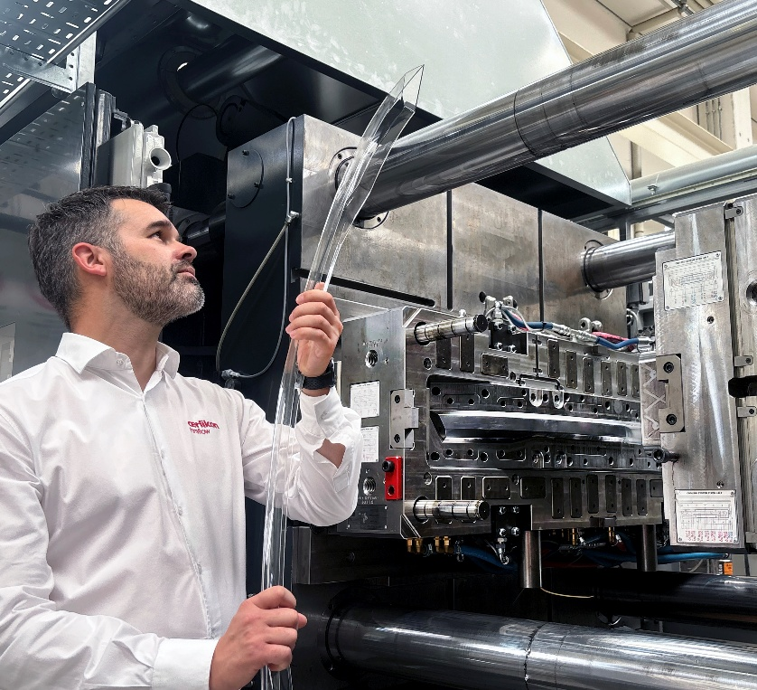
At the end of the technical presentations, a facility tour will follow, including a visit to the production department and live molding demonstrations. © Oerlikon HRSflow
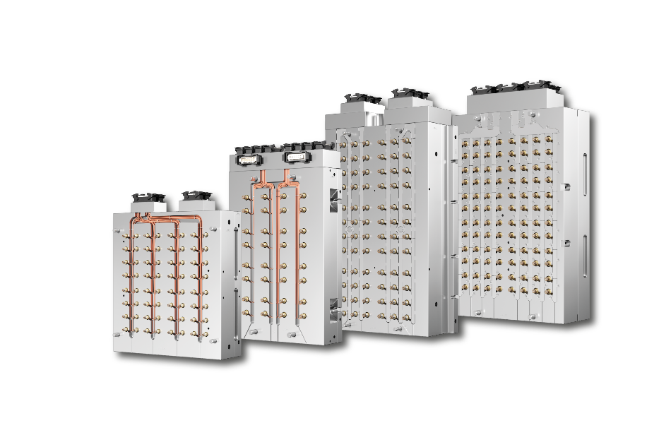
Among the technological insights are the latest developments in Oerlikon HRSflow’s multi-cavity solutions. © Oerlikon HRSflow

About Oerlikon HRSflow
Oerlikon HRSflow, part of the listed Swiss Oerlikon Group, operates worldwide with over 1,000 employees and develops, produces and distributes innovative hot runner and control systems for plastic injection molding.
Thanks to its many years of experience, Oerlikon HRSflow implements sophisticated and advanced injection molding solutions. The company has been growing for years in a wide range of sectors, from automotive, logistics and environmental, domestic appliances, mobility, houseware and gardening, technical applications, medical, beverage and home, thin wall packaging, beauty and personal care markets. A global network of three identically structured and networked plants (Italy-HQ/San Polo di Piave; China/Hangzhou and USA/Byron Center) and over 50 subsidiaries with expert teams that support our customers at the highest technical level enable us to respond quickly to high-demand markets. Thanks to the plants, targeted, customer-specific products can be manufactured with short lead times.
For further information: www.hrsflow.com
For further information, please contact:
Chiara Montagner  Marketing & Communication Manager  Oerlikon HRSflow  Tel: +39 0422 750 127  chiara.montagner@oerlikon.com  www.oerlikon.com/hrsflow | Erica Gaggiato  Marketing & Communication Specialist  Oerlikon HRSflow  Tel: +39 0422 750 120  erica.gaggiato@oerlikon.com  www.oerlikon.com/hrsflow

