Press Release
Oerlikon HRSflow Unveils the New-Generation T-Flow HRS Control Unit
New Generation T-Flow HRS Delivers Smarter Setup, Greater Flexibility and Enhanced Thermal Control
Friedrichshafen/Germany, October 2026 – Oerlikon HRSflow (Hall A1 – Stand A1-1211) presents the new generation of its T-Flow HRS thermal multi-zone control unit, featuring an upgraded design and enhanced functionality. The new controller ensures even greater reliability and precision in hot runner temperature management for injection molding applications.
Simplified setup. Advanced functionalities. Maximum flexibility.
The new generation of thermal hot runner controllers features an intuitive quick-start interface. A guided dialogue leads users step by step through the key settings, from wiring verification and automatic zone grouping, to temperature setup and other advanced feature configuration, ensuring a fast and reliable setup from the very first cycle.
Designed for maximum flexibility, the new T-Flow HRS is equipped with a high-resolution integrated display for direct operation at the control unit, or with a larger external display that can be mounted on top of the unit or positioned up to 10 meters away from it.
Available in multiple configurations, the new control unit can manage from 6 to 144 heating zones in a single device, delivering greater performance than ever before across a wide range of applications.
The new T-Flow HRS also features a compact footprint, with reduced width and depth, making it well suited to production environments where space is limited. Despite its compact dimensions, the controller offers many advanced features, including leakage detection, continued operation in the event of thermocouple failure, and comprehensive short-circuit protection.
Streamlining service operations to reduce downtime
Moreover, the new T-Flow HRS features a smartphone-based service function designed to streamline assistance and minimize downtime. By simply scanning a QR code with a smartphone, customers can access information about potential alarms, together with a step-by-step troubleshooting guide. This advanced functionality eliminates the need to search through manuals, significantly reducing troubleshooting time and machine downtime.
Oerlikon HRSflow ensures short lead times for the new-generation T-Flow HRS Control Unit, supported by a dedicated team that provides fast and responsive assistance before and after the sale to help minimize downtime. Furthermore, extended warranty coverage is available for MULTIflow HRS™ systems purchased in combination with the T-Flow HRS Thermal Control Unit, providing greater long-term operational reliability.

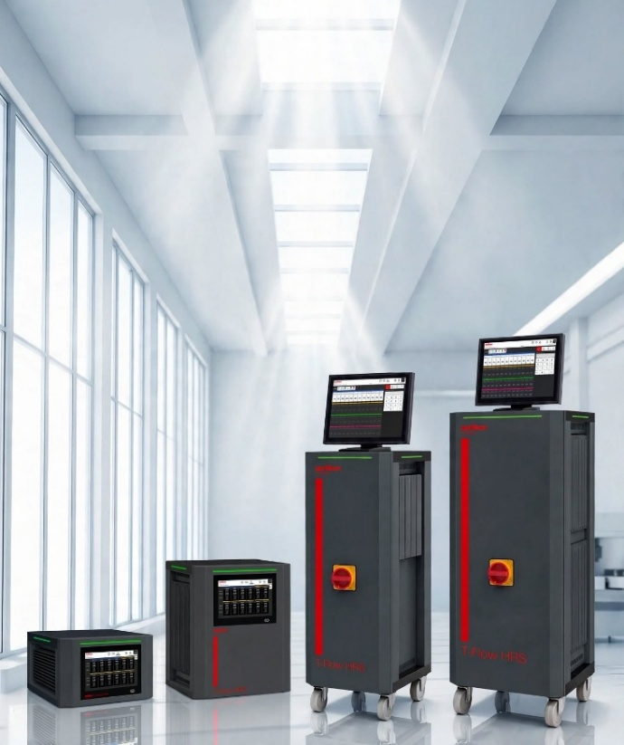

Oerlikon HRSflow's new-generation T-Flow HRS thermal multi-zone control unit features an upgraded design and enhanced functionality. © Oerlikon HRSflow
About Oerlikon HRSflow
Oerlikon HRSflow, part of the listed Swiss Oerlikon Group, operates worldwide with over 1,000 employees and develops, produces and distributes innovative hot runner and control systems for plastic injection molding.
Thanks to its many years of experience, Oerlikon HRSflow implements sophisticated and advanced injection molding solutions. The company has been growing for years in a wide range of sectors, from automotive, logistics and environmental, domestic appliances, mobility, houseware and gardening, technical applications, medical, beverage and home, thin wall packaging, beauty and personal care markets. A global network of three identically structured and networked plants (Italy-HQ/San Polo di Piave; China/Hangzhou and USA/Byron Center) and over 50 subsidiaries with expert teams that support our customers at the highest technical level enable us to respond quickly to high-demand markets. Thanks to the plants, targeted, customer-specific products can be manufactured with short lead times.
For further information: www.hrsflow.com
For further information, please contact:
Chiara Montagner  Marketing & Communication Manager  Oerlikon HRSflow  Tel: +39 0422 750 127  chiara.montagner@oerlikon.com  www.oerlikon.com/hrsflow | Erica Gaggiato  Marketing & Communication Specialist  Oerlikon HRSflow  Tel: +39 0422 750 120  erica.gaggiato@oerlikon.com  www.oerlikon.com/hrsflow
Editorial contact and please send voucher copies to:
Dr.-Ing. Jörg Wolters
Konsens PR GmbH & Co. KG
Hans-Böckler-Str. 20, D-63811 Stockstadt, Germany
Tel: +49 6027 99005 13
mail@konsens.de www.konsens.de
Please find text and image for download at https://www.konsens.de/hrsflow

