Press Release
New developments for Oerlikon HRSflow’s pin-less valve gate solution
STARgate HRS™ opens up new possibilities for polymer processing and applications
Friedrichshafen, Germany, October 2026 – STARgate HRS™ hot runner technology, a revolutionary solution featuring a diaphragm-based gate shut-off system for precise control of melt flow into the cavity, is expanding its application range to cover an even wider variety of materials and applications.
The STARgate HRS™ hot-runner nozzle concept has been expanded beyond traditional PP and r-PP packaging applications. The pin-less valve gate solution is now also suitable for the injection molding of additional resins, including PMMA, ABS, PS, HDPE, LDPE, and filled polymers, extending its use across a wide range of applications and market segments. It is also suitable for components ranging from 40 grams to 2.5 kg.
Compared to conventional solutions, the STARgate HRS™ diaphragm concept provides optimized cooling performance, enabling cycle-time reductions of up to 20% and, consequently, higher productivity. In addition, the free-flow design in the nozzle ensures smoother plastic flow at a consistent melt velocity while minimizing stagnation areas. This allows faster color changes, resulting in lower scrap rates.
Experience at the Oerlikon HRSflow R&D Technical Center shows that, with innovative STARgate HRS™ technology, part weight reductions of up to 17% can be achieved. By enabling more efficient and uniform filling, and in combination with optimized application engineering, mold design, and injection molding machine settings, the technology allows wall thickness to be reduced, resulting in lighter parts.
Its innovative design eliminates the need for actuator installation space, which in conventional systems is typically positioned axially above the valve pins, allowing for reduced tool stack height. In addition, the pin-less configuration enables smaller nozzle diameters and reduced mold pocket sizes, making STARgate HRS™ an exceptionally compact solution.
A real case study presented at Flow Beyond 2026
STARgate HRS™ was demonstrated live at Flow Beyond 2026, the international summit held in Italy in September. During a live production trial, a thin-wall 1.5-liter bucket made of r-PP was molded in a two-cavity tool developed by Inmold Group.
Thanks to the outstanding synergy between the injection molding machine, mold design, and hot runner system equipped with STARgate HRS™ technology, the 41-gram bucket achieved an ambitious cycle time of just 4.7 seconds without the use of a take-out plate, while delivering zero stringing and flawless part quality.
Project partners included ENGEL, Guztech Polymers, and Inmold Group. This achievement demonstrates that when the technologies involved in the injection molding process are perfectly matched, manufacturers can achieve a new level of productivity and process reliability without compromising product quality.
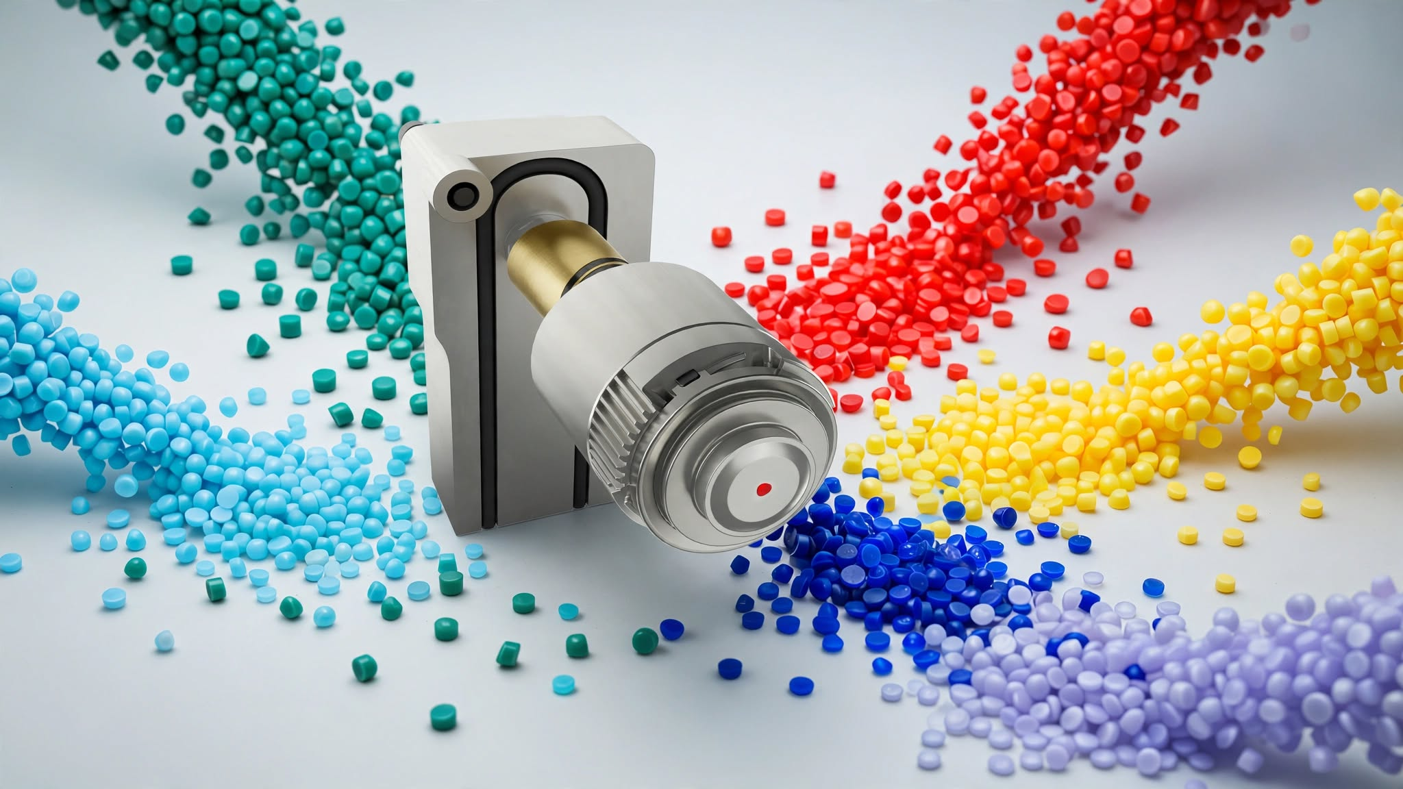
STARgate HRS™ expands its range of applications and materials, including PMMA, ABS, PS, HDPE, LDPE and filled polymers. © Oerlikon HRSflow
For further information, please contact:
Chiara Montagner  Marketing & Communication Manager  Oerlikon HRSflow  Tel: +39 0422 750 127  chiara.montagner@oerlikon.com  www.oerlikon.com/hrsflow | Erica Gaggiato  Marketing & Communication Specialist  Oerlikon HRSflow  Tel: +39 0422 750 120  erica.gaggiato@oerlikon.com  www.oerlikon.com/hrsflow
Editorial contact and please send voucher copies to:
Dr.-Ing. Jörg Wolters
Konsens PR GmbH & Co. KG
Hans-Böckler-Str. 20, D-63811 Stockstadt, Germany
Tel: +49 6027 99005 13
mail@konsens.de www.konsens.de
Please find text and image for download at https://www.konsens.de/hrsflow

