Press Release
Oerlikon HRSflow at Fakuma 2026:
Hot-runner solutions for all industries
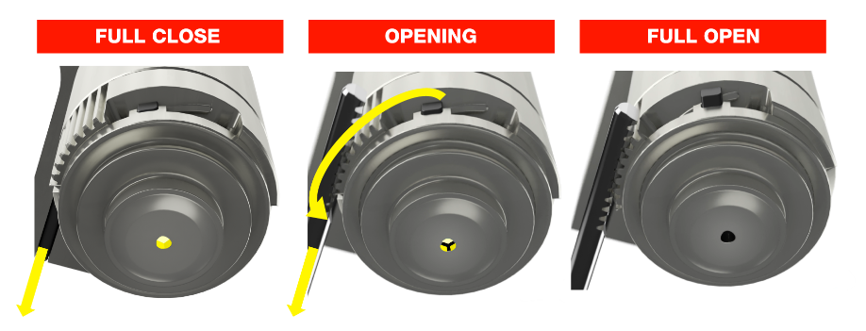
STARgate HRS™: The innovative hot-runner nozzle concept uses a mechanical system that operates like a diaphragm. © Oerlikon HRSflow
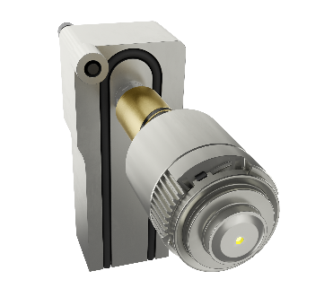
STARgate HRS™ will be presented not only for PP and r-PP applications but also for the processing of resins such as PMMA and ABS. This widens its range of applications across market segments.
© Oerlikon HRSflow
San Polo di Piave/Italy, August 2026 – At Fakuma 2026, taking place October 12–16 in Friedrichshafen, Oerlikon HRSflow (Hall A1 - Stand A1-1211) will highlight its cross-industry expertise in hot-runner injection molding. This includes developments related to the needle-less STARgate HRS™ system, new applications for the Xp nozzle series in thick-walled containers, and the use of GLOW HRS to minimize post-processing steps for automotive visible parts. Visitors will also be able to experience hot-runner applications live at partner companies’ booths.
STARgate HRS™ delivers proven results and supports an extended range of processable polymers
Following its official launch at K 2025, the innovative STARgate HRS™ hot-runner nozzle concept, which uses a diaphragm-like mechanical system, will be presented for PP and r-PP applications to comply with the new PPWR regulations, as well as for processing resins such as PMMA and ABS, expanding its range of applications across market segments. Compared with conventional solutions, this design enables a fast color change and optimal cooling performance resulting in a significant reduction in cycle time and increased productivity.
Matteo Badella, Global Sales Director Pac-Med, Consumer Goods, and Logistics at Oerlikon HRSflow, comments on this: “Less than a year after the official market launch of STARgate HRS™, we’ve already received many positive reports from customers who have achieved reduced part wall thicknesses, lower component weight and a significant reduction in cycle time compared with conventional production.”
An advanced nozzle solution for thick-walled cosmetic parts with a glass-like appearance
Following the success of Luxe Pack 2026 in New York, another highlight at Fakuma 2026 will be the new Xp series of valve gate nozzles, engineered for a wide range of applications and enhanced to meet the demanding requirements of the cosmetics industry. Accurate thermal control of the nozzle, combined with a new gate seal solution, ensures optimal injection quality for thick, transparent parts with shot weights up to 70 g. The new Xp nozzle series is specifically designed for thick-walled injection-molded parts, made from (r-)PET and recyclable copolyesters such as PETG, PCTA, and PCTG with further materials to be tested.
At the show, Oerlikon HRSflow will showcase an impressive application example in the form of multiple cosmetic jars with different challenging shapes, made from Eastman’s PET Cristal One™ Renew IM812, featuring a crystal-clear appearance and a flawless surface. Using this material ensures a high level of sustainability because its recycled content, as determined by mass balance, can be as high as 100%. Additionally, this r-PET enables the injection molding of parts with wall thicknesses of up to 12 mm.
These projects were developed in cooperation with Cromes, a leading mold maker for the cosmetics industry, and Technicaps, a premium converter that integrates this innovation into high-end, refillable packaging solutions.
Precision components for medical technology
Another highlight will be the use of r-PET in medical applications. One key example is a precision, direct-gated, Luer-lock component manufactured by using LNP™ ELCRIN™ W1000JiQ. This next-generation medical-grade PBT from SABIC is derived from chemically recycled PET and supplied by GUZTEC POLYMERS. The part will also be produced using PEEK technopolymer for demanding applications.
The related multi-cavity mold is equipped with an Oerlikon HRSflow TECHflow HRS valve gate line, which, thanks to its innovative, external nozzle end rings, offers increased wear resistance when processing abrasive, reinforced thermoplastics, including those with flame-retardant additives, that combine a narrow processing window with high processing temperatures. A uniform temperature profile ensures a wider processing window combined with high dimensional stability and easy machine restart of the Luer-Lock connectors.
The mold is manufactured by C.P. Stampi and equipped with a MOULDING DEVUP automatic unscrewing system for the precise demolding of the Luer-Lock internal threads.
High-quality automotive parts straight from the mold
The automotive industry, among others, demands reduced post-processing steps to increase process efficiency. To address this challenge, Oerlikon HRSflow launched GLOW HRS, a compact solution for direct injection molding of high-quality parts that prevents halos and enables superior surface aesthetics. This technology will be showcased at the exhibition.
Additionally, a scratch-resistant bumper will be presented, that combines polyurethane (PUR) coating and decorative film technology in a single, efficient process, reducing both production time and investment costs compared to the two-stage process. This is also made possible by the optimal configuration of the Oerlikon HRSflow system. It was developed specifically for the seamless integration of both technologies and features nine conical needle-valve nozzles. Project partners include Borealis, Cannon, DNP, ENGEL, INEVO, and the Inabata Group.
Live on-site at partner companies
The performance of Oerlikon HRSflow’s hot runner systems will be demonstrated live at:
Fanuc (Hall A7 – Stand A7-7304): As an example in the production of small technical parts, a Fanuc injection molding machine will produce 1.2 g parts for a cable clipper made of PA6.6-GF30. The mold used for this application features a 16-cavity hot runner system with TECHflow HRS valve gate technology and Sa series nozzles. Oerlikon HRSflow developed this system specifically for processing glass-fiber-reinforced plastics. The machine’s real-time monitoring system tracks the filling behavior of the cavities and automatically adjusts the process parameters to ensure uniform filling of all cavities. In addition to Fanuc, another partner company is Cavity Eye, a specialist in cavity pressure measurement in injection molding tools.
Haitian (Hall B1 – Stand B1-1205): At the company’s booth, a Haitian injection molding machine will be demonstrated in live operation, producing a lighting trunk bar as an example of a high-quality automotive application. The FLEXflow HRS valve gate technology's servo-driven flexibility enables direct injection of transparent materials and optimizes warpage control.
Wittman (Hall B1 – Stand B1-1204): The production of a PP pen cap for self-drug delivery is another example of a medical application of Oerlikon’s HRSflow MULTIflow HRS™ technology. The solution on display is an eight-cavity mold equipped with V-Series nozzles featuring a torpedo tip, which ensures a stable and reliable process.
About Oerlikon HRSflow
Oerlikon HRSflow, part of the listed Swiss Oerlikon Group, operates worldwide with over 1,000 employees and develops, produces and distributes innovative hot runner and control systems for plastic injection molding.
Thanks to its many years of experience, Oerlikon HRSflow implements sophisticated and advanced injection molding solutions. The company has been growing for years in a wide range of sectors, from automotive, logistics and environmental, domestic appliances, mobility, houseware and gardening, technical applications, medical, beverage and home, thin wall packaging, beauty and personal care markets. A global network of three identically structured and networked plants (Italy-HQ/San Polo di Piave; China/Hangzhou and USA/Byron Center) and over 50 subsidiaries with expert teams that support our customers at the highest technical level enable us to respond quickly to high-demand markets. Thanks to the plants, targeted, customer-specific products can be manufactured with short lead times.
For further information: www.hrsflow.com
For further information, please contact:
Chiara Montagner  Marketing & Communication Manager  Oerlikon HRSflow  Tel: +39 0422 750 127  chiara.montagner@oerlikon.com  www.oerlikon.com/hrsflow | Erica Gaggiato  Marketing & Communication Specialist  Oerlikon HRSflow  Tel: +39 0422 750 120  erica.gaggiato@oerlikon.com  www.oerlikon.com/hrsflow
Editorial contact and please send voucher copies to:
Dr.-Ing. Jörg Wolters
Konsens PR GmbH & Co. KG
Hans-Böckler-Str. 20, D-63811 Stockstadt, Germany
Tel: +49 6027 99005 13
mail@konsens.de www.konsens.de
Please find text and image for download at https://www.konsens.de/hrsflow

