Guardian Glass products installed in the first Courtyard by Marriott in Romania
Bertrange, Luxembourg, October 2020 – Guardian Glass Europe has provided the glass for the facades of the first Courtyard by Marriott hotel in Romania, officially opened in 2019 in Bucharest. The four-star hotel has 259 rooms, with 14 levels above ground. With a striking ground floor design, the hotel offers more options and greater flexibility for its guests. Located in the business area of Bucharest and surrounded by numerous office buildings, the hotel also offers seven conference rooms, a restaurant, a non-stop shop and a well-equipped fitness centre.
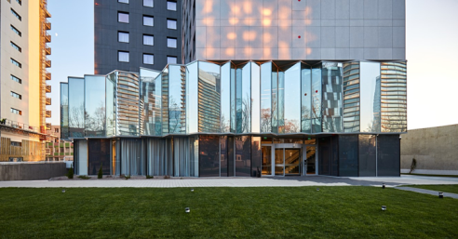
Cumulus architects creatively combined two types of glass due to their aesthetic and performance features, in order to generate the facade material and permeability, from agitated to smooth, from vivid to still, and to achieve a large glazed envelope with dimensions up to six metres. all Images © Arthur Tintu
”The clear expression of the outdoor-indoor relationship involved a large-size glass pane to cover the floor height. The glazed facades of the ground floor and the first floor represented a challenge from a technical point of view: from transport to mounting and fastening. Using Guardian Glass, we were able to cover without any problems high vertical dimensions of 5 metres on the ground-floor to 6 metres for the first floor, without requiring any horizontal separation,” explained Ivona Amariței, architect, Cumulus senior partner.
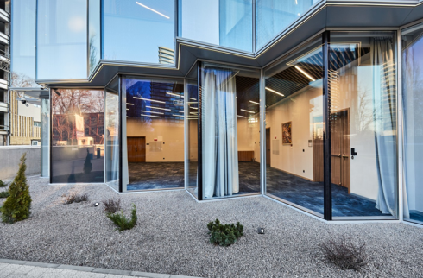
The ground-floor area takes advantage of the ”almost invisible glass” effect of Guardian Clarity anti-reflective glass.
In the ground-floor area, where the reception and restaurant are located, the view is completely open to the outside due to the ”almost invisible glass” effect of Guardian Clarity anti-reflective glass having a maximum degree of transparency and clarity, thus maximising the visibility and minimising the light reflection.
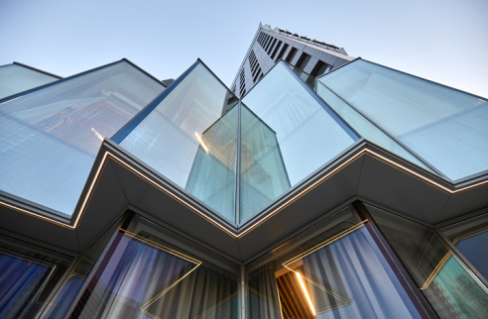
For the first floor the architects chose the solar control Guardian SunGuard HD Diamond 66 glass.
For the first floor, which hosts the conference rooms, the architects chose the solar control Guardian SunGuard HD Diamond 66 glass, which identical look and feel of a diamond provides a degree of privacy, as well as openness when viewed from the inside to the outside.
”We used the features of the glass from Guardian Glass to express the segregation of the functions according to the degree of inside - outside permeability. Thus, on the ground floor, the absolutely transparent glass is used, with no reflection which makes it accessible, fluent and connected to the outside. As for the first floor, where the conference rooms are located, we used glass with a strong mirroring coefficient which lets you see clearly from the inside to the outside, but not the other way around,” added Ivona Amariței, architect, Cumulus senior partner.
Guardian Clarity™ anti-reflective glass allows the penetration of a large amount of light, reduces reflection and has excellent optical properties. The glass is ideal for architectural projects where very high transparency is desirable, as well as reduced reflection and glare. Compared to standard glass, Guardian Clarity™ reduces reflection from 8% to approximately 0.7%, while increasing light transmission from 90% to 98%.
Guardian SunGuard® HD Diamond 66 creates bolder and brighter architectural projects without compromising on natural light transmission, colour distortion or exterior views through the glass. Optical colour neutrality and energy performance are key attributes of this glass, helping to create more comfortable buildings with bright, modern façades.
Architect: Cumulus Architecture
Glass processor: Delta Glass SRL, Bucharest
Cladder: Metalplast Construct SRL, Bucharest
Photo credits: Arthur Tintu, all rights reserved
***********
Guardian Glass, a major business unit of Guardian Industries, is one of the world’s largest manufacturers of float, coated and fabricated glass products. At its 25 float plants around the globe, Guardian Glass produces high performance glass for use in exterior (both commercial and residential) and interior architectural applications, as well as transportation and technical products. Guardian glass can be found in homes, offices, cars and some of the world’s most iconic architectural landmarks. The Guardian Glass Science & Technology Center continuously works to create new glass products and solutions using the most advanced technology to help customers see what’s possible®. Visit guardianglass.com.
Guardian Industries, a global company headquartered in Auburn Hills, Michigan, operates facilities throughout North and South America, Europe, Africa, the Middle East and Asia. Guardian companies employs more than 16,000 people and manufacture high-performance float glass; coated and fabricated glass products for architectural, residential, interior, transportation and technical glass applications; and high-quality chrome-plated and painted plastic components for the automotive and commercial truck industries. Guardian’s vision is to be a preferred partner to our customers, suppliers, employees and communities based on a foundation of mutual benefit. This drives our relentless focus on improving people’s lives by providing products and services they value more highly than their alternatives and doing so responsibly while consuming fewer resources. Guardian is a wholly owned subsidiary of Koch Industries, Inc. Visit guardian.com.
Courtyard Marriott is a 4-star brand of the group Marriott International. The first Courtyard hotel was opened in 1983 in Atlanta, and currently there are over 1,000 hotels operating under this brand in 42 countries. Courtyard by Marriott Bucharest Floreasca located in the most dynamic business area of Bucharest, the northern area, offers guests 259 rooms, arranged on 13 floors, combining the comfort and functionality in a modern ambience. The hotel also has 7 conference rooms, which can host a total of 538 people and a restaurant with SOLT Dining northern philosophy. The restaurant is open for breakfast, lunch and dinner, with daily business lunch menus, specific in terms of price and serving time, to the business area in which the hotel is located.

