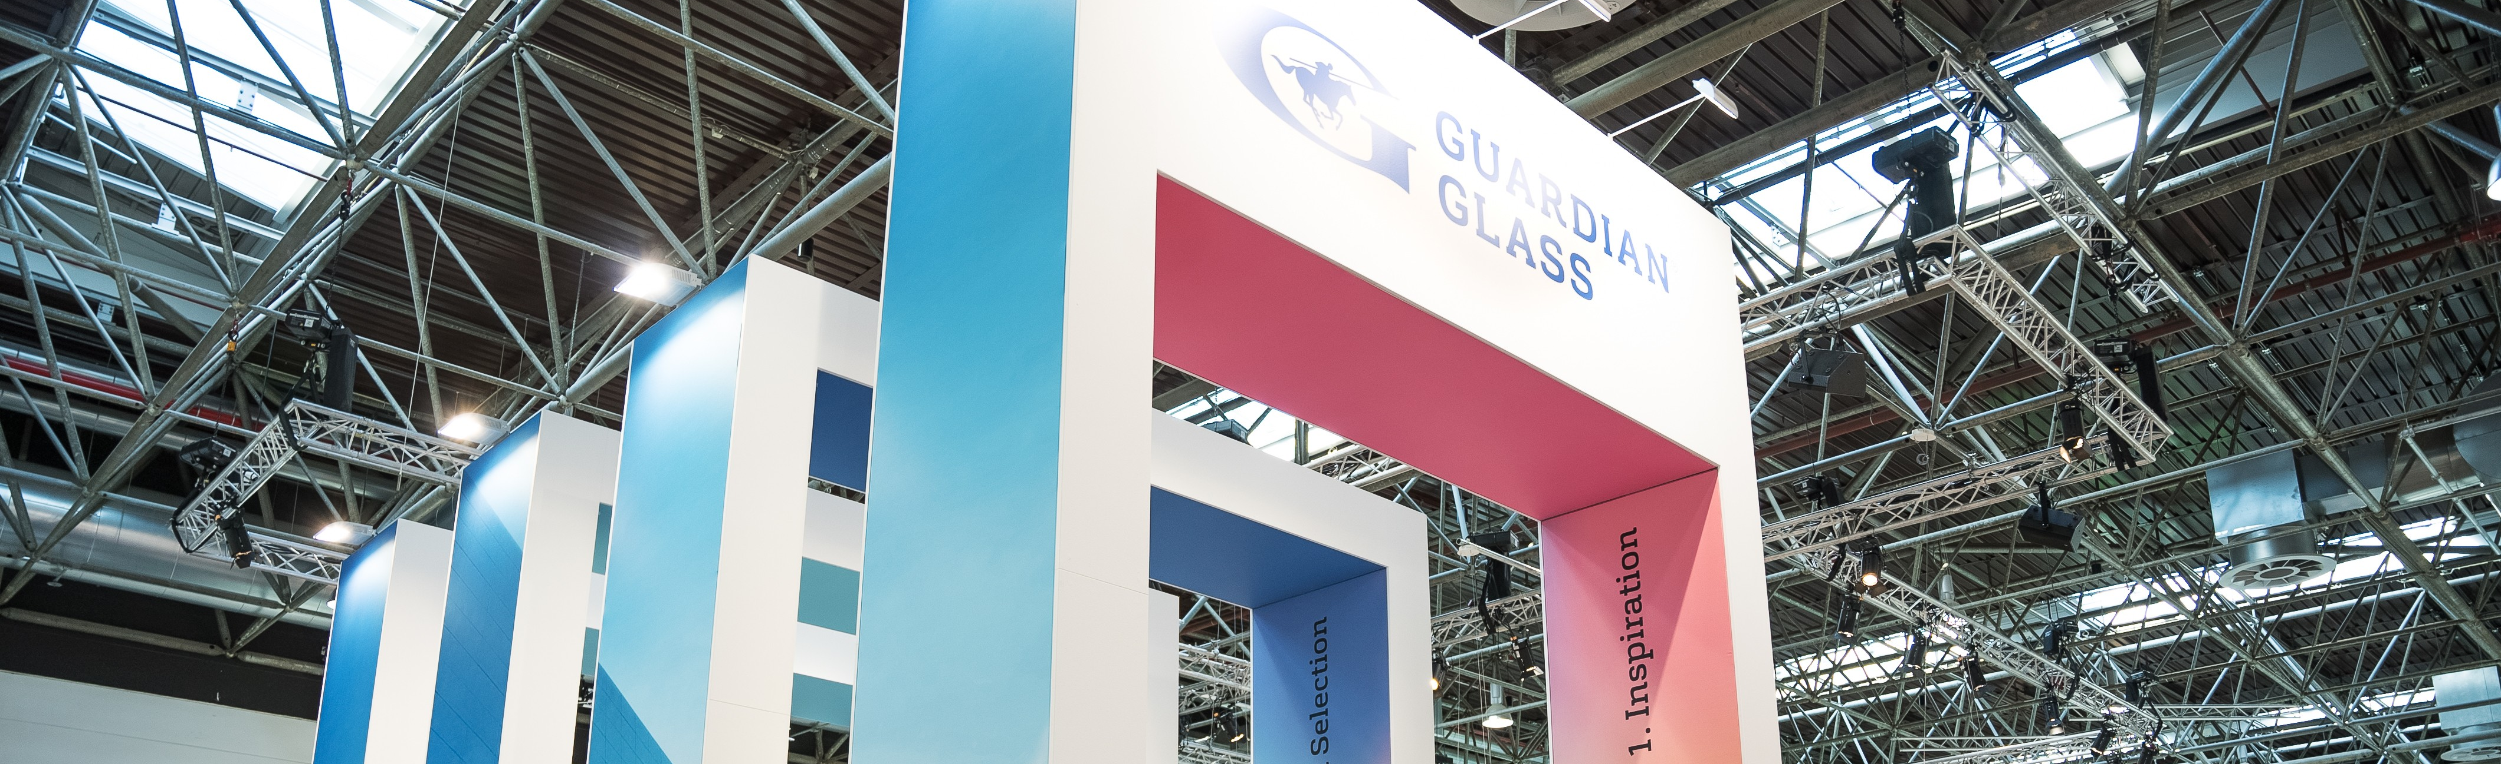

Guardian Glass to bring global expertise and application-led solutions to glasstec 2026

Luxembourg, September 2026 – Guardian Glass will return to glasstec 2026, taking place October 20–23 in Düsseldorf, Germany, with a showcase focused on application-led glass innovation and digital tools designed to support customers across a wide range of commercial and residential applications and glass processing needs. At this year’s glasstec, Guardian Glass will showcase how its global manufacturing footprint, product portfolio, and local teams help deliver consistency across regions, supporting customers ranging from glass processors and window manufacturers to facade specialists and project teams.

Building on the digital direction introduced during the last two editions of glasstec, Guardian Glass will continue to showcase tools designed to help customers access information, evaluate products and move projects forward efficiently. A central feature of the stand will be Guardian CLARIA™, the company’s AI-powered assistant, alongside other recently launched tools such as the Glass Visualizer and Project Locator.

The Guardian Glass exhibit will feature several dedicated areas showcasing solutions designed to help project teams balance performance, aesthetics, fabrication and environmental considerations. From globally aligned product platforms to regionally relevant innovations, the exhibit will illustrate how Guardian Glass supports customers with solutions that can be adapted to local requirements while drawing on experience from projects around the world.

Featured solutions will include:
- Guardian SunGuard™, with some of the new additions to its range of high-performance double and triple silver coated glass products, highlighting the globalization of these solutions across regions.
- Guardian NEXA™, a lower-carbon glass range that can help support project environmental goals. The Guardian NEXA range reflects Guardian Glass’ ongoing commitment to Stewardship, including reducing resource use and emissions through investments in manufacturing process improvements and furnace energy efficiency.
- Guardian Bird1st™, a range of globally available bird-friendly glass solutions, including Bird1st™ MIRAGE, a new technology that is expected to launch in 2027.
- Guardian ViewBoost™ and Guardian PureSight™ solutions that help reduce unwanted reflections in architectural applications and support visual clarity.
- Guardian BPC, an innovative temporary protective coating designed to help improve efficiency and support yield optimization during the transport and processing of coated glass products.

“Today’s projects require more than high-performing glass products,” said Guus Boekhoudt, Executive Vice President, Global Commercial, Guardian Glass. “Whether project teams are working locally or across multiple regions, customers need confidence that solutions can be delivered consistently wherever projects happen. At glasstec 2026, we look forward to meeting visitors from across the industry and demonstrating how we combine global capabilities with local execution to help them specify and realize projects successfully, from concept to completion.”

Visitors can meet the Guardian Glass team at Hall 10, Stand A24 during glasstec 2026 in Düsseldorf to SEE WHAT'S POSSIBLE™.

About Guardian Glass
Based in Auburn Hills, Michigan, Guardian Glass is one of the world’s largest glass manufacturers, with facilities on five continents. These sites produce high-performance float glass, coated glass and fabricated glass for exterior (commercial and residential) and interior architectural applications, as well as transportation and technical products. This glass can be found in homes, offices, cars, and some of the world’s most iconic architectural landmarks.

Guardian Glass helps people improve their lives through innovative products that support daylight, security, energy efficiency, and comfort. We work to create new glass products and solutions using the most advanced technology to help customers SEE WHAT’S POSSIBLE™. Guardian Glass is a Koch company. Visit guardianglass.com.

Guardian, the G Logo, Guardian Glass, CLARIA, Guardian NEXA, SunGuard, Bird1st, Guardian ViewBoost, Guardian PureSight and See what’s possible, are trademarks of Guardian Industries LLC and/or its affiliates.

PRESS CONTACT:
Sophie Weckx
sweckx@guardian.com
+352 671 881 032

