Quick to market with a customized product:
Compalen Slip Strip Compounds for a gentle, comfortable shave
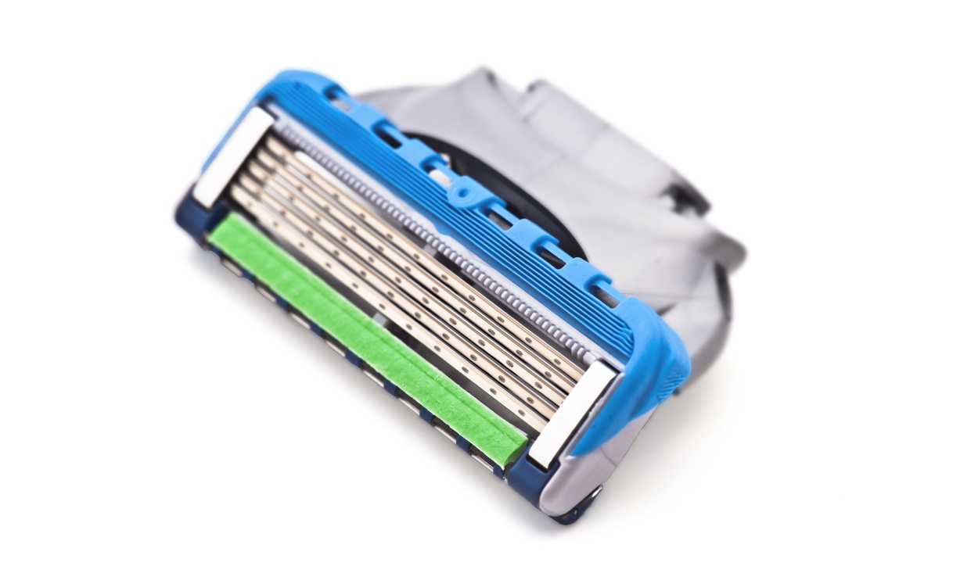
GRAFE develops and produces individually tailored, ready-to-process Compalen Slip Strip conditioning compounds for the manufacturing of wet razor lube strips. © = Jultud - stock.adobe.com
Compalen Slip Strip conditioning compounds are ready-to-process for the manufacturing of the lube strips that enable wet shaving particularly gentle and comfortable. Carrier resins are polystyrene (PS) or thermoplastic elastomers (TPE) for injection molding or extrusion. Individual formulations are developed in close partnership with the customer. GRAFE has all the necessary resources in-house, ranging from its staff’s many years of expertise and a state-of-the-art technology center providing the capability to perform and evaluate all analysis, inspection and testing.
When it comes to compounding Compalen Slip Strip, GRAFE can draw on its long and wide-ranging experience of thermoplastic additivation in order to combine the base material with freely selectable coloring pigments and functional fillers, which are purely physically incorporated without coupling agents. Customers can choose between proven active ingredient formulations and the development of individually tailored compounds. Supplied as free-flowing pellets, all compounds are suitable for direct co-extrusion or 2-component injection molding together with compatible thermoplastics such as PS or ABS that provide mechanical stability.
Due to the high filler contents, a certain proportion of the additive formulation remains on the surface of the resultant lube strips, which means that, on contact with water, these components can dissolve, swell and so show the expected effect. The soaps, fats and oils present in these components provide a pleasant lubricating effect that protects the skin from irritation. Further conditioning and fragrance components can also be incorporated and combined with the desired on-trend color. The range of potential combinations is virtually unlimited.
As Danny Ludwig, Head of Product Management at GRAFE explains, “Our selection of carrier polymers and processing technologies available for Compalen Slip Strip compounds results in a modular system allowing design to be optimally adapted to function and, in this specific case, to fitting to the razor head. Our development team can also advise on the selection of additives and reconcile customer wishes with processing realities, so eliminating potential problems at an early stage on the road to serial market application.”
About GRAFE:
In addition to color and additive masterbatches, GRAFE’s product range also includes a wide range of functional polymer compounds. One of the sector’s largest research and development departments is working on cutting-edge technologies to equip polymers with smart functions. Founded in 1991 by the four Grafe brothers, this family business today has over 300 staff developing and manufacturing products for national and international markets in the company’s ultra-modern plant in Blankenhain in Thuringia, central Germany. GRAFE attaches great importance to quality management - and does so with great success, being certified to ISO 9001:2015, IATF 16949:2016 and ISO 50001:2018. Further information: www.grafe.com

Media Contact
GRAFE Advanced Polymers GmbH
Anja Zimmermann Tel. +49 (0)36459 / 45-286
Waldecker Str. 21 Fax +49 (0) 36459/ 45-145
D-99444 Blankenhain anja.zimmermann@grafe.com

