PRESS RELEASE
Debut at Fakuma 2026:
Genesis Polymers Europe and Velogy are bringing European PP and PE production closer to customers
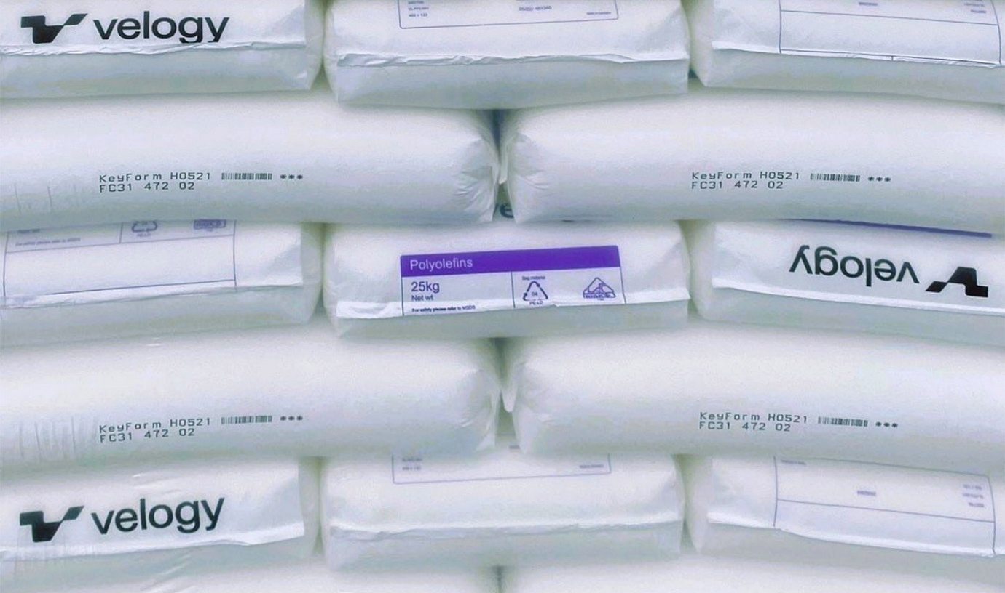
A new name in the polyolefin market. © Velogy
Augsburg/Germany, October 2026 – Genesis Polymers Europe and Velogy are set to make their debut at Fakuma 2026. In Hall B2 at Stand B2-3210, they will be showcasing their combination of European polyolefin production and dedicated local sales. Their shared goal is to provide European plastics processors with reliable access to high-quality polypropylene and polyethylene, supported by responsive local assistance and a supply chain centred on European production. Velogy will contribute its manufacturing and product expertise, while Genesis will handle the local market presence, logistics, and day-to-day customer support.
Velogy was founded in May 2026 following the acquisition by AEQUITA of four former LyondellBasell production sites: Berre (France), Münchsmünster (Germany), Tarragona (Spain) and Carrington (United Kingdom). Velogy now employs around 1,700 people at these sites and supplies more than 150 products to customers in over 60 countries.
Genesis Polymers Europe, a Ravago Group company, provides Velogy with a sales platform in most European markets. This combination of a strong focus on PP and PE with Ravago’s established logistics infrastructure and expertise in polymers is a key strength of the company.
Proven quality, reliable delivery, local expertise
For Genesis and Velogy, manufacturing in Europe is about more than just geographical location. In the face of international logistical disruptions, geopolitical uncertainties, and shifting global trade flows, having a strong manufacturing base close to European processing sites can make the supply chain more resilient, transparent, and predictable.
Velogy’s four production sites are located close to key European industrial markets, and Genesis provides local commercial and technical support throughout the region. This allows customers to reliably plan their supply of raw materials and rely on a manufacturer that is committed to producing in Europe rather than solely counting on importing materials into Europe, which are subject to the ever-changing conditions of the global market.
A new, forward-looking PP and PE portfolio
At Fakuma, Genesis and Velogy will present their new product portfolio nomenclature. This is based on three product platforms designed for a wide range of applications in sectors including packaging, consumer goods, mobility, construction, infrastructure, industrial applications and healthcare.
KeyForm provides reliable polypropylene (PP) and polyethylene (PE) solutions that are consistently high quality and easy to process.
AdvyForm combines high-performance materials designed to deliver improved properties, efficiency and end-product performance.
CertyForm meets the highest standards of consistency, transparency, controlled processes and regulatory compliance.
Velogy currently offers more than 150 grades for eleven industries in total. This portfolio is continually expanding with new PP and PE solutions to provide European converters with an ever-wider range of materials.
Healthcare as a key focus area
Applications in the medical, diagnostic and pharmaceutical sectors require high-performance materials that are consistent, produced under controlled conditions, traceable, compliant with regulations and supported by comprehensive documentation. Velogy’s CertyForm PP and PE grades have been specifically developed for these types of application. Genesis complements Velogy’s manufacturing and product expertise by working closely with customers on site to understand their qualification requirements and by providing support with the commercial, technical and regulatory information required throughout the entire process. By expanding its offering in this area, Velogy is creating additional opportunities for customers seeking reliable European material solutions.
A direct link from production to customer
At Fakuma, the joint stand of Genesis and Velogy will showcase the close partnership between the two companies, linking European production with processing plants across the continent. Visitors will therefore be able to discuss all aspects of their requirements with both the manufacturer and its specialist sales partner in one place, including material selection, technical queries, availability, logistics and commercial matters.
Moving forward with portfolio expansion
Velogy will continue to expand its production in Europe. In August 2026, SABIC announced an agreement to sell its European petrochemicals business to AEQUITA. This includes major production sites in Geleen (the Netherlands), Gelsenkirchen (Germany), Genk (Belgium) and Teesside (the UK), which manufacture PP, HDPE, LDPE and LLDPE, among other products.
Subject to the necessary regulatory and other approvals, the transaction is expected to be completed in Q4 of 2026. This will significantly increase the production capacity and range of products associated with AEQUITA’s petrochemicals platform in Europe, creating further opportunities for Genesis’s customers from 2027 onwards. For Genesis Polymers Europe, this means continuing to develop a specialised European PP and PE distribution business, built on strong local customer relationships and an expanding European production base.
Genesis Polymers Europe is a new European manufacturer of olefins and polyolefins, headquartered in Rotterdam. It was formed from the former European operations of LyondellBasell, which were consolidated by the Munich-based investment company AEQUITA following the acquisition of four production plants. The associated plants in Münchsmünster (Germany), Berre (France), Carrington (United Kingdom) and Tarragona (Spain) have a production capacity of around 2,500 kt for PE and PP. The main products are PP homo-, co- and random copolymers, PE-LD grades, and application-specific polyolefin compounds.
KeyForm™, AdvyForm™ and CertyForm™ are trademarks of Velogy.
Contact details for further information:
Rainer Konrad, Business Development Manager
Genesis Polymers Europe SA
Mobile: +49 (0) 151 1483 3498
Rainer.conrad@genesispolymers.com
www.genesispolymers.eu
Press enquiries, and please send copies of published articles to:
Konsens PR GmbH & Co. KG, Dr. Jörg Wolters
Hans-Böckler-Straße 20, D-63811 Stockstadt am Main
Tel.: +49 (0) 6027 99 00 5-13, mail@konsens.de
This press release (Word and JPG file) is available for download at https://www.konsens.de/genesispolymers .

