Ettlinger at the Plastics Recycling Show Europe 2019
Efficient melt filtration even for heavily contaminated plastics scrap
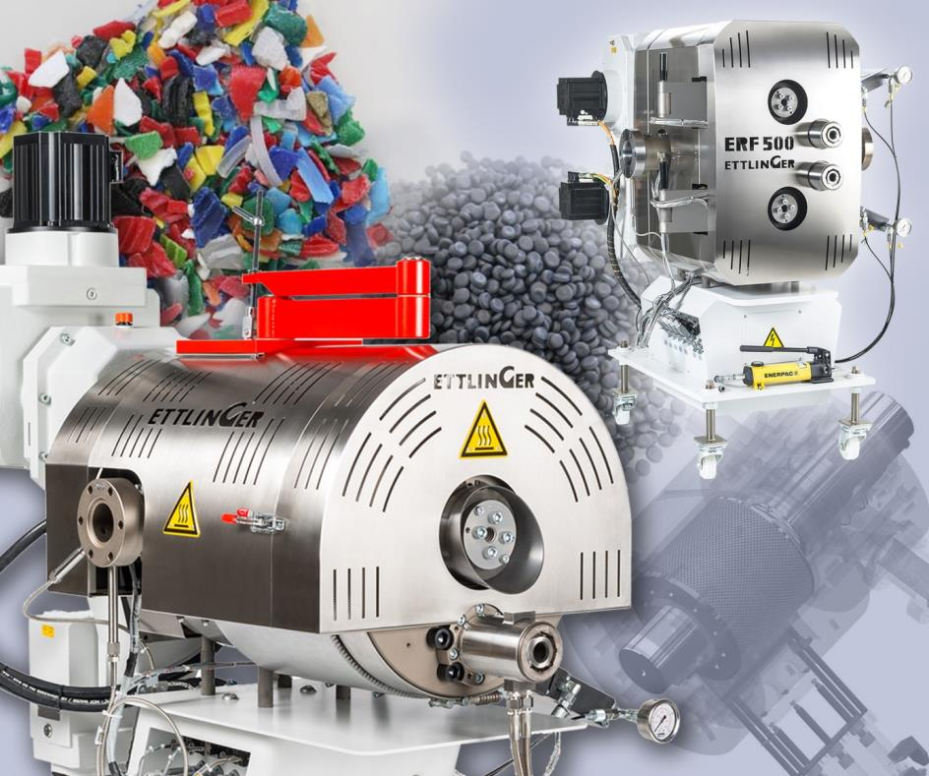
Ettlinger's specialties include their efficient and reliable ERF melt filters which remove even major contamination from polymer melts. © Ettlinger
Königsbrunn/Germany, March 2019 – Ettlinger will be presenting the ERF melt filter family of high-performance filtration solutions capable of handling even high degrees of contamination at the Plastics Recycling Show Europe 2019, booth D1. These are specially designed for processing polyolefins and polystyrenes, TPE and TPU with levels of contamination of up to 18%. Typical applications include reprocessing post-consumer plastics scrap such as LDPE packaging films, HDPE bottle flakes, PS-aluminum composites, for example from yogurt pots or cream chargers, automotive recycling and the recycling of refrigerator and electronics scrap. The filters are available in three sizes with throughputs of up to 6,000 kg/h. The ERF350, with its maximum throughput of 3800 kg/h, attracts most customer attention. Ettlinger also manufactures the ECO series melt filters which are specifically designed for very low viscosity materials such as PET and PA with degrees of contamination of up to 1.5%.
Gheorghe Campan, Managing Director of CANDI Plastic Recycling, Sollenau/Austria, is representative of a growing number of satisfied operators of Ettlinger's ERF high-performance filters around the world. From as long ago as 2014, an ERF 200 filter has been helping to make sure plastics scrap with high aluminum or paper contents can be straightforwardly and cost-effectively reprocessed over extended periods of service, as Campan can confirm. Thanks to this good experience, CANDI decided in 2016 to use the same model at its Romanian subsidiary SC CALEX, which has since enjoyed the same high performance as in Sollenau. This was reason enough for Campan to order a third ERF 200 in early 2019 which will also be used at SC CALEX for recycling film. SC CALEX is also an exhibitor at the Plastics Recycling Show Europe 2019 (booth F6).
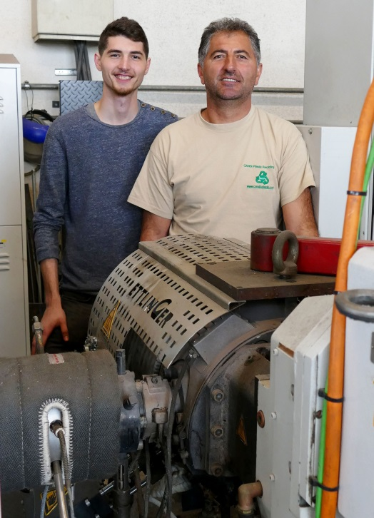 | Managing Director Gheorghe Campan (right) with his son Andreas behind one of the three ERF 200 filters which are currently providing continuous and trouble-free service at Candi Plastic Recycling.
This combination of ultra-pure filtrate and high efficiency is the outcome of the special principle on which all Ettlinger filters are based. The central component is a continuously rotating, cylindrical filter screen with millions of conical holes which is driven by a servo motor. When melt flows through these holes from the outside to the inside, any contaminants retained on the filter surface are continuously removed by a single, easily replaceable scraper. Because they can be operated continuously, these filter systems permit long periods of production uninterrupted by the filter changes which are otherwise required. Thanks to the special purge discharge method, these filters have the lowest melt losses in the industry. This leads to low operating costs and hence a rapid return on investment.
Ettlinger Kunststoffmaschinen GmbH was founded in 1983 and today is a global player in the development and manufacture of high performance melt filters and injection molding machines. With its headquarters in Königsbrunn, not far from Augsburg/Germany, Ettlinger has been part of the Maag Group since 2018.
Maag is a worldwide leading manufacturer of gear pumps, pelletizing and filtration systems and also pulverizers for sophisticated applications in the synthetic, chemical, petrochemical, pharmaceutical and food industries.
Dover is a diversified global manufacturer with annual revenue of approximately $7 billion. We deliver innovative equipment and components, specialty systems, consumable supplies, software and digital solutions, and support services through three operating segments: Engineered Systems, Fluids and Refrigeration & Food Equipment. Dover combines global scale with operational agility to lead the markets we serve. Recognized for our entrepreneurial approach for over 60 years, our team of over 24,000 employees takes an ownership mindset, collaborating with customers to redefine what's possible. Headquartered in Downers Grove, Illinois, Dover trades on the New York Stock Exchange under "DOV." Additional information is available at dovercorporation.com.
More information on Ettlinger
Karsten Bräunig, Manager Sales
Ettlinger Kunststoffmaschinen GmbH, Messerschmittring 49, D-86343 Königsbrunn
Phone: +49 8231 34908 -12, Fax: -28, Email: karsten.braeunig@maag.com
www.ettlinger.com
Editorial contact and specimen copies:
Dr. Jörg Wolters, Konsens PR GmbH & Co. KG
Hans-Kudlich-Strasse 25, D-64823 Gross-Umstadt – www.konsens.de
Phone: +49 (0) 60 78 / 93 63 - 0, Fax: - 20, Email: joerg.wolters@konsens.de

Ettlinger press releases with pictures in printable quality can be downloaded from: www.konsens.de/ettlinger.html

