Press Release
High performance melt filters from ETTLINGER:
MIRCAN 1979 takes over distribution in Spain and Portugal
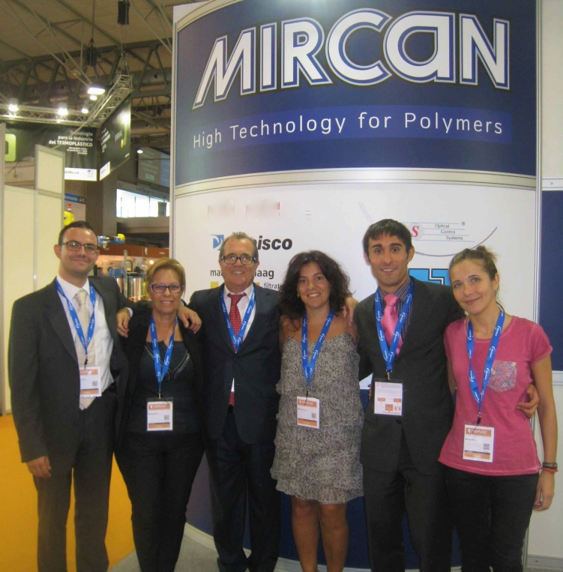 | The team of MIRCAN, ETTLINGER's new partner for the distribution of high performance melt filters on the Iberian Peninsula.  Note: This image is from the pre-Corona period. © MIRCAN
Königsbrunn/Germany and Barcelona/Spain, January 2021 - ETTLINGER, a member of the MAAG Group and a leading manufacturer of high performance melt filters, is now relying on the extensive experience and capabilities of MIRCAN 1979 S.L., Barcelona, for the distribution of its systems on the Iberian Peninsula.
The family-owned company MIRCAN (http://www.mircan1979.com) is a solution provider with over 40 years of experience in the production and quality control of polymers and their processing by extrusion - and correspondingly excellent market knowledge in the region. In addition to international companies, customers include many small and medium-sized enterprises. In this environment, MIRCAN sells gear pumps, screen changers and melt filters, wide slot dies and coextrusion feedblocks, measuring systems, web inspection and pellet quality control systems, pressure and temperature sensors, and equipment for viscosity and color measurement. The company has been a MAAG sales partner since it was founded.
MIRCAN now complements its portfolio with ETTLINGER's continuously operating high performance melt filters which, with their patented principle, are used worldwide for the filtration of low to very highly contaminated plastic melts. The two series ERF and ECO find applications for almost all common polymers in the recycling sector, the sheet and film industry, tape and fiber production up to compounding - also as retrofit components for existing extrusion lines.
As Uwe Kellner, Managing Director of ETTLINGER, says: "As a regional partner of MAAG for decades, MIRCAN impresses with its experience, its continuous track record in the distribution of plastics machinery and a clear commitment to the continuous improvement of processes and knowledge. We are pleased that MIRCAN is now also applying its extensive know-how to the distribution of our products. In this way, we can now join forces in helping to turn even highly contaminated plastic waste into valuable recyclates for new, sophisticated products in a cost-effective manner."

About MAAG Group:
The MAAG Group is a broadly diversified global solutions provider with integrated and customizable systems in process technology for the polymer, chemical, petrochemical, pharmaceutical and food industries. Its Pump & Filtration Systems, Pelletizing & Pulverizing Systems, Recycling Systems and Digitalization divisions consolidate the many years of experience and in-depth know-how of the AUTOMATIK, ETTLINGER, GALA, MAAG, REDUCTION, SCHEER and XANTEC product brands. The MAAG Group currently employs over 1,000 people at production sites in Switzerland, Germany, Italy, the USA, and China. Additional sales and service centers in France, Taiwan, Malaysia, India, Thailand and Brazil ensure close attention to customers’ needs. For more information visit www.maag.com.

The MAAG Group is a business unit of Pumps & Process Solutions, a segment of the Dover Corporation.
About ETTLINGER
ETTLINGER is the product brand for recycling systems within the MAAG Group. The focus is on high performance melt filters for the recycling of plastics. Injection molding machines round off the portfolio. The company was founded in 1983 and has its development and manufacturing headquarters in Königsbrunn near Augsburg, Germany. ETTLINGER has been part of the MAAG Group since 2018.
More information on ETTLINGER
Karsten Bräunig, Sales Manager
Ettlinger Kunststoffmaschinen GmbH, Messerschmittring 49, D-86343 Königsbrunn
Phone: +49 (0)8231 34908-12, email: karsten.braeunig@maag.com
www.maag.com
Editorial contact and specimen copies:
Dr. Jörg Wolters, Konsens PR GmbH & Co. KG
Im Kühlen Grund 10, D-64823 Groß-Umstadt - www.konsens.de
Phone: +49 (0)6078 9363-0, email: joerg.wolters@konsens.de
Press releases from ETTLINGER with pictures in printable resolution can be downloaded at https://www.konsens.de/ettlinger

