Press Release
Innovation centre for the recycling of styrene-based plastics opts for Ettlinger melt filters
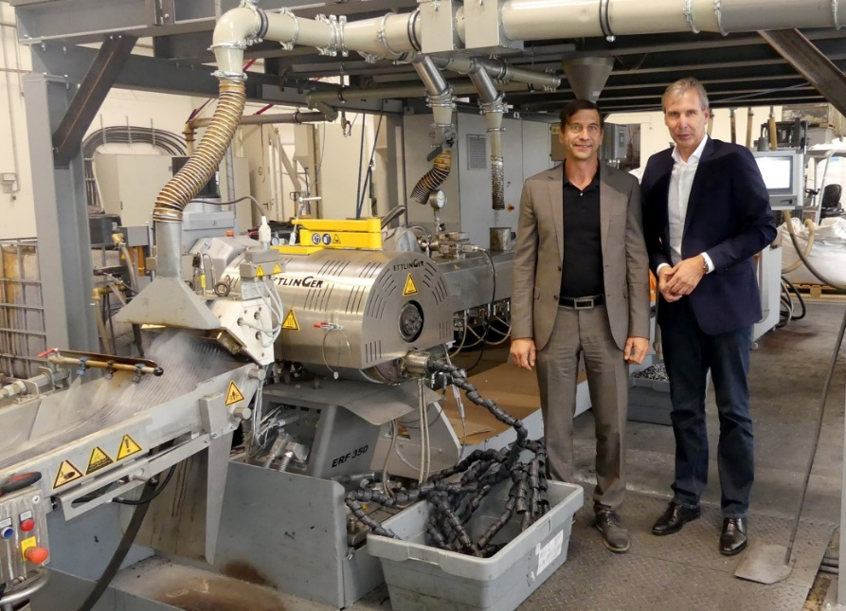
At Sysplast, an Ettlinger high-performance ERF 350 melt filter separates impurities from the melt in a self-cleaning and largely maintenance-free process; left: Sysplast Managing Director Udo Dobberke, right: Ettlinger Sales Manager Karsten Bräunig. Photos: © Ettlinger
Königsbrunn/Germany, July 2022 – As an innovation-oriented recycling company specialising in styrene-based thermoplastics such as PS, ABS and PC/ABS, Nuremberg-based Sysplast GmbH uses and develops pioneering technologies, including for the processing of surface-coated waste materials from the electronics and automotive industries. For this, the company uses high-performance melt filters from manufacturer Ettlinger, part of the Maag Group, whose continuous operation enables high production efficiency and consistent product quality over long operating periods.
The core of the system used at Sysplast is a Leistritz extruder that was commissioned in 2021. The feed material is single-type regrind from the recycling of old electrical appliances and the processing of mixed post-industrial and post-consumer plastics. The majority of these plastics come from energenta recycling solutions GmbH, which, like Sysplast, belongs to the Energenta group of companies. Sysplast currently has 14 employees, 11 in production, and produces approximately 40 t of recompounds per day, 70% of which are ABS, 20% PS and 10% PC/ABS; quantities that, according to managing director Ude Dobberke, are far short of covering demand.
Even carefully selected input still contains some impurities in the form of metals, other plastics, silicones, paper, etc. Processing into sophisticated recompound qualities therefore requires filtration of the melt in order to reliably separate even the smallest contaminating particles. Dobberke: “The electronics industry, including telecommunications, consumer electronics and the automotive industry, only accepts products whose processing and performance characteristics are on a par with new products.” What is required of an optimal filter, therefore, is a high throughput with high filtration performance and reliable, continuous availability over long running times: “Screen blockages and filter changes bring fluctuations in production that we cannot afford. And because we produce recompounds for premium applications, the filter must reliably separate impurities with minimal melt loss.”
Given these demanding requirements, Sysplast opted for an Ettlinger self-cleaning ERF 350 high-performance filter. Dobberke confirms that screen replacements are rarely necessary with this model: “We typically run our system continuously in three shifts over five days a week with constant output."
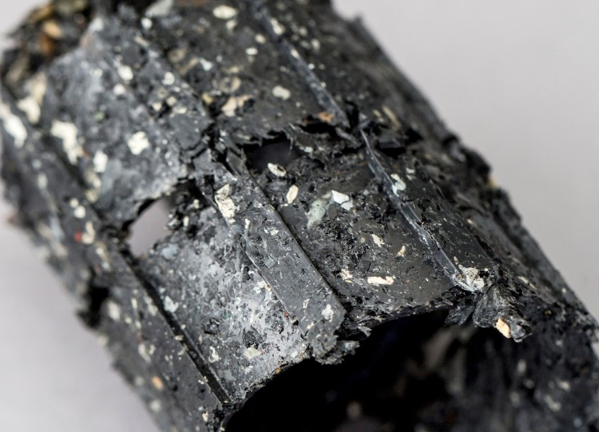
With minimal melt loss, the discharge material has a high concentration of impurities.
Surface-coated plastics at a glance
Among the pioneering projects commenced by Sysplast is the recycling of electroplated plastics, mostly ABS, from the automotive industry and the sanitary and household goods sector. Together with the Freiburg-based Fraunhofer Institute for Process Engineering and Packaging (IVV), the company has developed a process in which both the plastic and the metals are completely recycled. Here, too, an Ettlinger ERF 350 has been removing residual particles from the metallisation process reliably from the melt since the end of 2021.
Sysplast is currently launching a second pioneering project together with the Chair of Plastics Technology at the University of Erlangen involving the recycling of painted, spray-coated and laminated car bumpers. The first tests have been completed successfully.
Fivefold increase in throughput by 2030
For the future, Dobberke plans to expand its existing activities and ramp up its development projects to an industrial scale: “By the end of the decade, we want to achieve a fivefold increase in our current output of around 10,000 tonnes per year and thus bring Sysplast into the top group of recyclers in this material group in the German-speaking region. A second new system will increase capacity by 17,000 t/a by the end of 2022. The upgrade of a decommissioned system will contribute an additional 1,500 t/a. Here too, Ettlinger melt filters will once again form part of the system.”
About Sysplast:
The origins of Sysplast GmbH go back to the 1970s. At a time when recycling had hardly entered people’s minds, the company’s predecessor, as part of Grundig AG, started the clean and single-type processing of residual plastic material from production. This evolved into the larger Zentrum für Kreislaufwirtschaft (Recycling Management Centre) as a business unit of Grundig. From 1990, with support from the German Federal Ministry of Education and Research, Sysplast developed standards for the recycling of electrical devices, which still serve as a guide to other organisations worldwide. Separated from the insolvency estate in 2003, the successor company initially processed the manufacturing waste of a well-known plastic pressed sheet manufacturer. At the beginning of 2020, the company, which by that time had been renamed Sysplast, was taken over by Udo Dobberke together with a shareholder from the Ochtrup Energenta Group (www.energenta.de). As part of this group, which maps and controls every single step of the material cycle, from collection through to recycling, Sysplast today stands for the entire value chain of a closed-loop economy.
About the MAAG Group
The MAAG Group is a broadly diversified global solutions provider with integrated and customizable systems in process technology for the polymer, chemical, petrochemical, pharmaceutical and food industries. Its Pump & Filtration Systems, Pelletizing Systems, Pulverizing Systems, and Recycling Systems divisions consolidate the many years of experience and in-depth know-how of the AUTOMATIK, ETTLINGER, GALA, MAAG, REDUCTION, and SCHEER product brands. The MAAG Group currently employs over 1,000 people at production sites in Switzerland, Germany, Italy, the USA, and China. Additional sales and service centers in France, Singapore, Taiwan, Malaysia, India, Thailand and Brazil ensure close attention to customers’ needs. For more information visit www.maag.com.
The MAAG Group is a business unit of Dover Fluids, a segment of the Dover Corporation.
About ETTLINGER
ETTLINGER is the product brand for recycling systems within the MAAG Group. Its focus is on high performance melt filters for the recycling of plastics. Injection moulding machines round off the portfolio. The company was founded in 1983 and has its development and production base in Augsburg, Germany. ETTLINGER has been part of the MAAG Group since 2018.
More information on ETTLINGER
Karsten Bräunig, Sales Manager
Ettlinger Kunststoffmaschinen GmbH, Messerschmittring 49, D-86343 Königsbrunn, Germany
Tel.: +49 8231 34908 -12, e-mail: karsten.braeunig@maag.com
www.maag.com
Editorial contact, and please send voucher copies to:
Dr. Jörg Wolters, Konsens PR GmbH & Co. KG
Im Kühlen Grund 10, D-64823 Groß-Umstadt, Germany – www.konsens.de
Tel.: +49 (0) 60 78 / 93 63 - 13, e-mail: joerg.wolters@konsens.de
ETTLINGER press releases with pictures in printable quality can be downloaded from: https://www.konsens.de/ettlinger

