Press Release
New ECO high performance melt filters for higher throughputs in PET processing
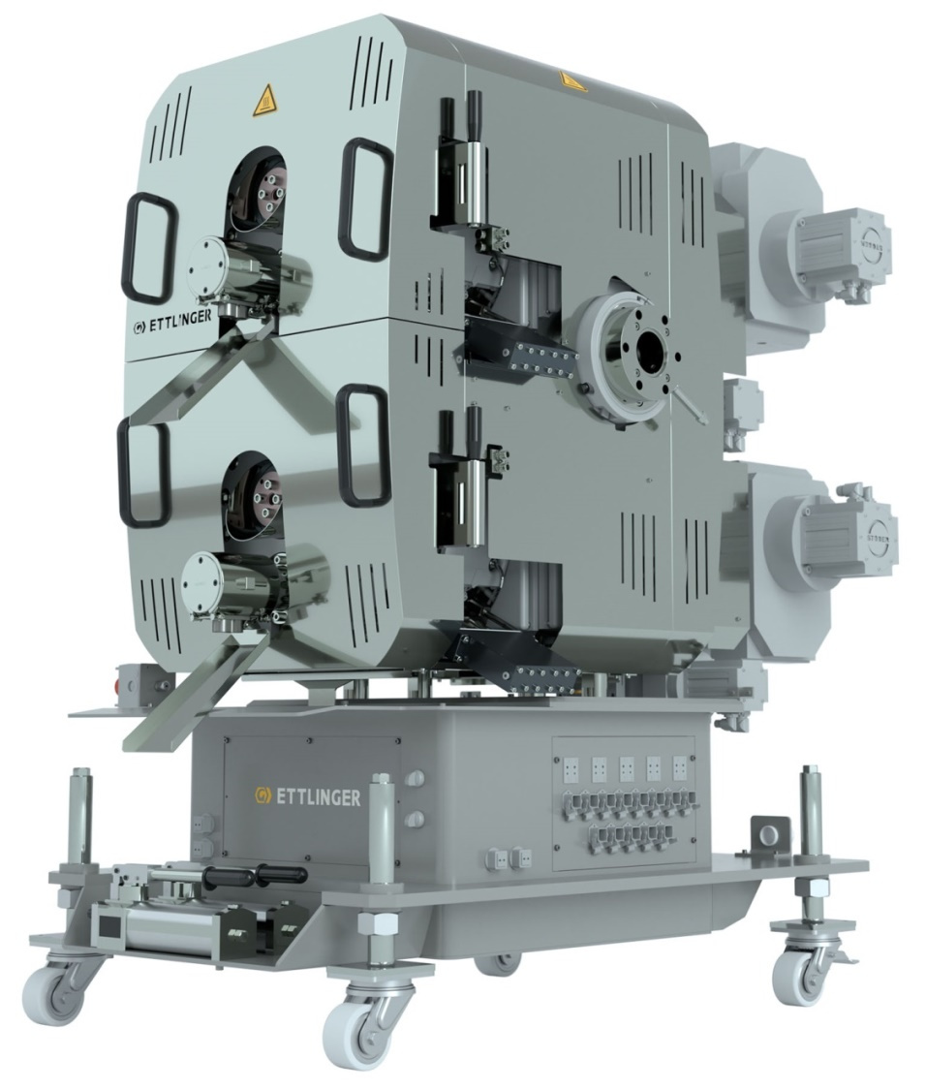
Ettlinger's new ECO 500 high performance melt filter achieves throughputs of up to 4,000 kg/h
© Ettlinger
Königsbrunn/Germany, June 2021 – ETTLINGER, a member of the MAAG Group and a leading manufacturer of continuously operating high performance melt filters, has unveiled a new generation of tried-and-tested ECO products for use in PET recycling. Their new features take into account the need for systems with a higher product throughput and are initially available in sizes suitable for medium-sized recycling lines. The new performance enhanced ECO 350 replaces the former ECO 250, while the new ECO 500, capable of achieving capacities of up to 4,000 kg/h, replaces the former ECO 250 Twin. The ECO 200 completes this range.
Ettlinger's melt filter technology is based on the principle of self-cleaning with a continuous flow of melt from the outside to the inside of a rotating, perforated drum. A scraper removes the contaminants that are held back on the surface and feeds them to the discharge system. Just like the ERF filters, which are designed for higher contamination, the new ECO filters also have a modular structure, thereby providing a wide range of options for adjusting the filter properties to the respective task. A new innovative system facilitates an even higher concentration of contaminated discharge, which, in turn, further decreases the already typically low loss of PET melt associated with Ettlinger's melt filters. Better access to the scraper system reduces the amount of time needed by the operator for maintenance and replacement tasks. The discharge now exits via the front side of the ECO filters, which is generally easier for the user to access.
Uwe Kellner, Managing Director Ettlinger: "PET recyclers are reporting ever-increasing volume flows, resulting in a sharp increase in the capacity utilisation of many machines. At the same time, buyers have more stringent requirements regarding the purity of the recycled material. Consequently, many of the filter systems in operation today are reaching maximum capacity. Our further developments have been tailored to these changes in the market. With these in mind, we have achieved enhanced performance without compromising on filtration efficiency. The new designs combine screen sizes up to 60 µm with a minimum loss of PET through the discharge."
The ECO melt filters are designed to process very low viscosity polymer feedstock (mainly PET and PA) and to facilitate the efficient filtration of contaminants such as paper, wood, aluminium, silicone, etc. Moreover, the closed discharge system prevents the occurrence of black specks. For this reason, the classic application for ECO melt filters is extrusion systems where PET bottle flake is converted into food packaging films, packaging tape and fibres, as well as PET repelletising and compounding processes. ECO melt filters are suitable for single-screw or twin-screw extrusion lines, irrespective of the pelletising system or other downstream units, and can achieve throughputs from 150 kg/h up to 4,000 kg/h.
About the MAAG Group
The MAAG Group is a broadly diversified global solutions provider with integrated and customisable systems in process technology for the polymer, chemical, petrochemical, pharmaceutical and food industries. Its Pump & Filtration Systems, Pelletizing Systems, Pulverizing Systems and Recycling Systems divisions consolidate the many years of experience and in-depth know-how of the AUTOMATIK, ETTLINGER, MAAG, GALA, REDUCTION and SCHEER product brands. The MAAG Group currently employs over 1,000 people at production sites in Switzerland, Germany, Italy, the USA and China. Additional sales and service centres in France, Singapore, Taiwan, Malaysia, India, Thailand and Brazil ensure close attention to customers' needs. For more information, visit www.maag.com.
The MAAG Group is a business unit of Dover Fluids, a segment of the Dover Corporation.
About ETTLINGER
ETTLINGER is the product brand for recycling systems within the MAAG Group. Its focus is on high performance melt filters for the recycling of plastics. Injection moulding machines round off the portfolio. The company was founded in 1983 and has its development and production base in Augsburg, Germany. ETTLINGER has been part of the MAAG Group since 2018.
More information on ETTLINGER
Karsten Bräunig, Sales Manager
Ettlinger Kunststoffmaschinen GmbH, Messerschmittring 49, D-86343 Königsbrunn, Germany
Tel.: +49 8231 34908 -12, e-mail: karsten.braeunig@maag.com
www.maag.com
Editorial contact and specimen copies:
Dr. Jörg Wolters, Konsens PR GmbH & Co. KG
Im Kühlen Grund 10, D-64823 Groß-Umstadt, Germany – www.konsens.de
Tel.: +49 (0) 60 78 / 93 63 - 0, e-mail: joerg.wolters@konsens.de
ETTLINGER press releases with pictures in printable quality can be downloaded from: https://www.konsens.de/ettlinger

