Press Release
Cost efficiency in melt filtration:
pressure consistency and long operating times even with large amounts of contaminates
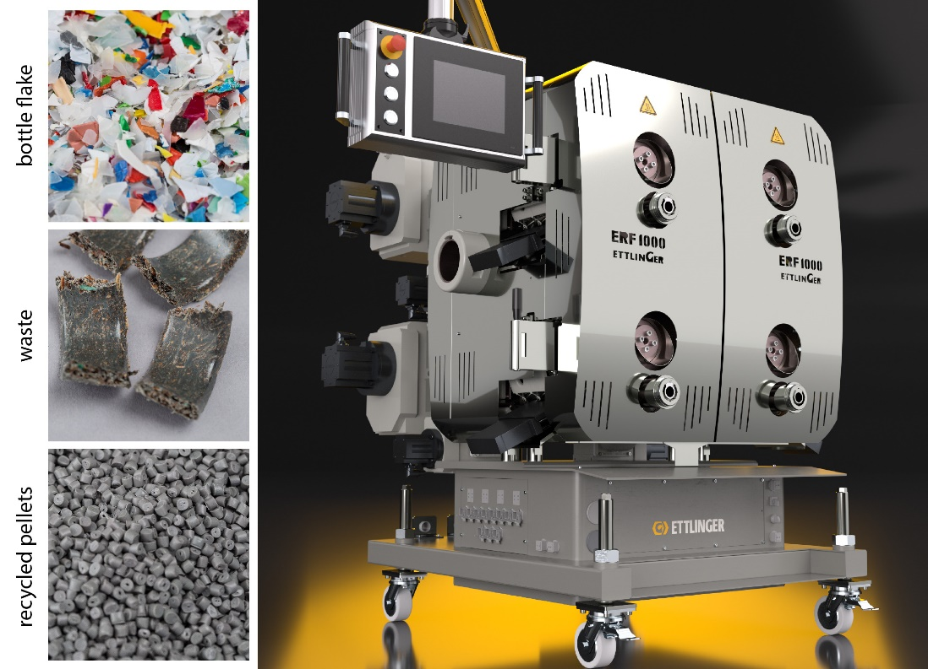
Recycling of PE, PE-HD and PP are among the most common industrial applications of the ERF 1000 continuous melt filter, which can process up to 10 t/h, depending on the material involved.
© Ettlinger
Königsbrunn/Germany, April 2023 - Recyclates of the highest quality are a highly sought-after commodity in the plastics processing industry. In line with demand, stricter requirements are also being placed on the productivity of the recycling systems. The high-performance melt filters from the ERF series from Ettlinger, the centre of competence for recycling in the MAAG Group, are a cost-effective solution for providing corresponding product quantities for the recyclable material cycle. The manufacturer's flagship is the powerful ERF 1000. When processing easy-flowing materials, for example for injection moulding applications, its four rotating, perforated drums can filter up to ten tonnes of plastic melt per hour. The system's benefits include continuous operation in a stable process at consistent pressure and long operating times without filter changes. The very low melt loss in the range of a just few percent as well as the possibility of changing each drum individually and without interrupting production also contribute to the high cost efficiency of the ERF 1000.
If throughputs lower than those provided by the ERF 1000 are sufficient, the ERF 350 (up to more than 3,000 kg/h) and ERF 500 (up to 6,000 kg/h) offer alternatives to meet such requirements. All three sizes are designed for energy efficiency and are suitable for filtering common thermoplastics, including soft PVC. The proportion of contaminates such as paper, aluminium, wood, elastomers (rubber or silicone) or high-melting polymer composites can be up to 16%. ERF melt filters can in principle be used in any extrusion line – either single or twin-screw and irrespective of the type of pelletising system or other downstream unit. Thanks to their compactness, they are also very suitable for retrofitting existing extrusion lines. Typical applications range from recycling through to sheet and film extrusion and compounding. In film recycling in particular, the finest mesh size of 60 µm opens up possibilities for achieving benchmark qualities.
About the MAAG Group
The MAAG Group is a broadly diversified global solutions provider with integrated and customisable systems in process technology for the polymer, chemical, petrochemical, pharmaceutical and food industries. Its Pump & Filtration Systems, Pelletizing Systems, Pulverizing Systems and Recycling Systems divisions consolidate the many years of experience and in-depth know-how of the AUTOMATIK, ETTLINGER, MAAG, GALA, REDUCTION, SCHEER and WITTE product brands. The MAAG Group currently employs over 1,500 people at production sites in Switzerland, Germany, Italy, the USA and China. Additional sales and service centres in France, Singapore, Taiwan, Malaysia, India, Thailand and Brazil ensure close attention to customers' needs. For more information, visit www.maag.com.
The MAAG Group is a business unit of Dover Fluids, a segment of the Dover Corporation.
About ETTLINGER
ETTLINGER is the MAAG Group's centre of competence for recycling. Its focus is on high performance melt filters for the recycling of plastics. Injection moulding machines round off the portfolio. The company was founded in 1983 and has its development and production base in Augsburg, Germany. ETTLINGER has been part of the MAAG Group since 2018.
More information on ETTLINGER
Karsten Bräunig, Sales Manager
Ettlinger Kunststoffmaschinen GmbH, Messerschmittring 49, D-86343 Königsbrunn, Germany
Tel.: +49 8231 34908 -12, e-mail: karsten.braeunig@maag.com
www.maag.com
Editorial contact and specimen copies:
Dr. Jörg Wolters, Konsens PR GmbH & Co. KG
NEW:
Hans-Böckler-Str. 20, D-63811 Stockstadt am Main
Tel.: +49 (0) 60 27 / 99005 - 13
E-mail: joerg.wolters@konsens.de, – www.konsens.de
ETTLINGER press releases with pictures in printable quality can be downloaded from: https://www.konsens.de/ettlinger

