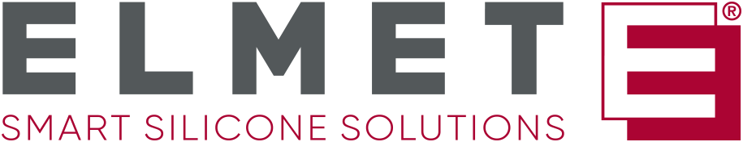
ELMET Elastomere
Produktions- und Dienstleistungs GmbH
Tulpenstraße 21 | A-4064 Oftering
Tel.: +43 (0)7221 / 74577-0
E-mail: office@elmet.com
Press Release
Elmet exhibiting again at numerous prestigious trade fairs worldwide in 2023
The Upper Austrian specialist in developing and manufacturing liquid silicone parts is living up to its reputation as a global player.
Elmet's trade fair and exhibition stands already drew large crowds last year. Be it at K, the leading international trade fair for the plastics industry, or at FIP in Lyon – the Upper Austrian specialist in developing and producing high-quality liquid silicone parts, dosing systems, and moldmaking succeeded in imparting a great deal of knowledge. And Elmet will be appearing at a wide variety of trade fairs again in 2023, including the renowned Fakuma in Friedrichshafen.
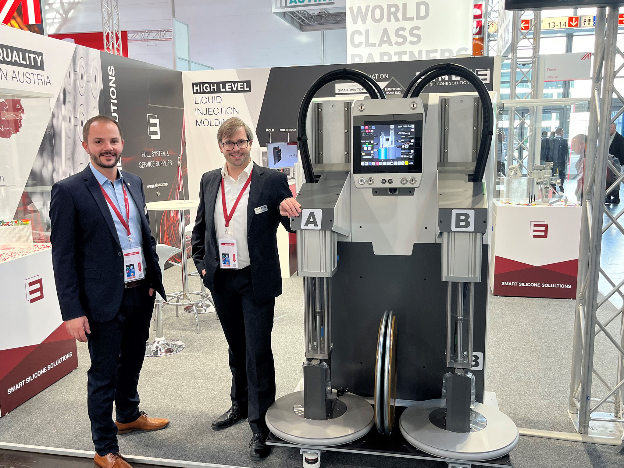
Elmet is presenting itself internationally again in 2023 at the industry's most important trade fairs. From Milan via Amsterdam and Friedrichshafen to Detroit, Elmet will be appearing with its own exhibition stands. © Elmet
Oftering/Austria, February 2023 – "It's important for us to keep our customers and partners around the world up to date with the latest news and developments in our company and the industry in general," explains Elmet's CEO, Harald Wallner. Trade fairs are the ideal place for this.
On the European stage
As a highly successful Upper Austrian company, Elmet conducts a lot of business on its home continent. Appearing at Fakuma in Friedrichshafen is therefore an absolute must. "At Fakuma, we have the opportunity to get in contact directly with our most important partners both in and outside the EU and at all levels of the supply and production chain of the various industrial sectors," explains Harald Wallner. "This trade fair has significant added value not only for potential new customers, but also for ourselves."
International reputation
Elmet will be presenting itself to a transatlantic audience in Detroit, Michigan, in fall 2023. "This trade fair is renowned for its technology conferences, live product demonstrations, and its potential as a think tank, so it is ideal for us in our role as a leading innovator," says Harald Wallner. "Silicone Expo USA offers a valuable opportunity for networking globally and for maintaining, extending, and building business relationships all around the world," he believes. Representatives of all levels in the silicone industry supply chain will also be present here.
At a glance
For Elmet, the trade fair year 2023 begins with Silicone Expo Europe in Amsterdam from March 21 to 23. It continues in late summer with Plast in Milan from September 5 to 8. In fall, appearances at Silicone Expo USA from October 4 to 5 and Fakuma in Friedrichshafen from October 17 to 21 bring this year's exhibition merry-go-round to an end.
Corporate Data
Molds. Dosing technology. Part production. Jobs. Elmet inspires with smart silicone solutions. This is Elmet's guiding principle. The innovative company was founded in 1996. A powerful, dedicated team with a wealth of experience in moldmaking, dosing technology, and liquid-silicone injection molding has since developed into an internationally successful systems builder. Today Elmet is a global player in designing and manufacturing high-quality equipment for the production of silicone parts.
Further information can be found at www.elmet.com
Kommhaus
Altausseer Straße 220, 8990 Bad Aussee, Austria
Tel.: +43 3622 55344-0, Fax: +43 3622 55344-17
E-Mail: presse@kommhaus.com
Text and image of this press release are stored for download at
https://www.konsens.de/elmet

