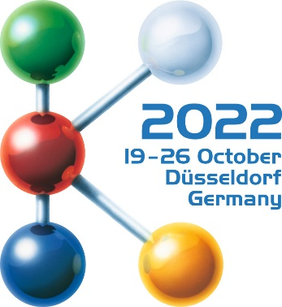  Hall 12 / Stand D36-08 | ELMET Elastomere  Produktions- und Dienstleistungs GmbH  Tulpenstraße 21 | A-4064 Oftering  Tel.: +43 (0)7221 / 74577-0  E-mail: office@elmet.com
Press Release
newsroom.kommhaus.com

Business/Industry/Plant Engineering/Trade Fair

SMARTcap gets trade fair in Düsseldorf off to impressive start
Elmet's innovative manufacturing cell for food cans is impressive; the caps produced are in high demand.

Elmet got off to a high-profile start at the K 2022 in Düsseldorf. The Upper Austrian company was represented on two stands. Presented highlights included a manufacturing cell with four-cavity mold and SMARTshot E all-electric gate valve cold runner and the new SMARTmix TOP 7000 Pro dispensing system. The caps for beverage and food cans produced on the system were very popular among the visitors. The system itself impressed experts and interested parties alike – a sound basis for the successful days in Düsseldorf.
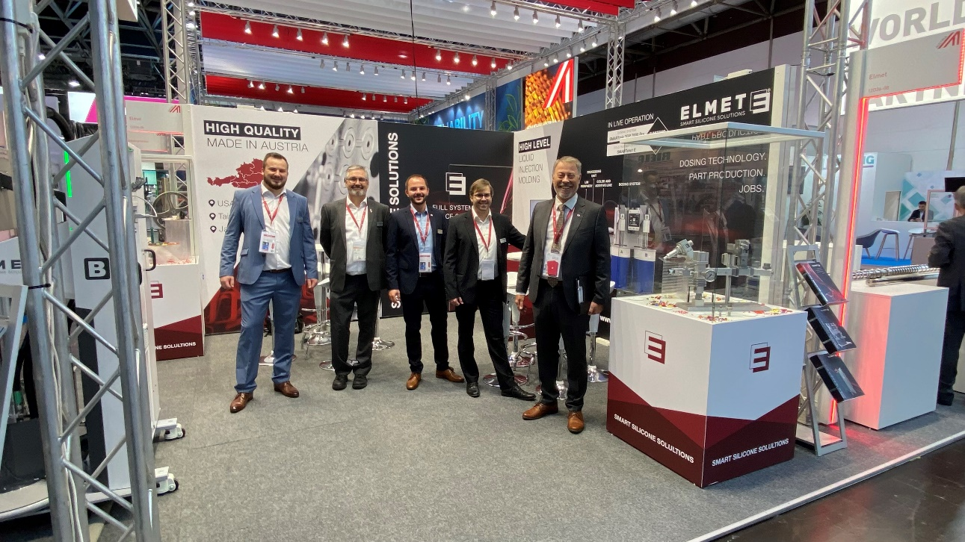

Oftering/Düsseldorf, October 20, 2022 – The K 2022 in Düsseldorf got off to a successful start. The world's leading trade fair for the plastics and rubber industry also went extremely well for the Upper Austrian company, Elmet. The global player in the development and production of high-quality equipment for making silicone parts had already impressed many visitors and interested parties within the first few days.

Success on two trade fair stands
There were many interesting discussions on the company's own stand in Hall 12. At the same time, Elmet also celebrated success on the Sumitomo partner stand in Hall 15. There, the partners presented an innovative manufacturing cell with four-cavity mold and SMARTshot E all-electric gate valve cold runner and the SMARTmix TOP 7000 Pro dispensing system developed in-house. "We address two different customer groups with this cell. On the one hand, we convince producers of the quality of our systems by visualizing the part weight, and on the other hand, the product produced is a real hit here at the trade fair," says a pleased Harald Wallner, Elmet CEO. "The process accuracy visualized by the part weight shows visitors how precisely a liquid silicone mold with the SMARTshot E all-electric gate valve and the SMARTmix TOP 7000 Pro dispensing system can produce," explains Wallner.

Efficiency meets sustainability
The innovative technology makes it possible to open the process window further and at the same time reduce the reject rate. In addition, the all-electric date valve cold runner reduces energy costs because production can be started more quickly thanks to the faster start-up process. The number of start-up parts that have to be disposed of as rejects is also significantly reduced. "This efficiency impressed the visitors, as we combine sustainability with precision to target the exact pain points of the industry," says Wallner. Elmet relies on two systems developed in-house. The manufacturing cell builds on an Elmet injection mold with the fully automatic SMARTshot E gate valve cold runner system. The material is supplied via Elmet's SMARTmix TOP 7000 Pro dispensing system. The SMARTmix TOP 7000 Pro dispensing system is a new development from Elmet. With a footprint of only 1,150 x 790 millimeters, it is the most compact dispensing system for liquid silicone on the market.

Corporate data
Molds. Dosing technology. Part production. Jobs. Elmet inspires with smart silicone solutions. This is Elmet's guiding principle. The innovative company was founded in 1996. A powerful, dedicated team with a wealth of experience in moldmaking, dosing technology, and liquid-silicone injection molding has since developed into an internationally successful systems builder. Today Elmet is a global player in designing and manufacturing high-quality equipment for the production of silicone parts.

Further information can be found at www.elmet.com

If you have any questions, please contact:
Kommhaus
Altausseer Strasse 220, 8990 Bad Aussee, Austria
Tel.: +43 3622 55344-0, Fax: +43 3622 55344-17
E-mail: presse@kommhaus.com

This press release as a.docx file and the photo in print-ready resolution are available for download from https://www.konsens.de/elmet

