Public debut at Fakuma:
SMARTshot i brings Intelligence to LSR Molds
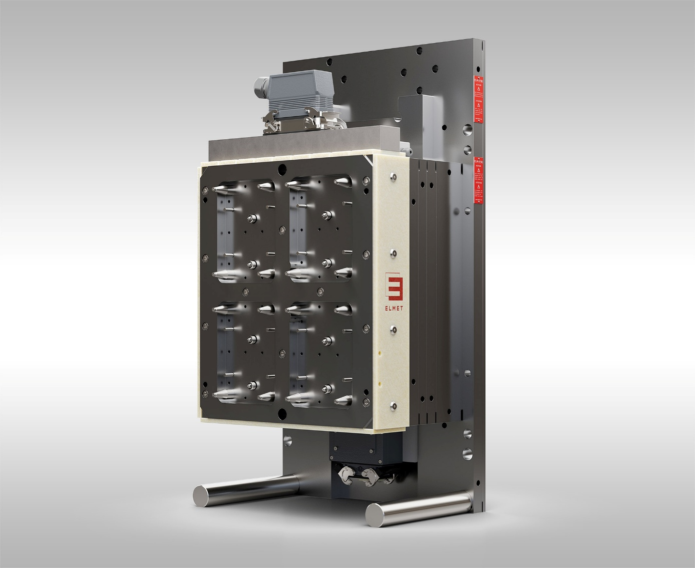
SMARTshot i is an intelligent cold runner system for LSR injection molding. © Elmet
Oftering/Austria, September 2026 – At Fakuma 2026, ELMET, an internationally active provider of precise and innovative solutions for liquid silicone rubber (LSR) processing, will present its SMARTshot i system to a broad, international audience of industry professionals for the first time. This new generation of intelligent cold runner technology for LSR injection molding continuously analyzes the injection process, automatically balances the cavities, and independently optimizes the nozzle pin positions.
SMARTshot i really shines when used with family molds featuring cavities of varying sizes. Instead of manually fine-tuning them individually through time-consuming filling studies, as was previously done, the system automatically adjusts the nozzle positions to match the specific filling behavior of each cavity. In tests with a 16-cavity mold, only 20 shots were needed to perfectly balance the cold runner. This reduced the ramp-up time by up to 95% compared to the conventional approach.
High-precision servo-electric needle control
As part of the optimization process, SMARTshot i uses the high-resolution data collected during injection to analyze and control the process. Pressure sensors in the cavities are not required. Thermal changes during the ramp-up phase are also detected and compensated for by continuously adjusting the needle positions. The system’s ability to position each nozzle needle servo-electrically with an accuracy of 2 µm is a key factor in its high balancing speed.
Dr. Thorsten Häuser, Head of R&D at ELMET, comments: “The potential of SMARTshot i is particularly evident with complex mold families. Automatically balancing the different cavities significantly reduces setup time and minimizes operator influence on the process. At the same time, we are paving the way for increasingly automated LSR processing.”
SMARTshot i is designed to be AI-ready and serves as the technological foundation for further automation steps. Currently under development are features such as online rheometry for real-time measurement of material viscosity and material fluctuation detection without external sensors.
Experience SMARTshot i live and digitally at Fakuma
Visitors to Fakuma 2026 can explore SMARTshot i from two perspectives. A live demonstration at the Momentive Performance Materials booth in Hall A4, Booth A4-4307, showcases the technology in a real-world production process. Additionally, a digital twin of the SMARTshot i at ELMET in Hall A5, Booth A5-5306, provides an in-depth look at the technology and development work behind the system. It reveals functions and interrelationships that are usually hidden during the injection molding process.
About Elmet
Since 1996, ELMET Smart Silicone Solutions has been an internationally active provider of precise and innovative solutions for liquid silicone rubber (LSR) processing. The company is headquartered in Austria and has branches in China, Japan, and the United States. Its portfolio includes LSR dosing systems, single- and multi-component molds, turnkey solutions, and services ranging from development to series production. With over 30 years of experience, ELMET offers integrated and reliable solutions for demanding applications in industries such as mobility, life sciences, industrial, and household.
Further Information:
Bernd Wolkerstorfer, Marketing Manager
ELMET Elastomere Produktions- und Dienstleistungs-GmbH
Tulpenstraße 21, A-4064 Oftering, Austria
Tel.: +43 (0) 7221 / 745 77-750; Email: marketing@elmet.com
Editorial Contact and Voucher Copies:
Dr. Jörg Wolters, Konsens PR GmbH & Co. KG
Hans-Böckler-Str. 20, D-63811 Stockstadt, Germany
Tel.: +49 (0) 60 27/9 90 05-13; Email: joerg.wolters@konsens.de
Please download this press release including text as a docx file and a high-res image from: https://www.konsens.de/elmet

