ELMET sets the course for further growth: Markus Nuspl becomes CEO
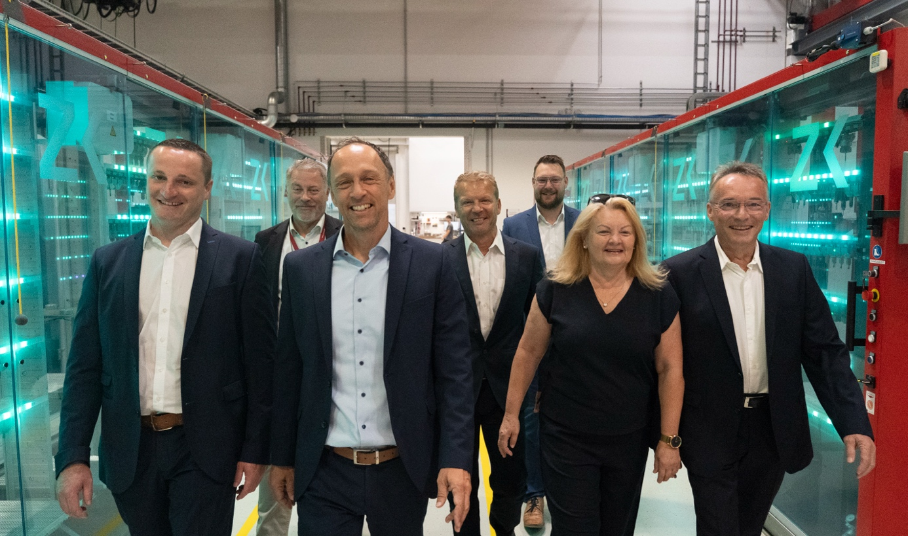
From left to right: Moritz Manigatter, Paul Fattinger, Markus Nuspl (new managing director), Christian Reslhuber, Roman Adlesgruber, Christine Adlesgruber, Kurt Manigatter. Photo: ELMET
Oftering, Austria, July 2026 – Dr. Markus Nuspl, an experienced manager and proven industry expert, is taking over as CEO of ELMET. A mining engineer with a Ph.D., he brings more than 20 years of industry experience as well as extensive expertise in silicone processing, quality management, innovation, and corporate development. Most recently, he served as CEO of RICO Elastomere Projecting GmbH, where he was responsible for the company’s strategic and operational development for several years.
“In Dr. Nuspl, we have gained a leader who combines professional excellence, entrepreneurial thinking, and strong interpersonal skills. He knows our industry, understands the challenges our customers face, and shares our conviction that sustainable business success can only be achieved together with dedicated employees. We are very much looking forward to leading ELMET into the future alongside him,” the owners agree.
Markus Nuspl has a clear vision for the coming years: sustainable and continuous growth based on long-term partnerships with customers, suppliers, and employees. This vision places people at the center, alongside the highest level of customer satisfaction, uncompromising quality, technological innovation, and the consistent improvement of efficiency and competitiveness. At the same time, the company aims to further strengthen its international market position and strategically drive diversification into various industries and regions.
“ELMET has outstanding employees, a strong technological foundation, and an excellent reputation in the market. Together, we want to further build on these strengths. My goal is to combine innovation, quality, and economic success with a corporate culture in which responsibility is embraced, trust grows, and collaboration is put into practice.”
With Markus Nuspl at the helm, ELMET is setting the course for the company’s next phase of development and consistently continuing on its path as an innovative partner for the international silicone industry.
About ELMET
ELMET Smart Silicone Solutions has been an international provider of precise and innovative solutions for liquid silicone rubber (LSR) processing since 1996. The company is headquartered in Austria and has branches in China, Japan, and the USA. Its portfolio includes LSR dosing systems, single and multi-component molds, turnkey solutions, and services ranging from development to series production. With over 30 years of experience, ELMET offers integrated and reliable solutions for demanding applications in industries such as mobility, life sciences, industrial, and household.

Further information:  Bernd Wolkerstorfer, Marketing Manager  ELMET Elastomere Produktions- und Dienstleistungs-GmbH  Tulpenstraße 21, A-4064 Oftering, Austria  Tel.: +43 (0) 7221 / 745 77-750  Email: b.wolkerstorfer@elmet.com | Editorial contact and voucher copies:  Dr. Jörg Wolters  Konsens PR GmbH & Co. KG  Hans-Böckler-Str. 20, D-63811 Stockstadt, Germany  Tel.: +49 (0) 60 27/9 90 05-13  Email: joerg.wolters@konsens.de
Please download this press release including text as a docx file and a high-res image from: https://www.konsens.de/ELMET

