All-electric cold runner maximizes LSR injection molding flexibility and precision
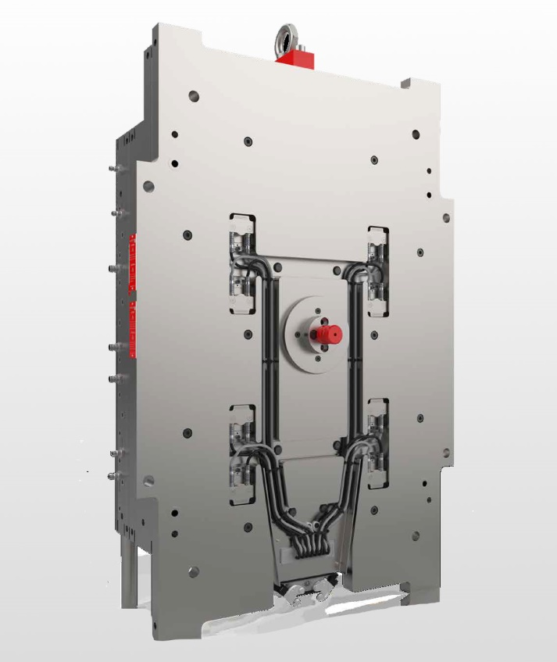 | The new high-end, all-electric SMARTshot E cold runner for LSR injection molding enables perfectly balanced filling of multi-cavity molds with up to 16 cavities. © ELMET
Oftering/Austria, October 2021 – ELMET’s new all-electric SMARTshot E valve gate cold runner system has servo-driven nozzle needles to maximize flexibility, precision and controllability when injecting two-component liquid silicone rubbers (LSR) into multi-cavity molds. It complements ELMET’s range of SMARTshot Liquid Injection Molding (LIM) cold runners which also includes a pneumatic version, the model P, and a hybrid version with pneumatic needle movement and electrical stroke adjustment, the model PE.
Compact brushless DC servomotors used in the high-end SMARTshot E move and position the needles during nozzle opening and closing, while the 18.5” color display allows needle position to be set very quickly and uniformly to an accuracy of 0.002 mm and provides constant feedback about instantaneous position. Thanks to opening and closing times of the order of hundredths of a second, needle movements can be perfectly synchronized and precisely balanced during injection into up to 16 cavities. In comparison with alternative solutions, the servomotors with their low waste-heat output and small space requirements also enable compact mold design due to a significantly reduced nozzle spacing of as little as 44 mm.
One time-saving advantage of the SMARTshot E is that it is connected via virtually wear-free miniature industrial connectors capable of withstanding even frequent assembly and disassembly. Optimized cable management with a cable harness which, after disconnection of the motor connectors, can be removed as an assembly without requiring a qualified electrician further boosts ease of use and reliability. The harness also prevents incorrect connection on reassembly. Clear recipe management with import and export options as well an integrated authorization system with user management also maximizes operating reliability.
All SMARTshot models allow each individual nozzle to be calibrated and filling behavior to be defined. They also all boast a particularly long needle guide and complete protection from twisting of the needle, the tip of which is part of the molding cavity contour. The innovative cooling system and thermal isolation of the cold runner from the mold side ensure process stability. The molding principle used ensures almost complete elimination of production waste such as sprues and runner scrap.
ELMET Elastomere Produktions- und Dienstleistungs GmbH of Oftering, Austria, established in 1996, is an internationally successful developer and manufacturer of LSR dosing systems, fully automatic injection molds, valve gate cold runners, and turnkey installations for processing silicones and rubbers. Including the personnel of its ELMET North America sales and service organization, ELMET Greater China and ELMET Japan, the company has some 200 staff.
“Molds. Dosing technology. Part production. Jobs. ELMET inspires with smart silicone solutions”, is ELMET’s new mission statement.
Further information:
Veronika Rensch, Marketing and Communication Management
ELMET Elastomere Produktions- und Dienstleistungs GmbH
Tulpenstraße 21, A-4064 Oftering
Tel.: +43 (0) 7221 / 745 77-167; Email: marketing@elmet.com
Editorial contact and voucher copies:
Dr. Jörg Wolters, Konsens PR GmbH & Co. KG
Im Kühlen Grund 10, D-64823 Groß-Umstadt
Tel: +49 (0) 60 78/93 63-13; Email: joerg.wolters@konsens.de
This press release as a.docx file and the photo in print-ready resolution are available for download from https://www.konsens.de/elmet

