Cost-efficient and sustainable:

UHMWPE for injection moulding, extrusion and 3D printing

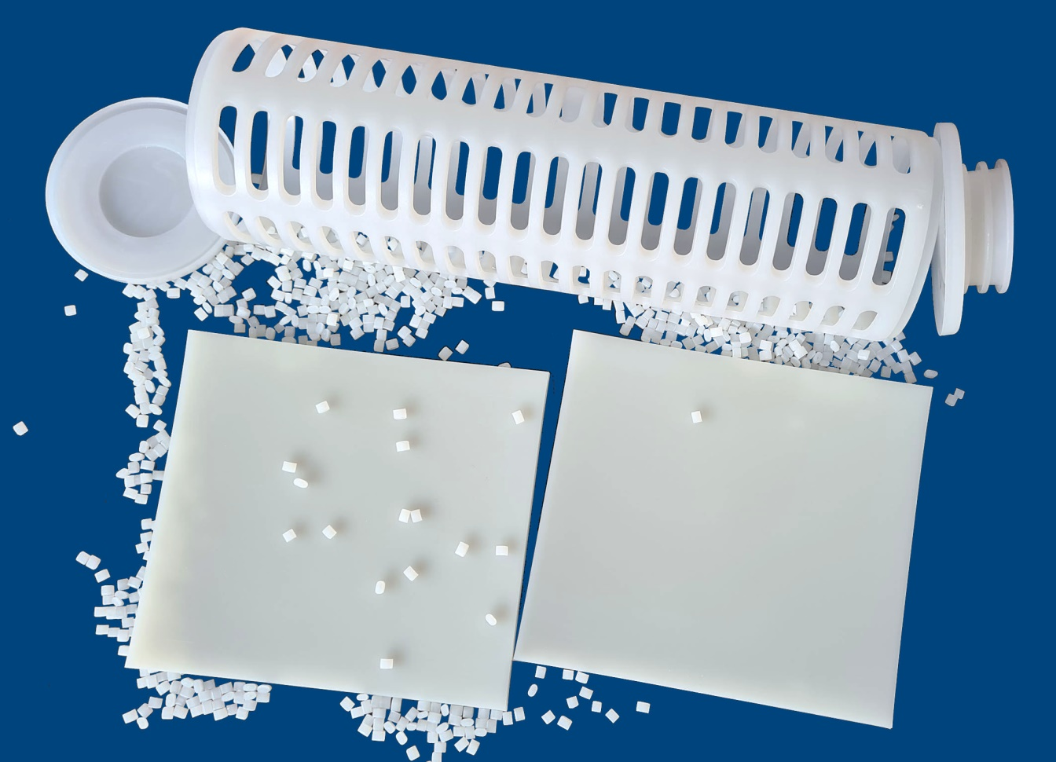

UHMWPE types in the DREYPLAS portfolio that are suitable for injection moulding, extrusion and 3D printing allow considerable cost savings compared with the machining of semi-finished products. © Dreyplas
Meerbusch/Germany, August 2021 – At Fakuma, plastics distributor DREYPLAS (www.dreyplas.com) will showcase innovative application possibilities for the ultra-high-molecular-weight polyethylene (UHMWPE) LUBMER™ from Mitsui Chemicals. Compared with conventional sintered semi-finished products, this offers possibilities for considerable cost savings in the production of moulded parts and profiles that also boast excellent surface slip properties. This advantage comes from the thermoplastic processability by injection moulding and extrusion. In this way, it is no problem with Lubmer to produce parts with narrow tolerances and very low depths of roughness. As a result, the amount of time required is significantly reduced, and the large quantities of costly, non-reusable production scrap from the machining of semi-finished products are no longer produced. In current sampling trials at customers, Lubmer has also proved that the product is suitable for 3D printing.
The difference between the various UHMWPE types lies in the length of the molecule chains. With conventional types, they are so long that they cannot be melted but have to be sintered into the semi-finished products. Compared with that, the molecular weight of the Lubmer types supplied in granule form is reduced by just enough for processing to be possible on conventional injection moulding machines and extruders. As a result, it provides greater design freedom than with the machining of semi-finished products and, furthermore, the production scrap – which is less anyway – can be melted again and returned to the process in an environmentally friendly manner.
Despite the reduced molecular weight, Lubmer offers, with smooth friction partners such as steel, equally good tribological properties as components made of a sintered semi-finished product. This and its recyclability in the polyolefin stream make it in many applications a sustainable alternative to engineering plastics such PPS, POM, PA or PBT. Lubmer can be used in applications at long-term temperatures down to –200°C, and its chemical resistance, heat resistance and (low-temperature) impact strength are the same as those of UHMWPE semi-finished products. It complies with all the REACH regulations and is approved to FDA and EU10/2011 for food-contact applications.
Alongside the basic types, namely Lubmer L3000 with the highest flowability, L4000, and L5000, which is also suitable for extrusion and has the highest abrasion resistance, DREYPLAS also markets the higher temperature-resistant Alloy LS4140, which, thanks to its polyamide modification, combines elevated temperature resistance with good flow properties. Lubmer can be used both with hot runner systems and with traditional tunnel gates. The light and opaque intrinsic colour facilitates the use of colour masterbatches. Other functional additives can also be incorporated via the conventional metering systems.
Lubmer offers very good sound insulation and better electrical insulation properties than most other polyolefins. It is suitable, for example, for low-noise cogwheels and also for applications that specify low-temperature resistance and high chemical resistance. The combination of low sliding friction and high abrasion resistance also make it an effective alternative for applications such as bearings that are subjected to high stresses, and generally also for technical components that are subjected to sliding friction during use. At the same time, extruded guide elements and profiles also offer the typical benefits of UHMWPE.
In addition to the sales and marketing of Lubmer, the development of innovative applications and products is a core competency of DREYPLAS. This involves accompanying customer projects as well as in-house developments. The latter also include the UHMWPE types Dreylub 5HK5 and 5HK10 with 5 and 10 % by wt. respectively of hollow glass spheres, combining high abrasion resistance and low specific weight with almost complete freedom from warpage.
DREYPLAS is a distributor founded in 2010 and based in Meerbusch, Germany. The portfolio covers high-performance additives and polymers as well as adhesive raw materials, mainly produced by large Asian companies. The focus is on technically high-quality alternatives to established products. Its customers are polymer manufacturers, compounders, coating producers and plastics processors in Europe. The US subsidiary DREYTEK Inc., New Jersey, founded in 2015, markets these products in Mexico, the US and Canada. With this subsidiary and a partner in Asia, DREYPLAS offers global technical support in development and processing. All products are marketed globally and stored and invoiced locally.
DREYCHEM GmbH, Moormerland, Germany, which also belongs to the DREYPLAS group, develops, produces and markets highly efficient cleaning granules for injection molding and extrusion, also for the high temperature range. EFP GmbH, Meerbusch, Germany, which is also part of the group, markets specialty films, e.g. of polycarbonate and PMMA, as well as flame-retardant film in Europe and the US. EFP is currently the only provider worldwide of extruded films of UHMWPE.
Further information:
Norbert Hodrius, DREYPLAS GmbH, Meerbuscher Str. 64-78 Haus 6A, D-40670 Meerbusch
Tel. +49-2159-815 31-11, Fax. +49-2159-815 31-29, hodrius@dreyplas.com
Editorial contact and voucher copies:
Dr. Jörg Wolters, Konsens PR GmbH & Co. KG, Im Kühlen Grund 10, D-64823 Groß-Umstadt
Tel: +49 (0) 60 78/93 63-0, E-Mail: joerg.wolters@konsens.de
Sie finden diese Presseinformation zum Herunterladen unter:
https://www.konsens.de/dreyplas

