PFAS Alternative: Thermoplastic UHMW-PE with Potential for Replacing PTFE

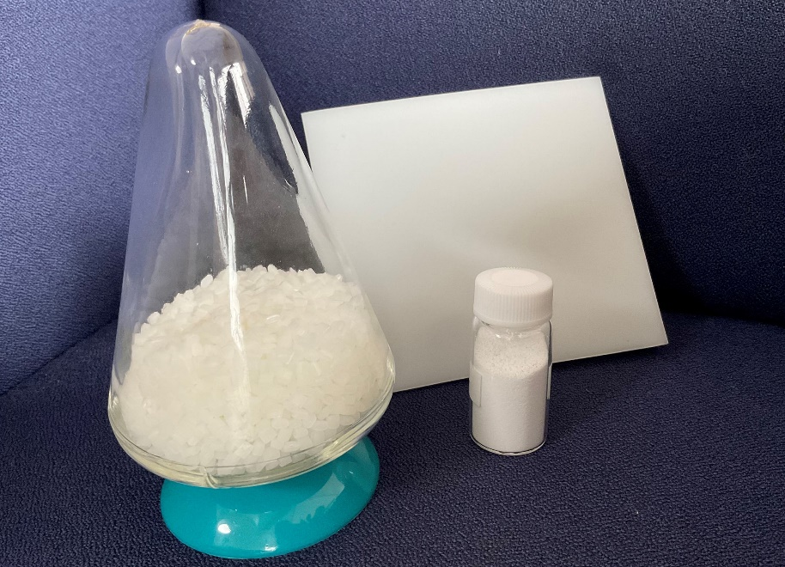

Melt-processable UHMW-PE grades can replace PTFE in many applications that do not require the particularly high temperature and chemical resistance of fluoropolymers. © DREYPLAS
Meerbusch, Germany, May 2023 – Mitsui Chemicals’ LUBMER™ UHMW-PE pellets and spherical powder grades HI-ZEX MILLION™ and MIPELON™, which DREYPLAS distributes, offer a range of properties close to those of fluoropolymers. Hence, in specific applications they can replace PTFE, which is more costly, in short supply and affected by the controversy around PFAS. Apart from high wear resistance and excellent sliding properties, these properties also include good chemical resistance as well as high flexibility and impact strength at low temperatures. Most of these ultra-high molecular weight PE grades meet the food-contact requirements of 1935/2004/EC or 10/2011/EC and the FDA. Advantages over many other polyolefins include very high sound damping and good electrical insulation properties.
The LUBMER™ UHMW-PE pellet range comprises the highly abrasion-resistant grades L5000, L4000 and L3000 together with LS4140 as an alloy of PA and UHMW-PE. These pellets can be injection molded into industrial parts and extruded into sheets, profiles and hoses using both hot runner systems and conventional tunnel gates. In addition to these base grades, the additives LY1040 and LY4100 can raise the abrasion resistance of many engineering polymers while simultaneously reducing their coefficient of friction. The grades’ opaque light color facilitates the use of color masterbatches.
Used instead of PTFE, the highly dispersible HI-ZEX MILLION™ and MIPELON™ powder grades with particle diameters from 10 μm are suitable for abrasion-resistant, chemically resistant surface coatings or as an additive in compounding.
As Norbert Hodrius, Technical Marketing Director at DREYPLAS, explains: “Our customers have been using Mitsui’s UHMW-PE grades for some time as an alternative to PTFE in applications that do not need its particularly high heat resistance. These polymers are also an attractive alternative from the point of view of sustainability. They can be returned to the PE recycling loop and, being melt-processable and not requiring machining, they generate only small quantities of production waste. We’ll be delighted to provide application advice on further new developments and material substitutions.”
DREYPLAS has also collaborated with a German specialty film manufacturer to develop and bring to market a UHMW-PE film that can be extruded with a minimum thickness of 30 µm. It can be used in place of existing film applications affected by the controversy around PFAS. It is also suitable for thermal insulation in automotive batteries and as part of opaque multilayer films in other applications.
DREYPLAS, founded in 2010, is a distributor with its registered office in Meerbusch, Germany. Its portfolio covers high-performance additives and polymers as well as adhesive raw materials, mainly from major Asian manufacturers, and focuses on technically high-quality alternatives to established products. Its customers are polymer manufacturers, compounders, coating producers and plastics processors in Europe. The US subsidiary DREYTEK Inc., New Jersey, founded in 2015, markets these products in Mexico, the US and Canada. With this subsidiary and a partner in Asia, DREYPLAS offers global technical support in development and processing. All products are marketed globally but held in stock and invoiced locally.
DREYCHEM GmbH, Moormerland, Germany, which also belongs to the DREYPLAS group, develops, produces and markets highly effective cleaning granules for injection molding and extrusion, including for elevated temperatures. EFP GmbH, Meerbusch, Germany, another member the group, markets specialty films, e.g. of polycarbonate and PMMA, as well as flame-retardant films in Europe and the US. EFP is currently the world’s only supplier of extruded UHMW-PE films.
Further information:
Norbert Hodrius, DREYPLAS GmbH, Meerbuscher Str. 64-78 Haus 6A, D-40670 Meerbusch, Germany
Tel. +49-2159-815 31-11, Fax +49-2159-815 31-29, hodrius@dreyplas.com
Editorial contact and voucher copies:
Dr. Jörg Wolters, Konsens PR GmbH & Co. KG
NEW address: Hans-Böckler-Str. 20, D-63811 Stockstadt, Germany
Tel: +49 (0) 60 27/99005-13, Email: joerg.wolters@konsens.de
This press release can be downloaded from:
https://www.konsens.de/dreyplas

