New solutions for additives and reinforcing materials:

Improved tribological properties and more sustainable engineering plastics
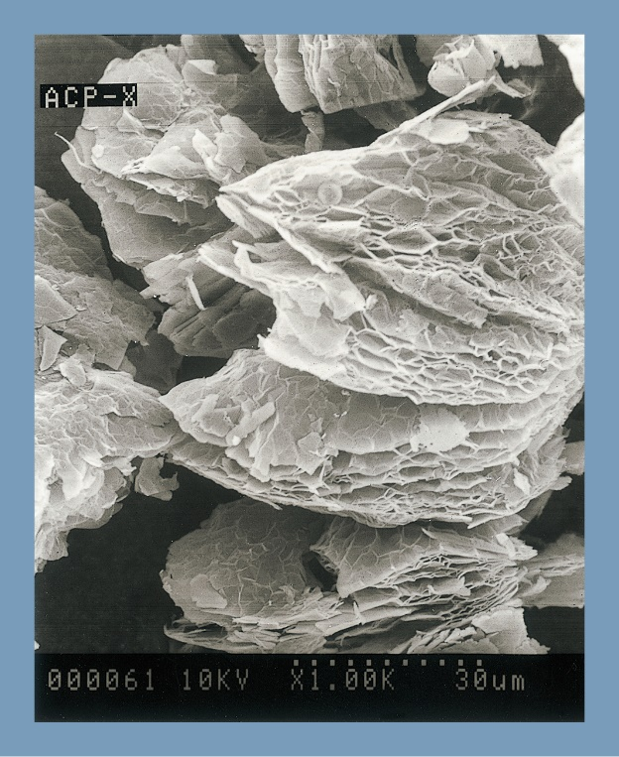 | 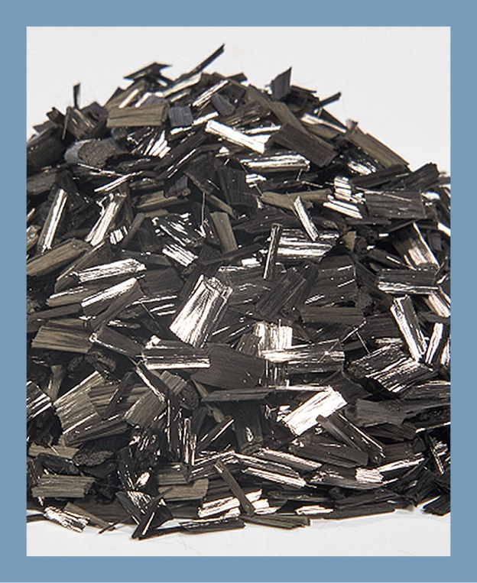
Tribological properties:  When used as a filler in thermoplastics, graphite, with its flake-like structure, improves friction and wear behaviour.  © Nippon Graphite Industries |  | Mechanical properties:  Chopped carbon fibres made from post-consumer recycled material (PCR) are a sustainable and high-performance alternative to virgin material. © Nippon Polymer Sangyo
Meerbusch, Germany, October 2026 – At Fakuma 2026, Dreyplas will be presenting the latest additions to its portfolio of additives for modifying engineering and high-performance plastics. These include para-aramid powders, hexagonal boron nitride (h-BN) and speciality graphite, as well as recycled carbon fibres, which help to reduce the environmental footprint. Depending on the polymer matrix and application requirements, these additives can reduce friction, improve wear resistance and optimise the performance of components in demanding applications.
Reduced friction and wear
Para-Aramid powder is now available from Dreyplas. In addition to its use as a compound component in thermoplastics to improve tribological properties, it can be used in a wide range of applications, where properties such as a density of around 1.44 g/cm³, high temperature resistance, extremely low thermal conductivity and very high chemical resistance offer application-specific advantages.
Nippon Graphite Industries is the manufacturer of the friction-reducing graphite grades now distributed by Dreyplas. These are available in a wide range of variants, including flake, spherical and laminate forms, with particle sizes ranging from 5 µm to 350 µm and bulk densities from 0.08 to 0.53 g/cm³.
Also new to Dreyplas’ additive portfolio is the SHOBN-UHP series from Japan. This is a high-purity, white, platelet-shaped crystalline powder made of hexagonal boron nitride (h-BN). Depending on requirements, it is available with average particle sizes of 0.7 µm, 8 µm or 11 µm. It improves the sliding properties of thermoplastics and enhances mould release. Furthermore, it combines very good thermal conductivity and high thermal stability with high corrosion resistance and good dielectric properties.
Sustainable carbon fibres
Another highlight that Dreyplas will be presenting at Fakuma 2026 is a new range of chopped carbon fibres from Nippon Polymer Sangyo. These are based on post-consumer recycled (PCR) materials sourced from wind turbine rotor blades or pressure vessels. Like conventional variants, they reduce creep and enhance the dimensional stability and mechanical strength of components. As an alternative, they also support resource-efficient material concepts without compromising the performance potential required for engineering plastics.
DREYPLAS GmbH is a distributor founded in 2010 and based in Meerbusch/Germany. Its product range comprises high-performance additives and polymers, as well as raw materials for adhesives, which are mainly sourced from major Asian manufacturers. The company focuses on new, technically advanced and, in some cases, unique products, as well as on cost-effective alternatives to established materials of the highest quality. Its customers include polymer manufacturers, compounders, coating manufacturers and plastics processors. The company also offers high-quality cleaning pellets for injection moulding and extrusion, including for high-temperature applications. Furthermore, EFP GmbH, which forms part of the group, is one of the few suppliers of polycarbonate and coated PET films for the printing, domestic appliance and electronics industries, as well as the mechanical engineering sector. Partner companies in the USA and Asia ensure a global presence.
Further information:
Dr. Ulrich Kückelmann, Managing Director DREYPLAS GmbH
Meerbuscher Str. 64-78 Haus 6A, D-40670 Meerbusch
Tel. +49 21 59 815 31-0, info@dreyplas.com
Editorial contact and please send voucher copies to:
Dr. Jörg Wolters, Konsens PR GmbH & Co. KG, Hans-Böckler-Str. 20, D-63811 Stockstadt
Tel: +49 60 27 990 05-13, E-Mail: joerg.wolters@konsens.de
This press release can be downloaded from:
https://www.konsens.de/dreyplas

