Press Release
BUSS optimizes COMPEO series for compounding plasticized PVC
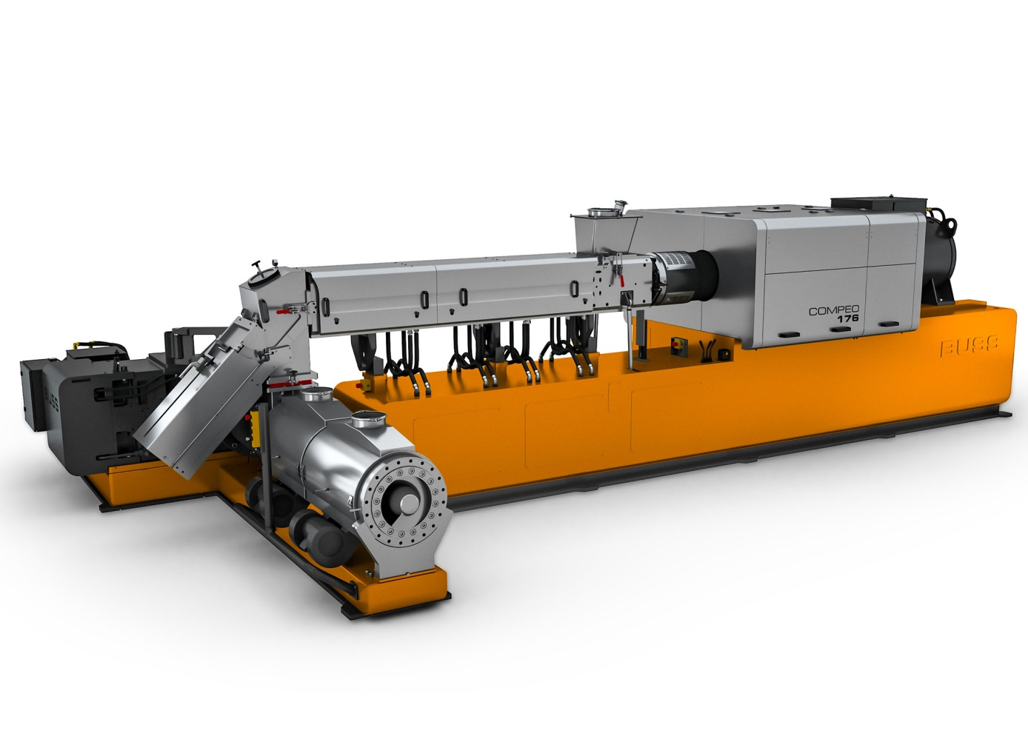
COMPEO 176 in cascade configuration for compounding plasticized PVC at up to 12.5 metric tons/hour. © Buss
Pratteln, Switzerland, April 2021. BUSS’s modular COMPEO plasticized PVC compounding systems are now also available in a cascade configuration for optimum results. The discharge and pelletizing unit is mechanically decoupled from the compounder and is fed in free fall via a connecting tube. This arrangement avoids back-pressure build-up at the transition between compounder and discharge unit and prevents the PVC compound from being exposed to excessive temperatures.
The new two-stage configuration enhances ease of use and operator safety. For instance, the tube and diverter valve can be operated and cleaned without tools. The single screw discharge unit, which generates the pressure required for pelletization, is arranged at right angles to the compounder, so helping to keep the overall unit short. Depending on requirements, screw lengths of 4 or 6 L/D are possible.
The swivelable, easy access BUSS die-face pelletizing unit is equipped with a two-, three-, or four-bladed knife and is likewise mounted on the discharge unit to save space. The adjustable blade drive ensures optimum cutting quality and uniform, cylindrical pellets. A braked motor securely locks the knife drive, so greatly increasing safety for maintenance and cleaning personnel. A sensor on the heated die plate sensor trips an automatic safety shutdown if the maximum permissible pressure is exceeded.
As Dino Kudrass, head of development and design at BUSS, explains, “When it comes to compounding plasticized PVC, the decoupled configuration has particular advantages over our usual conical twin-screw discharge unit. It helps to minimize residence times for the thermally sensitive compound in the cylinder and so provides effective protection from degradation. And because the melt can be degassed in the connecting tube, the compounder’s process section can be shortened by the length of a degassing module.”
There are currently five members of the COMPEO family, beginning with the model 55 for throughputs from approximately 150 kg/h up to the model 176 for PVC compound throughputs as high as around 12,500 kg/h. From the model 137 upwards, the COMPEO in cascade configuration can have the BUSS die-face pelletizing unit replaced with a particularly high throughput underwater pelletization unit.
At present, BUSS Inc. in the USA has sold two COMPEO 176 lines for compounding plasticized PVC to one of the region’s leading plastics manufacturers and has won orders to supply further model 88 units which only goes to underline the global acceptance of these systems with their renowned effective yet gentle mixing action.
BUSS AG with its registered office in Pratteln, Switzerland, international distribution network and subsidiaries in China, Japan and the USA, designs, manufactures and supplies custom, product-specific compounding solutions, in particular to meet demanding process technology and product quality requirements. These capabilities are backed up by over 70 years of experience in developing and producing BUSS co-kneaders and a long track record of meeting the market’s ever higher technological demands. BUSS’s strength is built not on its size but on its capacity for innovation, flexibility and agile responsiveness to customer needs for any kind of compounding technology.

Further information:
Marco Senoner, BUSS AG
Hohenrainstrasse 10, CH-4133 Pratteln
Tel.: +41(0) 61/825 65 51, Fax: +41(0) 61/825 66 88
Email: marco.senoner@BUSScorp.com; www.BUSScorp.com

Editorial contact and voucher copies:
Dr.-Ing. Jörg Wolters, KONSENS Public Relations GmbH & Co. KG,
Im Kühlen Grund 10, D-64823 Gross-Umstadt
Tel.: +49(0) 60 78/93 63-13, Fax: +49(0) 60 78/93 63-20
Email: joerg.wolters@konsens.de; www.konsens.de
Text and images for BUSS press releases are available for download from: https://www.konsens.de/en/press-releases/buss-ag

