Press Release
BUSS enters into distribution partnerships in the United Arab Emirates and on the Indian subcontinent
Pratteln/Switzerland, Sharjah/UAE, and Mumbai/India, July 2020. To strengthen its global presence and to provide local customers with a further improved sales and after-sales service, the Swiss Buss AG, for 75 years manufacturer of the BUSS Kneader for demanding compounding applications in the plastics, aluminum and chemical industries, has entered into distribution partnerships in the Middle East and India as of June 1, 2020. Reifenhäuser Middle East & Africa (MEA) represents BUSS in the United Arab Emirates (UAE) and surrounding countries. Reifenhäuser India Marketing PVT Ltd. represents BUSS on the Indian subcontinent. Both companies will support BUSS in developing the compounding market in their respective regions.
Reifenhäuser (MEA) is a joint venture between the German Reifenhäuser GmbH & Co. KG Maschinenfabrik, Manish Mehta, founder and managing director of Reifenhäuser India Marketing Private Ltd., and Bharath Yalla, managing director of Reifenhäuser (MEA) founded in 2018. Besides the Reifenhäuser Group, Reifenhäuser MEA represents a number of renowned plastics processing technology brands and has now taken over the marketing of BUSS’ cutting-edge compounding technology in UAE, Bahrain, Kuwait, Oman and Qatar.
Dr. Philip Nising, President and CEO of BUSS AG, says: “BUSS historically has a strong and loyal customer basis in the Middle East. With the newly formed entity located centrally in Sharjah (UAE), Reifenhäuser MEA offers the ideal platform for future business support. We are proud to be part of this step from the very first moment and bring to our customers the added value of a local partner with field service capabilities and the technical expertise they rightly expect from BUSS.”
Reifenhäuser India Marketing PVT Ltd. was founded in 1994 by Mr. Manish Mehta, managing director, and family in a joint venture with Reifenhäuser GmbH & Co. KG Maschinenfabrik, Germany. Not limited to just providing technology, Reifenhäuser India has a fully equipped service team for installations, preventive maintenance and repair services. Besides the Reifenhäuser Group, Reifenhäuser India represents an impressive portfolio of renowned Plastics Processing, Converting (Printing) & Labels technology brands and is now supporting BUSS in the marketing of cutting-edge compounding technology in India, Sri Lanka and Bangladesh. Furthermore, Reifenhäuser India will use its vast service organization to support BUSS customers across the Indian subcontinent.
“With Reifenhäuser India, we have found a great partner to support our business on the Indian Subcontinent and provide our many customers the ideal combination of localized service products and technical expertise with Swiss quality culture”, BUSS’ President and CEO Dr. Philip Nising says. “It’s an important step to further grow our footprint in this bustling economy and opens plenty of opportunity to further enhance our added value as solution provider and next door service partner.”
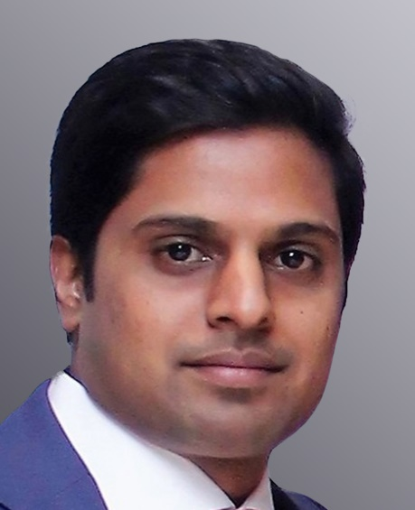 |  | 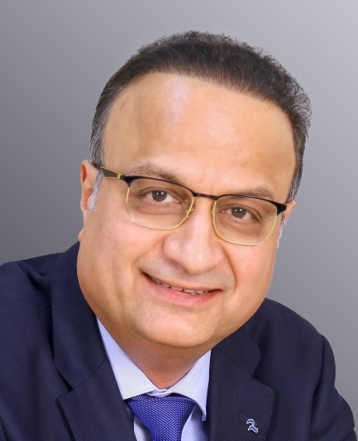 |  | 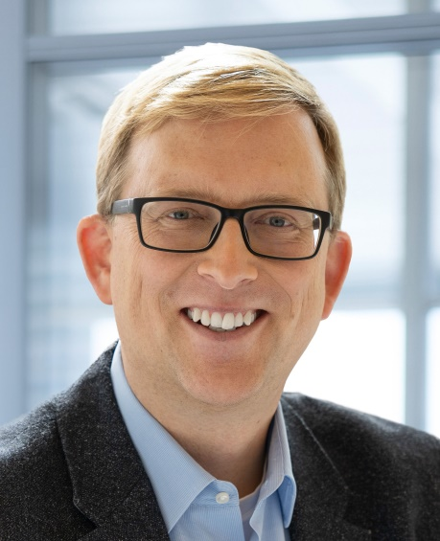
Bharath Yalla, managing director of Reifenhäuser (MEA) | Manish Mehta, managing director of Reifenhäuser India |  | Dr. Philip Nising, President and CEO of BUSS AG


Further information:
Marco Senoner, BUSS AG
Hohenrainstrasse 10, CH-4133 Pratteln
Tel.: +41(0) 61/825 65 51, Fax: +41(0) 61/825 66 88
Email: marco.senoner@BUSScorp.com;

Editorial contact and voucher copies:
Dr.-Ing. Jörg Wolters, KONSENS Public Relations GmbH & Co. KG,
Im Kühlen Grund 10, D-64823 Gross-Umstadt
Tel.: +49(0) 60 78/93 63-13, Fax: +49(0) 60 78/93 63-20
Email: joerg.wolters@konsens.de; www.konsens.de
Text and images for BUSS press releases are available for download from: https://www.konsens.de/en/press-releases/buss-ag

