Press Release
Repsol choose BUSS LSHC™ Technology to produce high-purity XLPE cable compounds
First-of-its-kind plant for the production of EHV AC & DC cable insulation materials to be built in Tarragona, Spain

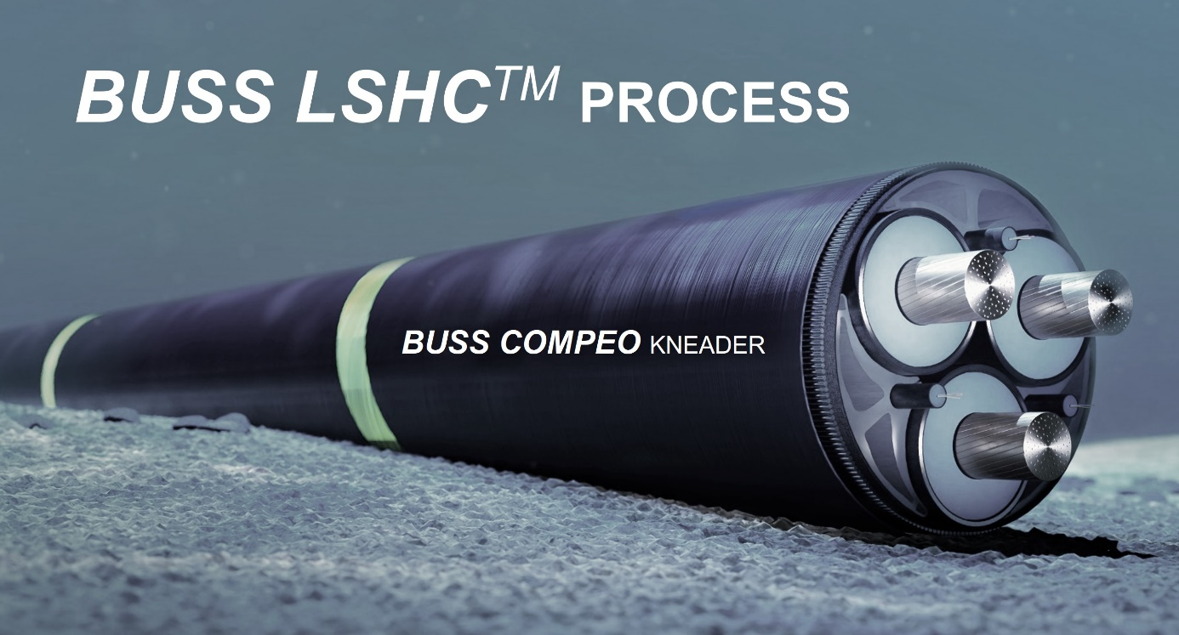
Repsol will use a first-of-its-kind energy-efficient process to produce high-purity XLPE cable compounds, based on BUSS’ LSHC process (Linear Short Hyper Clean).
© Buss/Shutterstock
Pratteln/Switzerland, June 2022. Buss AG has been awarded a contract for the realization of a 27kta production plant for crosslinkable polyethylene XLPE cable compounds by Repsol, a global multi-energy company offering a wide range of solutions for different types of cables.
The new, patented LSHC™ process („Linear Short Hyper Clean“) has been developed by Buss AG in close cooperation with P&M Cable Consulting LLC, a Swiss based consulting firm in the field of cable compounds. It offers access to, among others, various High Voltage (HV) and Extra High Voltage (EHV) insulation materials, exhibiting superior product quality and process efficiency compared to the well-known soaking technology. XLPE grades for both, alternating (AC) or direct current (DC) cable applications are readily produced with this innovative and flexible process.
The LSHC™ technology relies on direct peroxide injection and gentle compounding of a newly developed additive cocktail by using BUSS state-of-the-art COMPEO™ co-kneader series, allowing at the same time for significantly reduced capital expenses and clean room requirements. Further advantages are the compact plant design without high-rise soaking tower and improved cleanliness and physical-electrical properties of the produced materials.
Buss AG is proud to work with Repsol on the realization of this first-of-its-kind industrial production plant and will eagerly continue the excellent collaboration towards the scheduled start-up in mid-2024. The LSHC™ technology is available to BUSS customers world-wide on the basis of a competitive licensing model. A corresponding pilot plant for production of HV and EHV materials will be available around the end of this year at the BUSS Campus in Pratteln, Switzerland.
BUSS is an international market leader in compounding systems for demanding applications. As the original manufacturer of the Co-Kneader technology, the company offers unique compounding solutions that set the benchmark for heat- or shear-sensitive applications in the plastics, aluminium, chemical and food industries. The core competence is customer and application specific solutions for advanced compounding tasks in line with the high demands on process technology and product quality as well as the continuously increasing technological market needs. BUSS has a strong global presence in wire and cable applications with reference plants for low voltage materials, HFFR compounds, filling compounds, conductive layers and insulation materials ranging from medium to extra-high voltage applications.
P&M Cable Consulting LLC has become the leading consulting firm in the Wire and Cable industry, established in 1993. Thanks to its lifelong experience in the field, P&M Cable Consulting supplies the most advanced expertise over five continents.

For further details please contact:
Krischan Jeltsch, BUSS AG
Hohenrainstrasse 10, CH-4133 Pratteln
Phone: +41(0) 61/825 63 06
Email: krischan.jeltsch@BUSScorp.com; www.BUSScorp.com

Editorial contact, and please send voucher copies to:
Dr.-Ing. Jörg Wolters, KONSENS Public Relations GmbH & Co. KG
Im Kühlen Grund 10, D-64823 Gross-Umstadt
Phone: +49(0) 60 78/93 63-13
Email: joerg.wolters@konsens.de; www.konsens.de
Texts and images of BUSS’ press releases are ready for download at https://www.konsens.de/buss.

