Press Release
Tyre Recycling Solutions (TRS) choose BUSS Compounding Technology to manufacture performance materials from used tires
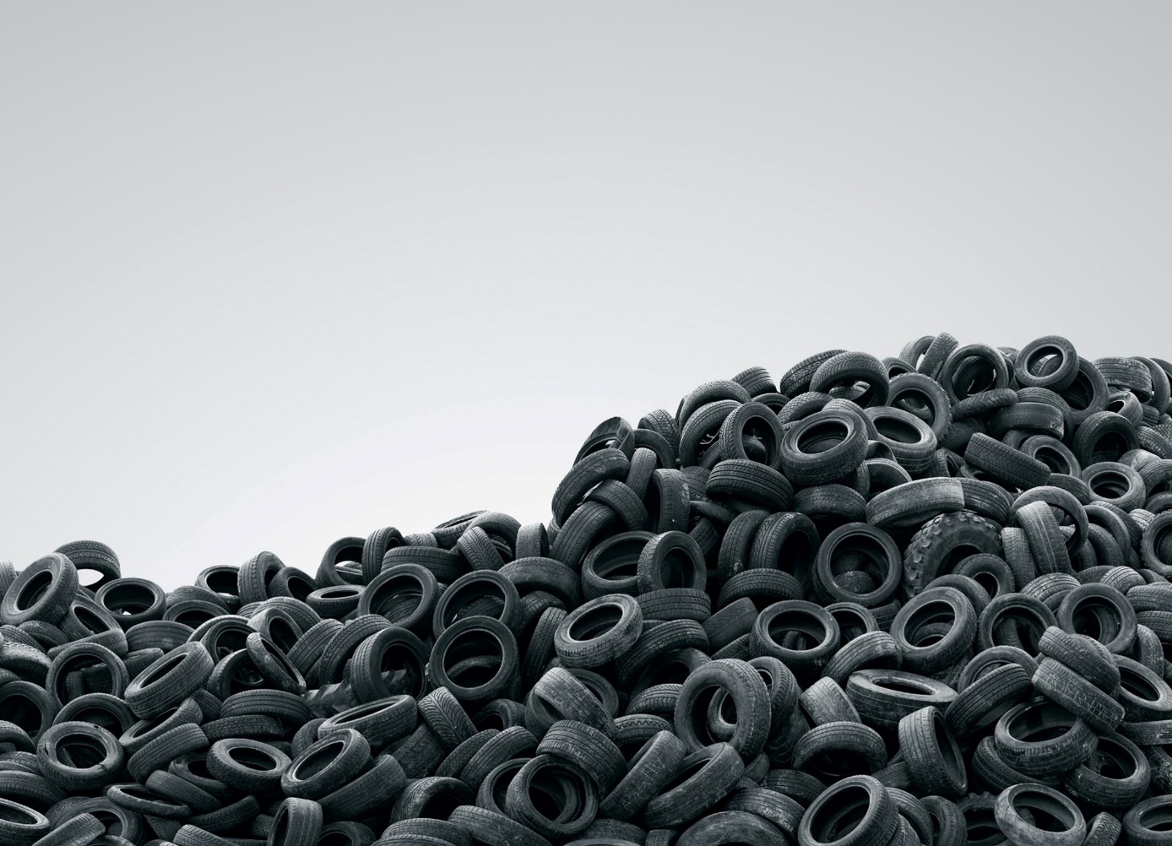
Tyre Recycling Solutions will use BUSS’ Compeo compounding technology to transform end-of-life tires into innovative and valuable compounds. © Shutterstock
Pratteln/Switzerland, July 2022. The Swiss innovator and scale-up company Tyre Recycling Solutions SA (TRS), Préverenges, has chosen BUSS’s COMPEO™ technology for implementation of their trs Intelligent Compounding© concept, which transforms powder products obtained from recycled end-of-life tires into innovative and valuable compounds at industrial scale.
TRS’s performance materials, which require a specific, proprietary compounding process of TPE/TPU based resins with recycled rubber powder, bring a truly green transformation to a wide range of applications – from gaskets, logistics, automotive and construction industry to footwear and 3D printing.
After extensive market and technology research, TRS specialists chose COMPEO™ compounding technology for its unique combination of powerful, low shear mixing with a conical discharge pump (CDP) unit for pressure build-up.
BUSS’ technical expertise in the handling of elastomers and the possibility of pilot scale production campaigns at the BUSS Campus in Pratteln has helped TRS with the development and evaluation of their innovative products until the commissioning of TRS’ own compounding plant in early 2022.
Both companies are working closely together to grow the product platform globally and install further compounding plants within the TRS licensing universe. The successful implementation of this ground-breaking innovation represents a true, ecologically sound solution to remove the >1.5 billion scrap tires discarded every year worldwide. In some countries, scrap tires still end up into landfills and are often burnt, creating toxic smoke and contaminants leeching into the environment. By compounding the powder from waste car and truck tires obtained by TRS technology into TPE/TPU resins, not only the tire waste is recycled, but performant sustainable materials are generated which add value in a wide range of applications.
BUSS is a global leader in compounding systems for demanding applications. As the original manufacturer of the reciprocating Co-Kneader technology, BUSS offers unique compounding solutions that continue to set the standard for heat or shear critical applications in the plastics, aluminum, chemical and food industries. The core competence is customer and application specific solutions for advanced compounding tasks in line with the high demands on process technology and product quality as well as the continuously increasing technological market needs. The performance strength and investment security in BUSS compounding systems can be summarized in two words: Swiss quality. All of this makes the company a leading supplier of high-quality compounding technology.
Tyre Recycling Solutions SA (TRS) was founded in 2013 in Switzerland with the aim of enabling sustainable recycling of the materials contained in scrap tyres. TRS has developed Swiss proprietary technologies to process scrap tyres and deliver output products with significant value-in-use.
Creator of a circular economy solution, TRS is a technology developer and integrator. TRS has developed a toolbox of technologies and know-how to implement the best available process. The cornerstones of TRS’ toolbox are rubber powder functionalization technologies, powder chemical coating treatment, a unique water milling technology and intelligent compounding. TRS implements technologies and processes into tyre recycler operations, enabling them to become a supplier of a unique specialty chemical – TyreXol™ rubber powders. TRS relies on in-house “Intelligent Compounding©” to commercialize TyreXol™ rubber powders in specific market applications. As the youngest addition, TyreXol™ rubber powders are compounded with recycled thermoplastics to generate TyreXol™ TPE, with a recycling content of up to 98%. At the center of a transformation, TRS solves a hazardous waste issue, creating value for existing players of the recycling chain, providing cost-efficient new materials and unique compounding solutions.

For further details please contact:
Krischan Jeltsch, BUSS AG
Hohenrainstrasse 10, CH-4133 Pratteln
Phone: +41(0) 61/825 63 06
Email: krischan.jeltsch@BUSScorp.com; www.BUSScorp.com

Or at TRS:
salestyrexol@trs-ch.com:

Editorial contact, and please send voucher copies to:
Dr.-Ing. Jörg Wolters, KONSENS Public Relations GmbH & Co. KG
Im Kühlen Grund 10, D-64823 Gross-Umstadt
Phone: +49(0) 60 78/93 63-13
Email: joerg.wolters@konsens.de; www.konsens.de
Texts and images of BUSS’ press releases are ready for download at https://www.konsens.de/buss.

