Buehler ITW Test & Measurement:
85 years of preparation and testing of material samples

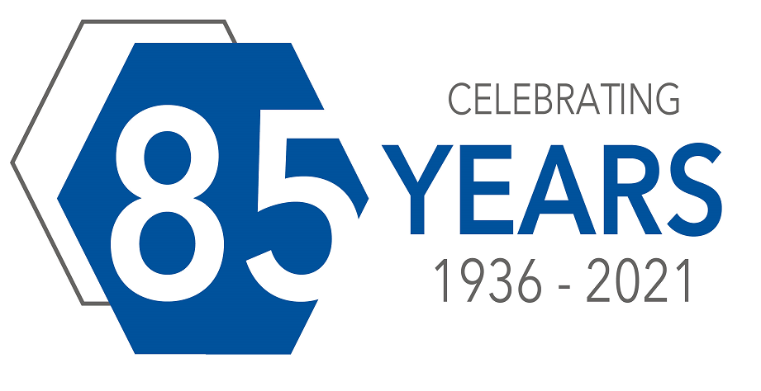
Leinfelden-Echterdingen, Germany, December 2021 - Buehler ITW Test & Measurement, headquartered in Lake Bluff, Illinois/USA, is celebrating 85 years in the business of preparation and testing equipment for materials including metals, ceramics, glass and plastics in key industries such as aerospace, automotive, metal and electronics, among others
Buehler was founded in 1936 by Swiss immigrant, Adolph I. Buehler, who saw a need for metallographic sample preparation equipment and optical inspection instruments for the steel and automotive industries in the Midwest USA. In the 1960s, the company expanded to Europe, and since 1979 it has also been represented in China. In Asia, there are subsidiaries in Shanghai, Tokyo and Hong Kong. In November 2021, the company relocated its Germany based European headquarters from Esslingen to Leinfelden-Echterdingen. With brands including Reicherter, Wolpert, Rockwell and Wilson hardness testers, Buehler has been part of Illinois Tool Works (ITW) since 2006, with worldwide distribution to currently over 100 countries and 45 Buhler Solutions Centres.
Says Eugenio Calderón, who was appointed Vice President of Buehler effective February 1st, 2021: "85 years of success in the market are based on our innovative and robust full-lab solutions, reliable service, and access to the knowledge that comes from serving the industry over this long period of time. We thank our customers for their loyalty and partnership, which will enable us to remain a global leader in instrumentation, equipment, consumables and application solutions for materials preparation and analysis."
Buehler – ITW Test & Measurement GmbH, Leinfelden-Echterdingen/Germany has been a leading manufacturer of instruments, consumables and accessories for metallography and materials analysis since 1936, and also supplies a comprehensive range of hardness testers and hardness testing systems. A dense network of branch offices and dealers means our customers can rely on professional assistance and service around the world. The Buehler Solutions Centers in Esslingen and Dusseldorf/Germany, Dardilly/France, Coventry/UK and elsewhere can offer all kinds of assistance with application questions or with devising reproducible preparation procedures.
Buehler is part of the Test and Measurement Segment of the US company Illinois Tool Works (ITW) with some 800 decentralized divisions in 52 countries and around 45,000 employees
For further information about products and services available from Buehler ITW Test & Measurement please visit https://www.buehler.com
Editorial contact and voucher copies:
Dr.-Ing. Jörg Wolters, Konsens PR GmbH & Co. KG,
Im Kühlen Grund 10, D-64823 Groß-Umstadt – www.konsens.de
Phone: +49 (0) 60 78 / 93 63 - 0, Fax: - 20, E-Mail: mail@konsens.de
Dear colleagues, Press releases from Buehler including text and pictures in printable resolution can be downloaded from https://www.konsens.de/buehler

