Castable (Cold) Mounting of Porous Samples for Metallography:
SimpliVacTM Vacuum Impregnation System with Automatic Cycle Control, Enhances Reliability and Efficiency
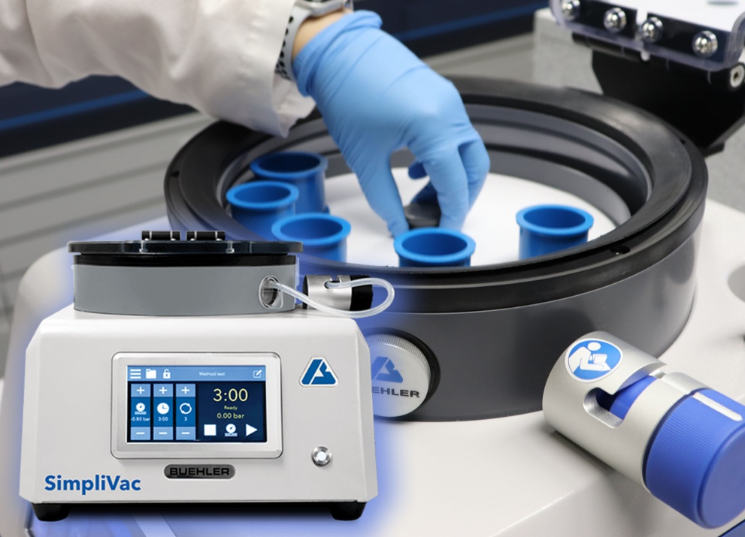 | SimpliVac is a compact vacuum impregnation system by Buehler – ITW Test & Measurement, for efficient and time-saving castable mounting of porous and heat-sensitive samples in epoxy resin.  © Buehler
Esslingen (Germany), January 2021 – SimpliVac™, the new castable vacuum mounting system by Buehler – ITW Test & Measurement GmbH, allows impregnation of porous samples or structures more efficiently by means of an automatic cycle control system. The system generates a vacuum – reliably, rapidly and efficiently, and without the need for an external pump. Thus, pores and cracks will be filled completely with epoxy resin, resulting in optimized edge retention for metallographic examinations. The system is also ideal for mounting delicate samples where pre-impregnation before sectioning and/or grinding ensures samples are well protected.
The number of cycles, the vacuum level and the time under vacuum can be set according to your needs. To optimize the mounting process, multiple cycles can be run without user intervention between cycles. Due to these special features, SimpliVac ensures consistent uniformity, even at high throughput, and reduces the time required to complete the mounting process. The large chamber diameter allows simultaneous mounting of multiple small samples. Alternatively, SimpliVac can also accommodate samples with larger dimensions. Its compact and small footprint allows more space on the lab bench.
The new vacuum impregnation system offers cold mounting solution of test samples to both quality control and/or research laboratories. Examples include electronics components, thermal spray coatings, additive manufactured components and other specialty aerospace surface treated test samples. Technicians or metallographers will appreciate the ability to optimize sample impregnation in a faster, more automated way. SimpliVac is easy to use. A video showing its simple operation is available at https://youtu.be/5bphC-lyUxY.
When it comes to hot compression mounting, the equivalent of the new SimpliVac is the SimpliMet™ 4000 by Buehler, for quick and reliable use. It is ideal for demanding industrial environments, both in terms of sample throughput and mounting quality.
Buehler – ITW Test & Measurement GmbH, Esslingen/Germany has been a leading manufacturer of instruments, consumables and accessories for metallography and materials analysis since 1936, and also supplies a comprehensive range of hardness testers and hardness testing systems. A dense network of branch offices and dealers means our customers can rely on professional assistance and service around the world. The Buehler Solutions Centers in Esslingen and Dusseldorf/Germany, Dardilly/France, Coventry/UK and elsewhere can offer all kinds of assistance with application questions or with devising reproducible preparation procedures.
Buehler is part of the Test and Measurement Segment of the US company Illinois Tool Works (ITW) with some 800 decentralized divisions in 52 countries and around 45,000 employees
For further information about products and services available from Buehler ITW Test & Measurement please visit https://www.buehler.com
Editorial contact and voucher copies:
Dr.-Ing. Jörg Wolters, Konsens PR GmbH & Co. KG,
Im Kühlen Grund 10, D-64823 Groß-Umstadt – www.konsens.de
Phone: +49 (0) 60 78 / 93 63 - 0, Fax: - 20, E-Mail: mail@konsens.de
Dear colleagues, Press releases from Buehler including text and pictures in printable resolution can be downloaded from https://www.konsens.de/buehler

