With customer satisfaction as goal: Buehler delivers metallographic products faster and provides enhanced services with specialist distributor OMNILAB
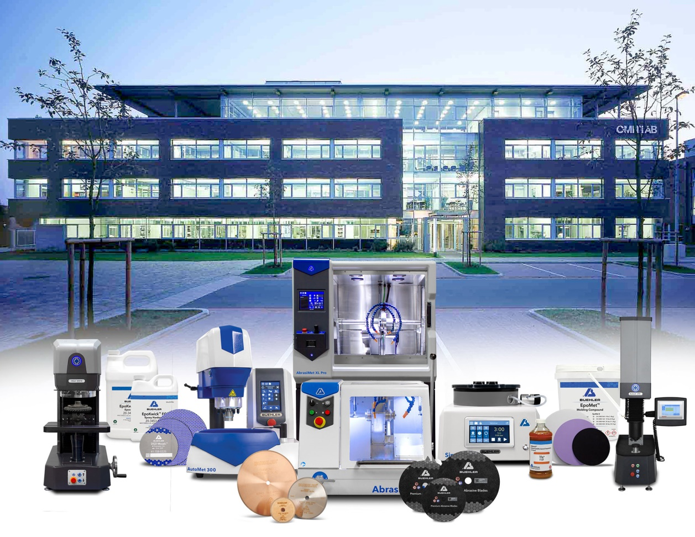
Buehler – ITW Test & Measurement and specialist laboratory distributor OMNILAB are jointly ensuring short delivery response times for metallography and hardness testing systems, spare parts and consumables. © Buehler, OMNILAB
Esslingen/Germany, December 2020 – Since October 2020, Buehler – ITW Test & Measurement GmbH, a leading manufacturer of metallographic and hardness testing equipment, consumables and accessories has been cooperating in a strategic partnership with OMNILAB-Laborzentrum GmbH & Co. KG, one of Germany's largest independent specialist laboratory distributors.
The objective of this collaboration for the EMEA region, is to boost efficiency and thus increase customer satisfaction. With an expanded inventory, response times for the delivery of equipment, spare parts and consumables have been shortened; this with a focus on customer service will accomplish this goal. Buehler's sales, service, marketing and application teams will continue to serve existing customers in Europe from the European headquarters in Esslingen and further sites in Germany, as well as in France and the United Kingdom.
OMNILAB, a family-managed company, offers individual service solutions and first-class customer care to the industrial and scientific markets. As CEO Nils Herrmann explains, “Doubling the number of products held in stock and extending shipping hours will make Buehler synonymous with rapid fulfillment and seamless customer service throughout Europe and the Middle East and parts of Africa too.”
Lutz Werner, Business Unit Manager for Buehler in Europe, adds: “The partnership with OMNILAB will strengthen the already deep trust our customers and partners have developed in Buehler over our 70 years of commitment to Europe. As ever, they will be able to rely on the technical expertise of our sales and service teams in material sample preparation, image analysis and hardness testing. And they will also benefit from the additional know-how and the logistical and organizational expertise of OMNILAB in supplying machines and consumables. All in all, this will enhance our ability to meet demand for innovative material sample preparation solutions quickly and expertly.”
OMNILAB, founded in 1935 and headquartered in Bremen, serves the research, industrial and scientific markets and is today a globally active laboratory equipment supplier delivering innovative products, consulting expertise and individual solutions for laboratory work. The group has some 140 employees in Germany and also has three international subsidiaries.
For further information about products and services available from OMNILAB, please visit https://www.omnilab.de.
Buehler – ITW Test & Measurement GmbH, Esslingen/Germany has been a leading manufacturer of instruments, consumables and accessories for metallography and materials analysis since 1936, and also supplies a comprehensive range of hardness testers and hardness testing systems. A dense network of branch offices and dealers means our customers can depend on professional assistance and service around the world. The Buehler Solutions Centers in Esslingen and Dusseldorf (Germany), Dardilly (France), Coventry (UK) and elsewhere offer all kinds of assistance with application questions or with devising reproducible sample preparation procedures. Buehler is part of the Test and Measurement Segment of the US company Illinois Tool Works (ITW) with some 800 decentralized divisions in 52 countries and around 45,000 employees.
For further information about products and services available from Buehler ITW Test & Measurement please visit https://www.buehler-met.de/
Editorial contact and voucher copies:
Dr.-Ing. Jörg Wolters, Konsens PR GmbH & Co. KG,
Im Kühlen Grund 10, D-64823 Groß-Umstadt – www.konsens.de
Tel.: +49 (0) 60 78 / 93 63 - 0, Fax: - 20, Email: mail@konsens.de
Press releases from Buehler including text and pictures in printable resolution can be downloaded from https://www.konsens.de/buehler

