Metallographers of Robert Röntgen Rely on Sample Preparation Systems from Buehler
PlanarMet 300 planar grinder and EcoMet AutoMet 300 grinder-polisher offer significant savings in time and consumables
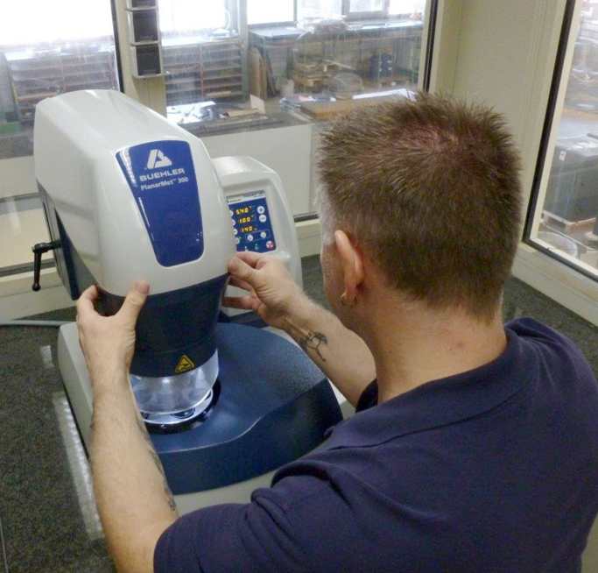 | 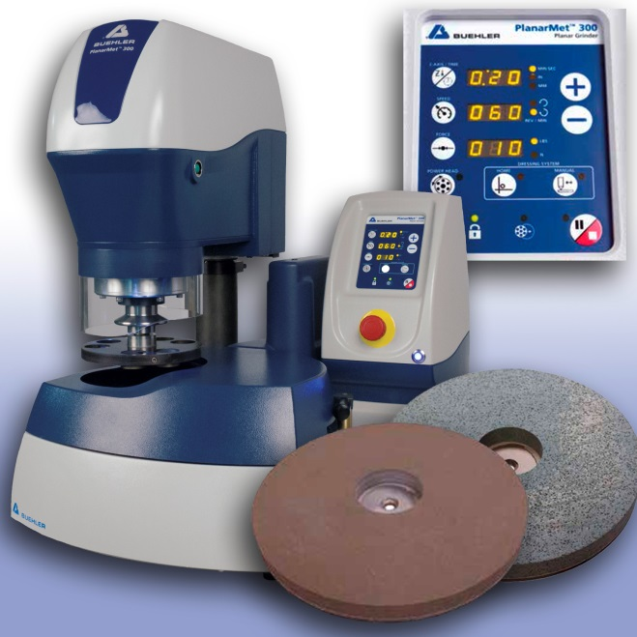
A PlanarMet 300 planar grinder from Buehler – ITW Test & Measurement enables extremely short preparation cycles and significant cost savings in the day-to-day operation of the metallographic laboratory at Robert Röntgen. | The PlanarMet 300 incorporates a fixed grinding stone for time-saving grinding of up to 10 samples in a central force sample holder  © Buehler – ITW Test & Measurement GmbH
Esslingen/Germany, January 2020 – Robert Röntgen GmbH & Co. KG one of the internationally leading manufacturers of saw bands and saw blades for metal cutting, based in Remscheid, Germany, are using a PlanarMet 300 planar grinder in combination with an EcoMet AutoMet 300 grinder-polisher from Buehler for time and cost efficient preparation of metallographic samples analysis in their laboratory.
The samples being prepared are segments of highly wear-resistant, carbide-tipped high-performance saw bands, used worldwide in applications such as high-speed sectioning of high strength steels. After preparation steps are carried out, the metallographic cross sections are checked for hardness, grain structure, and the quality of welded joints between the carbide tip and the steel substrate, followed by documentation of the results with a view to ensure strictest manufacturing tolerances and process reliability in accordance with ISO 9001:2015 are achieved.
The PlanarMet 300 table-top planar grinder was designed by Buehler specifically for fast, accurate and convenient sample preparation in metallography. Its 305 mm grinding stone that is easily interchangeable after prolonged use and wear, and a powerful motor provide ability for high material removal rates of up to 0.6 mm per minute – allowing grinding processes to be completed up to ten times faster than with traditional SiC paper. For higher sample throughput, sample holders that can hold up to ten samples are used, and when used with dedicated work stations allow shorter preparation time. Material removal can be programmed with an accuracy of up to 0.1 mm. All in all, PlanarMet 300 offers the same high performance as larger floor-standing models, whilst saving time, space and cost.
Alicja Kaplan, Laboratory Manager at Robert Röntgen reports: “Since purchasing the PlanarMet 300 planar grinder, the machine's high removal rate and superior accuracy have enabled us to achieve perfect sample surfaces within extremely short grinding cycles of only 8 to 10 min for six samples. In comparison, the grinding process took approximately five times longer with our previous system, despite the fact that we were using diamond grinding discs. Another significant benefit of the PlanarMet 300 grinder lies in that the drive adapter used in the machine's multi-sample holder is compatible with our EcoMet AutoMet 300 polishing system, thus eliminating additional setup times. The transition from grinding to polishing can be achieved within a minimum of time.”
Alicja Kaplan goes on to explain that the laboratory was also able to reduce its consumable spend. “Whereas in the previous set up, we needed up to three different diamond grinding discs to reach the target plane on the sample, we only need one SiC or Al₂O₃ stone when using the PlanarMet 300. Although the system is in operation for several hours every day in our lab, we need only two stones per year, resulting in considerable cost savings.”
Kaplan is also impressed with the level of service offered by Buehler. “We value the uncomplicated partnership, short response times and rapid delivery of consumables. In addition, we have strong, long-standing relationships with our contacts at Buehler, most of which have worked for Buehler for many years. They understand our requirements and help us to develop solutions ideally suited to our needs. For example, the Buehler team provided our laboratory with a PlanarMet 300 unit free of charge for trial purposes during the decision-making phase. On another occasion, Tobias Berger, the field engineer in charge of our region, who is also a trained metallographer, assisted us in the development of a new preparation method tailored specifically to our needs. We are well satisfied with this system, as it has enabled us to optimize preparation results, reduce preparation time and save on consumables, so that our staff are able to focus on other tasks in the laboratory. On the whole, the system enabled us to significantly increase efficiency in sample preparation, and the PlanarMet 300 system therefore paid for itself in a reasonable short period.”
Building on this strong, result-oriented and successful partnership, Robert Röntgen is also relying on other systems from Buehler: In addition to the PlanarMet300 planar grinder and the EcoMet Automet 300 grinder-polisher, the metallographic laboratory also uses SimpliMet 1000 compression mounting presses, AbrasiMet 250 sectioning machines, and a PolitMat 2 electrolytic polishing and etching unit. Kaplan is planning ahead: “We will be evaluating the acquisition of an automatic section system in the near future, and a system from Buehler will certainly be on the short list.”
Buehler – ITW Test & Measurement GmbH, Esslingen/Germany has been a leading manufacturer of instruments, consumables and accessories for metallography and materials analysis since 1936, and also supplies a comprehensive range of hardness testers and hardness testing systems. A tight network of branch offices and dealers means our customers can depend on professional assistance and service around the world. The Buehler Solutions Centre in Esslingen and further centres of this kind in Europe and elsewhere can offer all kinds of assistance with application questions or with devising reproducible preparation procedures.
Buehler is part of the Test and Measurement Segment of the US company Illinois Tool Works (ITW) with some 100 decentralized business units in 52 countries and around 51,000 employees
For further information about products and services available from Buehler ITW Test & Measurement please visit https://www.buehler.com
Editorial contact and voucher copies:
Dr.-Ing. Jörg Wolters, Konsens PR GmbH & Co. KG,
Hans-Kudlich-Straße 25, D-64823 Groß-Umstadt – www.konsens.de
Tel.: +49 (0) 60 78 / 93 63 - 0, Fax: - 20, E-Mail: mail@konsens.de
Dear colleagues, Press releases from Buehler including text and pictures in printable resolution can be downloaded from www.konsens.de/buehler.html

