Complete lab solutions for metallography and hardness testing from scratch in just a few weeks
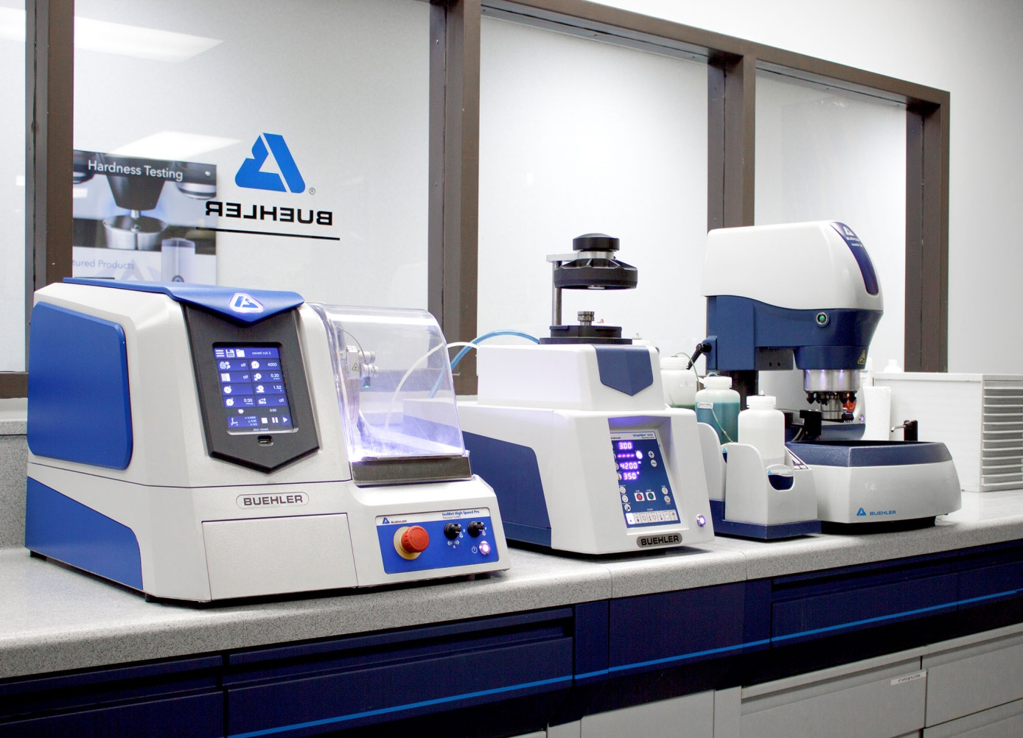
As a manufacturer and supplier, Buehler can meet short delivery times for the installation of complete lab solutions for materialographic investigations and hardness testing.
© ITW Test & Measurement GmbH
Esslingen, Germany, December 2019 – As a developer and manufacturer of complete system solutions for materialography and hardness testing, Buehler can meet short delivery times for the installation of fully equipped laboratories with perfectly matched equipment and consumables. The company is thus responding to the growing demand for innovative, intuitive and dependable equipment, for R&D as well as for quality monitoring in heat treatment, medical technology, electronics, automotive, aerospace and other industries.
Buehler's range of systems available for short delivery includes the Wilson VH3100 (Vickers) and Wilson Rockwell 574 hardness testers and associated DiaMet software and, for materialography, also ranges from IsoMet high-speed precision cutters to SimpliMet 4000 mounting presses, AutoMet and EcoMet grinders and polishers and the Burst Dispensing Systems up to the OmniMet image analysis software. An experienced application engineering team can give customers the dedicated all-round support they need to choose the ideal configuration for their particular tasks.
Buehler’s sales manager Raphael Ayasse comments: “When it comes to installing and updating test laboratories, companies and institutions are no longer willing to accept long delivery times. As a manufacturer of such devices and systems, Buehler is capable of equipping a fully functional laboratory in under four weeks.”
Buehler – ITW Test & Measurement GmbH, Esslingen/Germany has been a leading manufacturer of instruments, consumables and accessories for metallography and materials analysis since 1936, and also supplies a comprehensive range of hardness testers and hardness testing systems. A dense network of branch offices and dealers means our customers can depend on professional assistance and service around the world. The Buehler Solutions Centre in Esslingen and further centers of this kind in Europe and elsewhere can offer all kinds of assistance with application questions or with devising reproducible preparation procedures.
Buehler is part of the Test and Measurement Segment of the US company Illinois Tool Works (ITW) with some 100 decentralized business units in 52 countries and around 51,000 employees
For further information about products and services available from Buehler ITW Test & Measurement please visit https://www.buehler.com
Editorial contact and voucher copies:
Dr.-Ing. Jörg Wolters, Konsens PR GmbH & Co. KG,
Hans-Kudlich-Straße 25, D-64823 Groß-Umstadt – www.konsens.de
Phone: +49 (0) 60 78 / 93 63 - 0, Fax: - 20, E-Mail: mail@konsens.de
Dear colleagues, Press releases from Buehler including text and pictures in printable resolution can be downloaded from www.konsens.de/buehler.html

