Marek Domanski new Operations Director at Buehler ITW Test & Measurement – Focus on supply security
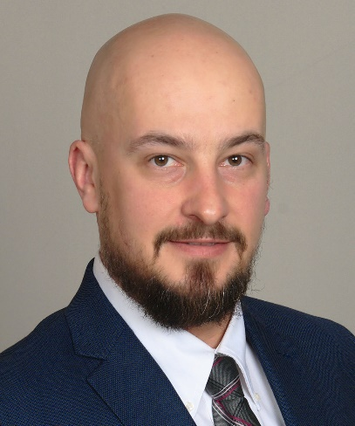
Mark Domanski is Buehler ITW Test & Measurement‘s new Operations Director.
Leinfelden-Echterdingen/Germany, June 2022 – Marek Domanski has been Operations Director at Buehler ITW Test & Measurement since the beginning of the year. From the company's headquarters in Lake Bluff/Il, USA, he coordinates and manages the production and sourcing of suppliers of all the company's systems for materialography and hardness testing. Domanski comes from Loma, the manufacturer of inspection equipment for the food, packaging and pharmaceutical industries, which is also part of the group, where he managed production, purchasing and quality assurance for three years. Prior to that, he gained 14 years of experience in production at other industrial companies. He cites short delivery times and reliable delivery dates as primary goals in order to give customers worldwide planning security, even in the face of the current, general shortages of raw materials and primary products.
According to Domanski, one target-oriented measure is the intensive cooperation with the company’s key suppliers. "In order to proactively meet Buehler's medium-term needs, we continuously work with our suppliers to improve our communication and their delivery, giving them all the support, they need from us to be better partners. In some cases, we plan up to 50 weeks in advance to ensure the availability of the components needed for our systems. We also work together to develop secondary sources for parts that are in short supply in the market, and we increase our own stock levels for critical components."
"Supply security is a supporting pillar of the trusting cooperation with our customers," says Domanski. "In order to achieve further improvements here despite all the uncertainties in the political situation, we are tapping all the resources in the supply chain that are still unused. In this context, we are also intensively reviewing our own processes, and we are working on further expanding our supplier base as well as improving the supply chain and lead times for raw materials for important components."
Buehler – ITW Test & Measurement GmbH, Leinfelden-Echterdingen/Germany has been a leading manufacturer of instruments, consumables and accessories for metallography and materials analysis since 1936, and also supplies a comprehensive range of hardness testers and hardness testing systems. A dense network of branch offices and dealers means our customers can rely on professional assistance and service around the world. The Buehler Solutions Centers in Esslingen and Dusseldorf/Germany, Dardilly/France, Coventry/UK and elsewhere can offer all kinds of assistance with application questions or with devising reproducible preparation procedures.
Buehler is part of the Test and Measurement Segment of the US company Illinois Tool Works (ITW) with some 800 decentralized divisions in 52 countries and around 45,000 employees
For further information about products and services available from Buehler ITW Test & Measurement please visit https://www.buehler.com
Editorial contact and voucher copies:
Dr.-Ing. Jörg Wolters, Konsens PR GmbH & Co. KG,
Im Kühlen Grund 10, D-64823 Groß-Umstadt – www.konsens.de
Phone: +49 (0) 60 78 / 93 63 - 0, Email: mail@konsens.de
Dear colleagues, press releases from Buehler including text and pictures in printable resolution can be downloaded from https://www.konsens.de/buehler

