Buehler Webinar:
Fundamentals for Efficient Sample Preparation
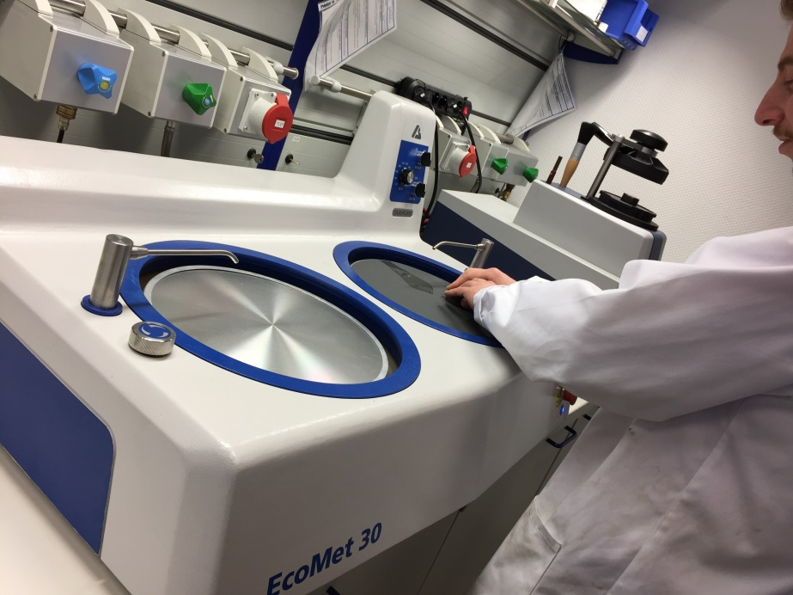
Esslingen/Germany, June 2020 – In a one-hour webinar, Buehler, an ITW company, will take attendees through the fundamentals of efficient preparation of metallographic samples for microstructure analysis or hardness testing on 30 June 2020 from 11:00 AM CEST. Metallographic preparation involves multiple stages that present challenges relating to equipment, consumables, and what are the optimal settings for a fast and reproducible preparation. The key concepts will be applicable to industrial and research laboratory environments with low or high sample throughputs.
Instructions on material selection and preparation processes will help the participants, to
- recognize common problems in preparation approach,
- identify improvement opportunities in their current approach,
- find the right information for their material and application, and
- optimize the preparation process for time, cost and quality.
The free webinar is primarily aimed at metallurgical technicians, engineers, quality control staff or laboratory managers. The registration can be done via https://www.buehler-met.de/buehler-webinar-registration.php. Participants will receive a confirmation of participation after the webinar. For interested parties who cannot use the date, Buehler will provide a recording shortly after the event.
Buehler – ITW Test & Measurement GmbH, Esslingen/Germany has been a leading manufacturer of instruments, consumables and accessories for metallography and materials analysis since 1936, and also supplies a comprehensive range of hardness testers and hardness testing systems. A dense network of branch offices and dealers means our customers can depend on professional assistance and service around the world. The Buehler Solutions Centre in Esslingen and further centers of this kind in Europe and elsewhere can offer all kinds of assistance with application questions or with devising reproducible preparation procedures.
Buehler is part of the Test and Measurement Segment of the US company Illinois Tool Works (ITW) with some 100 decentralized business units in 52 countries and around 51,000 employees
For further information about products and services available from Buehler ITW Test & Measurement please visit https://www.buehler.com
Editorial contact and voucher copies:
Dr.-Ing. Jörg Wolters, Konsens PR GmbH & Co. KG,
Im Kühlen Grund 10, D-64823 Groß-Umstadt – www.konsens.de
Phone: +49 (0) 60 78 / 93 63 - 0, Fax: - 20, E-Mail: mail@konsens.de
Dear colleagues, Press releases from Buehler including text and pictures in printable resolution can be downloaded from
https://www.konsens.de/en/press-releases/buehler-itw-test-measurement-gmbh

