For Metals, Plastics and Carbon Materials:
New Hardness Tester Wilson RH2150 Brings Maximum Flexibility to Industry and Research
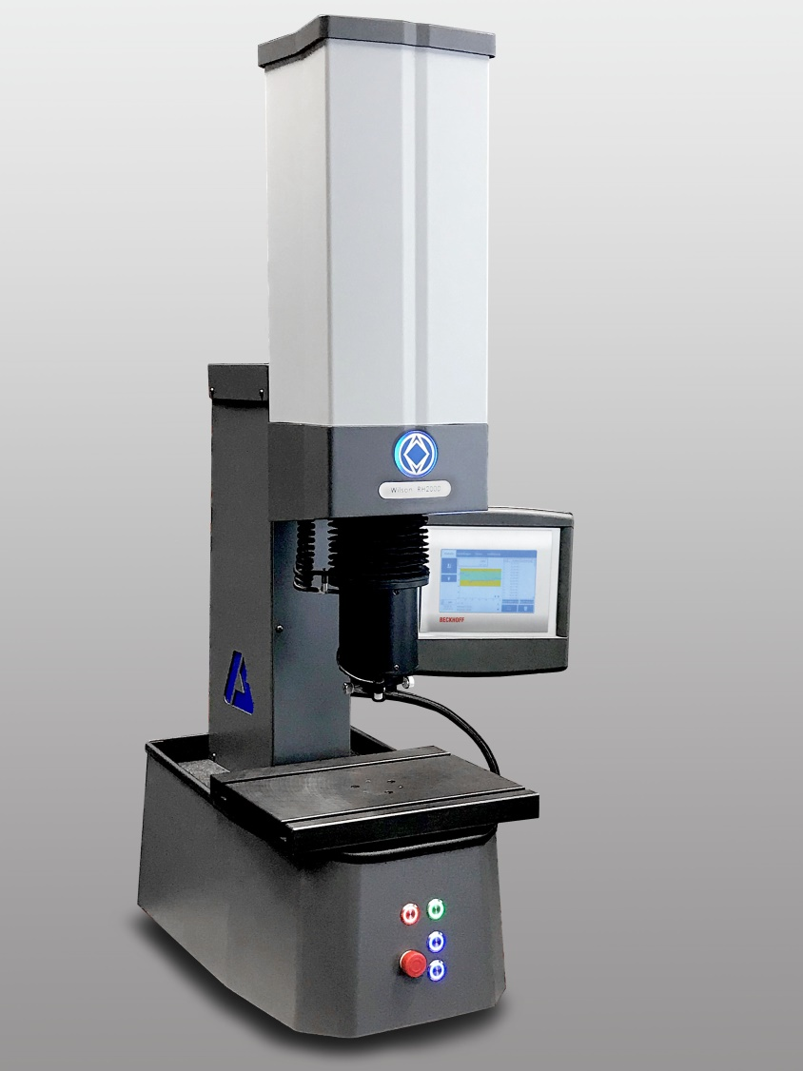 | With its vast amount of testing scales, the new Wilson RH2150 hardness tester by Buehler – ITW Test & Measurement is an appropriate solution for a large range of applications in quality control and research environments. © Buehler
Esslingen/Germany, November 2020 – The new Wilson RH2150 represents the next generation of hardness testers by Buehler – ITW Test & Measurement GmbH, a leading manufacturer of instruments, consumables and accessories for materialography and hardness testing. Based on the concept of the proven, globally used RB2000 and offering a large range of testing scales and newly developed functions, the RH2150 meets today's testing requirements. Due to its numerous accessories, it is capable of testing many different parts and components, – whether in high-volume production applications in quality control or in the R&D lab.
With its completely new user interface and advanced statistical calculations, results graphing and easy test programmability, the Wilson RH2150 optimizes testing processes. Via an integrated USB interface, results can be exported as csv and/or txt file on a memory device. The optional, individually configurable DiaMet™ test software with its further advanced programming and export functions provides for additional flexibility.
The new Wilson RH2150 series is available in two configurations for different load ranges. Whereas the Regular version is appropriate for the regular Rockwell scale, the Twin version also allows measuring in the superficial Rockwell scale. In addition, both can be used for Brinell depth testing with up to 187.5 kgf and for und ball indentation testing that is common in the plastics and the carbon industry. The maximum specimen heights are 10″ (254 mm) with size 1 and 14″ (356 mm) with size 2 of the tester. The maximum specimen weight is 50 kg (centered on anvil).
A number of special features provide for easy working without compromising on safety and efficiency. These include the innovative clamping device that fixes the part securely on the tester and provides stability during testing, the adjustable LED for optimum workspace illumination, indenter extensions for testing on more complex shapes as well as rigid control buttons for automatic testhead movement and test initiation. With the design and manufacturing of the RH2150 tester, the DiaMet software and test blocks all in-house by Buehler, system integration is guaranteed.
Buehler's Hardness Product Manager Matthias Pascher explains: "The trend towards ever tighter manufacturing tolerances and more advanced heat treatment methods in the automotive and aerospace industries require hardness testing systems to be durable while maintaining precise control during critical test data generation. They must be easy to use, yet flexible enough to meet the increasing demands in the industries. The new Wilson RH2150 meets these demands: This reliable and easy-to-use system offers superior accuracy and repeatability against low training requirements. The DiaMet software package enables the system to be controlled via the user interface, automatic reporting and full traceability of test results thanks to the integrated DiaMet database."
Buehler – ITW Test & Measurement GmbH, Esslingen/Germany has been a leading manufacturer of instruments, consumables and accessories for metallography and materials analysis since 1936, and also supplies a comprehensive range of hardness testers and hardness testing systems. A dense network of branch offices and dealers means our customers can depend on professional assistance and service around the world. The Buehler Solutions Centers in Esslingen and Dusseldorf/Germany, Dardilly/France, Coventry/UK and elsewhere can offer all kinds of assistance with application questions or with devising reproducible preparation procedures.
Buehler is part of the Test and Measurement Segment of the US company Illinois Tool Works (ITW) with some 800 decentralized divisions in 52 countries and around 45,000 employees
For further information about products and services available from Buehler ITW Test & Measurement please visit https://www.buehler.com
Editorial contact and voucher copies:
Dr.-Ing. Jörg Wolters, Konsens PR GmbH & Co. KG,
Im Kühlen Grund 10, D-64823 Groß-Umstadt – www.konsens.de
Phone: +49 (0) 60 78 / 93 63 - 0, Fax: - 20, E-Mail: mail@konsens.de
Dear colleagues, Press releases from Buehler including text and pictures in printable resolution can be downloaded from https://www.konsens.de/buehler

