'Open Week' at Buehler ITW Test & Measurement:
Live Experience: State-of-the-Art Sample Preparation and Hardness Testing
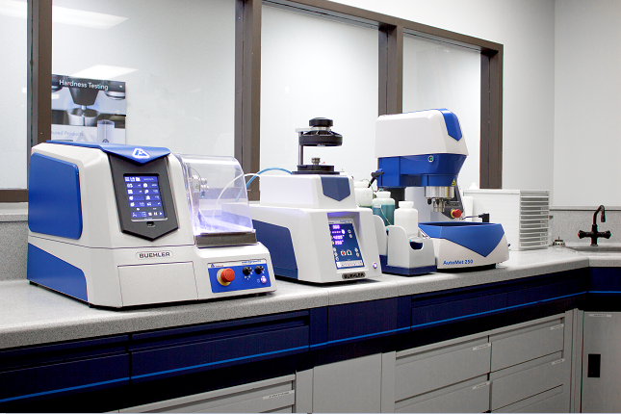The spacious laboratory at Buehler's new European location is equipped with state-of-the-art technology for the preparation of metallographic samples and hardness testing. © Buehler
Leinfelden-Echterdingen, Germany, April 2022 – From May 2 to May 6, 2022, Buehler ITW Test & Measurement GmbH invites to the opening of the laboratory at its new European location in Leinfelden-Echterdingen. Conveniently located next to Stuttgart Airport and Stuttgart Trade Fair Centre, the company will be demonstrating its potential for solving specific tasks in quality assurance and materials science during this 'Open Week'. This gives visitors from industry, research and teaching the opportunity to experience cutting-edge technology for the preparation of metallographic samples and observe the latest generation of hardness testers in practical use. Moreover, visitors may want to bring along some material samples to find out, together with Buehler's specialists, which preparation technique is the most appropriate for them.
Dr. Lutz Werner, Business Unit Manager for EMEA of Buehler ITW Test & Measurement, points out: "An added plus for visitors is the fact that the international "Control" trade fair will take place simultaneously in the nearby Trade Fair Centre. Thus, they can attend both events with hardly any additional travel expense." Buehler itself will not be represented at Control this year. Dr. Werner explains: "Even in view of the general trend towards opening, it is not really clear how and to what extent an international trade fair can take place. For this reason, we have decided to offer our customers a more personal experience in a controlled environment. Our 'Open Week' will be the ideal framework for this and provide ample opportunities, as we can discuss demanding tasks there on an individual basis in a manageable setting."
Participants can use the form at https://www.buehler.com/uk/buehler-open-house/ to register and indicate their preferred date and time of visit. Buehler will take care of the transfer from Stuttgart Trade Fair Centre, Stuttgart Airport or the city centre – all just a few minutes' ride from Buehler. The German 3G rule will apply (i. e. all visitors must be vaccinated, recovered, or tested negative). Covid-19 tests for self-testing will be offered on site free of charge.
Buehler – ITW Test & Measurement GmbH, Leinfelden-Echterdingen/Germany has been a leading manufacturer of instruments, consumables and accessories for metallography and materials analysis since 1936, and also supplies a comprehensive range of hardness testers and hardness testing systems. A dense network of branch offices and dealers means our customers can rely on professional assistance and service around the world. The Buehler Solutions Centers in Esslingen and Dusseldorf/Germany, Dardilly/France, Coventry/UK and elsewhere can offer all kinds of assistance with application questions or with devising reproducible preparation procedures.
Buehler is part of the Test and Measurement Segment of the US company Illinois Tool Works (ITW) with some 800 decentralized divisions in 52 countries and around 45,000 employees
For further information about products and services available from Buehler ITW Test & Measurement please visit https://www.buehler.com
Editorial contact and voucher copies:
Dr.-Ing. Jörg Wolters, Konsens PR GmbH & Co. KG,
Im Kühlen Grund 10, D-64823 Groß-Umstadt – www.konsens.de
Phone: +49 (0) 60 78 / 93 63 - 0, Fax: - 20, E-Mail: mail@konsens.de
Dear colleagues, press releases from Buehler including text and pictures in printable resolution can be downloaded from https://www.konsens.de/buehler

