September 2019

AGC Chemicals at K 2019:
Functionalised Fluoropolymers for Innovative Material Combinations and Ion Exchange Membranes for a Range of Applications
At K 2019, AGC Chemicals Europe (www.agcce.com), a leading manufacturer of fluoroplastics and the world's largest producer of ETFE (ethylene-tetrafluoroethylene copolymer) and ion exchange membranes, will be showcasing new applications for functionalised fluoropolymers in Hall 7a, Stand C12 as well as further developments in PEEK compounds, fluoroelastomers and ion exchange membranes.
Reactive Fluoropolymers for Innovative Material Combinations
AGC's functional fluoropolymers, marketed under the Fluon + brand, are based on an innovative technology that allows for functionalisation during the polymerisation stage. These high-performance polymers that are modified with reactive groups are ideal for innovative combinations of materials, as compatibilisers for novel polymer blends or in composite and sandwich constructions. In this way thermoplastic composites with certain fluoropolymer properties, for example, can be produced, which also have excellent fibre-matrix adhesion and therefore good mechanical properties.
The new Fluon + ™ EA-2000 is particularly suitable for the production of high-speed PCBs or Copper Cladded Laminates (CCL). The adhesive properties of the product make it possible to produce ultra-thin dielectric coatings on copper or other metals that have very low surface roughness. This enables extremely high data transfer rates as required for innovative technologies such as the mobile phone standard, 5G, or IoT (Internet of Things).
Modified PEEK compounds
AGC's new fluoropolymer-modified PEEK compounds have improved flexibility, impact resistance, wear resistance and better electrical properties than standard grades. They are suitable for the production of semi-finished products such as plates, rods and tubes, for gears, housings, wire and cable sheathing and foils. They can be processed by extrusion and injection moulding.
Fluoroelastomers for Outstanding Media Resistance in Automotive Applications
AFLAS® FEPM fluoroelastomers from AGC consist of alternating monomers of tetrafluoroethylene and propylene. This gives them excellent temperature, chemical, fuel, acid, base, solvent, ozone and vapor resistance. The new AFLAS® grades 400E and 600X have been developed for a new laminating technology for the production of media-resistant multi-layer hose assemblies for the automotive industry. They are ideal for applications in the automotive engine room where hoses are subjected to high service temperatures and pressures, as well as nitrogen and sulphur oxides, engine oils or other highly aggressive media.
Market-leading Range of Ion Exchange Membranes
The FORBLUETM family was launched in 2017 and is AGC´s new brand for providing solutions for separating various chemicals and will be exhibited at K 2019. It consists of:

- FORBLUETM S-series is a fluorinated cation exchange membrane based on sulfonic acid polymer that offers a variety of functions depending on grade (high ion selectivity or very low resistance with high mechanical strength and chemical resistance).

- FORBLUETM FLEMIONTM is a fluorinated cation exchange membrane that offers extremely low resistance and is the preferred product by many customers in the Chlor Alkali Industry. It minimises the influence of impurities on membranes by investigating the mechanisms of impurities effects. As a result of this process, membranes can achieve stable long-term performance.
- FORBLUETM SELEMIONTM is a pioneer ion-exchange membrane with long experience since 1950. It can dilute and concentrate ionic materials in a solution and offers solutions for purifying wastewater and recovering and refining valuable materials. A laboratory scale electrodialyzer with SELEMIONTM will also be exhibited.
- FORBLUETM sunsepTM is a tubular membrane module that utilises hollow fibres processed from perfluorinated cation exchange polymer with high moisture-selectivity. It generates dry air necessary for pneumatic devices and also functions as key component for gas analytical devices.

About AGC and AGC Chemicals
AGC is one of the world's leading manufacturers of glass, chemicals, electronic materials and ceramics and the world's largest producer of automotive and flat glass, ETFE fluoroplastic and ion exchange membranes. Headquartered in Tokyo, Japan, AGC employs approximately 53,200 people worldwide and is one of the largest companies in the Mitsubishi Group. It is listed on the Tokyo Stock Exchange and was named by Thomson Reuters as one of the Top 100 Global Innovators. The products are used in the automotive and aerospace industries, in architecture, in sports arenas, greenhouses, refrigeration and air conditioning, pharmaceutical and agrochemical applications and in the extraction of minerals, oil and gas. Fluon®, the leading brand for ETFE, is widely used in the automotive industry due to its low weight. The Fluon® brand also includes ETFE films, PTFE and PFA. Other well-known trademarks of AGC Chemicals include AFLAS® (fluorinated rubbers), AMOLEA ™ (refrigerant gases and solvents), AsahiGuard® (water and oil repellents), CYTOP ™ (amorphous fluoroplastics), F-CLEAN ™ (ETFE greenhouse films), Flemion ™ (ion exchange membranes), LUMIFLON ™ (FEVE, paint soluble additives) & PREMINOL ™ (polyols for polyurethanes).

For more information visit: www.agcce.com
END
Contact at AGC Chemicals Europe:
Karolina Zielony
e-mail: marketing@agcce.com
Phone: + 44 (0) 1253 209-560, -567

Editorial Contact:
Konsens PR GmbH & Co. KG
Barbara Welsch
e-mail: mail@konsens.de
Phone: +49 (0) 6078 936314
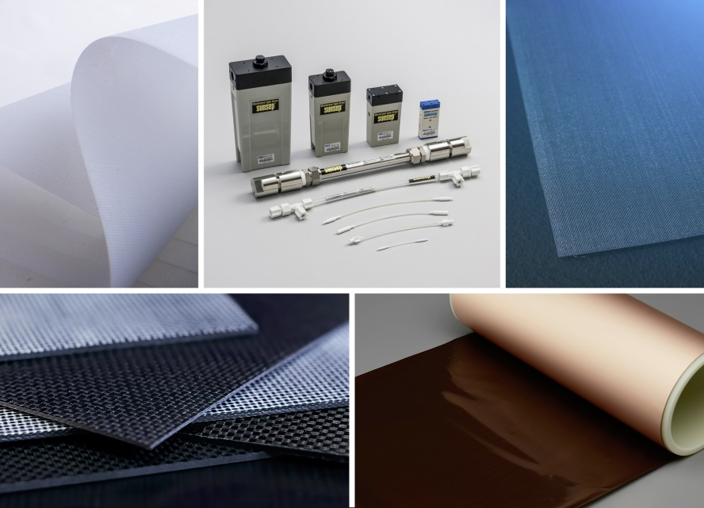
At the K show AGC showcases its full range of FORBLUE ™ ion exchange membranes as well as Fluon+ functional fluoropolymers, that make possible, for example, novel composite materials and material combinations for structural and communication applications.
Image: AGC Chemicals Europe
Press releases from AGC Chemicals Europe with text and images in printable resolution can be downloaded from www.konsens.de/AGC-Chemicals.html

