Keller at StocExpo Europe 2019:
CMM® Columns with Mixed Moduli Enable Time-saving and Cost-efficient Tank Farm Foundations
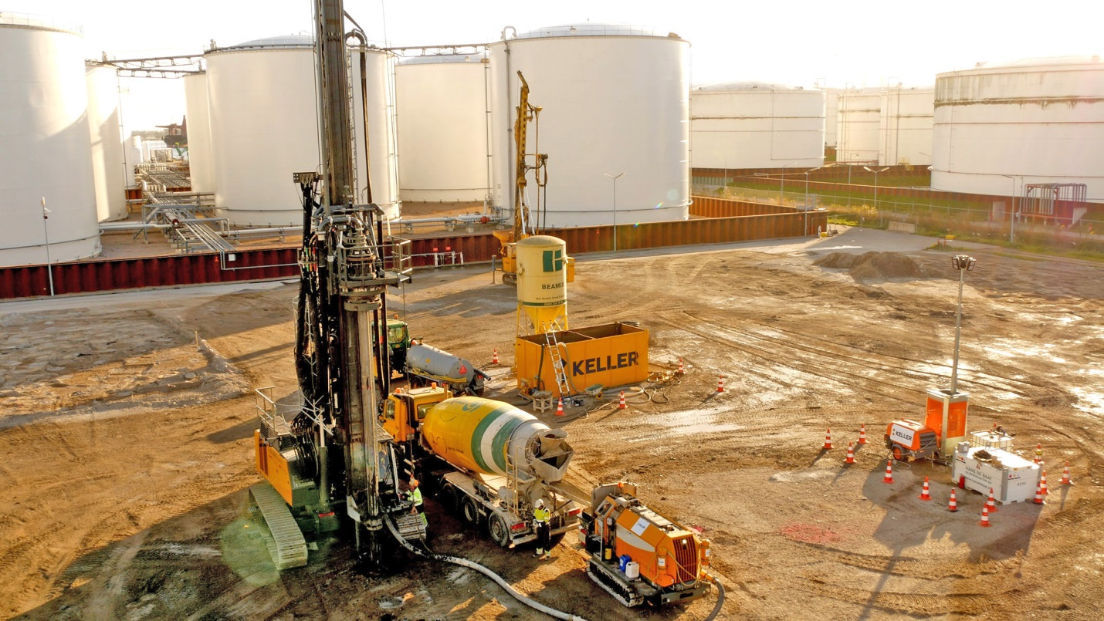
The expansion of GPS Group's Amsterdam Westpoort tank farm is a current example of the customized ground improvement and foundation technologies offered by Keller worldwide. Photo © Keller
Offenbach / Germany, February 2019 --- At StocExpo Europe, the leading international event for the bulk liquid storage industry, which will be held from 26 to 28 March in Rotterdam/The Netherlands, Keller will be presenting on stand J3 its expertise as an experienced provider of a wide range of geotechnical services in the area of tank farm foundation. Illustrating its capabilities, the company will highlight its recent contribution towards the expansion of GPS Group's tank farm at Amsterdam Westpoort (GPSA). Using its technology of CMM® Columns with Mixed Moduli Keller provided a customized, streamlined solution for the reliable foundation for this tank farm in a challenging, soft soil, offering significant time and cost savings over conventional deep foundations with driven piles.
Beyond, visitors to the Keller booth will find a multitude of examples on how the company has for years been developing and using specialist techniques for the foundations of heavy structures in soft soils, such as oil storage tanks in swampy coastal areas. The company shows how its custom-made ground improvement techniques can help to optimize costs and construction time all over the world, and how these advanced technologies are applicable to deep soil treatments to avoid any future expensive remediation operations.
Further services offered by Keller include the restoration of existing tank storage facilities exhibiting excessive settlement and inadequate structural stability, as well as the encapsulation and immobilization of contamination. In addition, Keller's subsidiary GeTec, a company specializing in providing instrumentation and monitoring solutions for a wide range of applications, can provide real time remote monitoring of foundations and tanks during operation.
About Keller
Listed at the London stock exchange, Keller is the world's largest independent ground engineering specialist, and a well-respected partner and problem solver for all matters relating to subsoil, foundation and ground water engineering, offering a broad spectrum of leading-edge technologies. Combining global resources with local knowledge, Keller is able to solve even the most difficult technical challenges in more than 40 countries worldwide. Keller has the necessary staff, expertise and financial strength to respond swiftly to customer requirements, and to carry out all work safely and reliably.
Global strength and local focus: Keller is the undisputed market leader in North America, Australia and Sub-Saharan Africa, and amongst the industry leaders in the major European markets, and also has a strong presence in the developing markets. Originally established in Germany, Keller Grundbau can look back upon a more than 150 year old tradition, and is the origin of the London-based Keller Group plc. Worldwide, Keller employs a staff of 10,000, generating a revenue of approx. € 2.1 billion.
For more information about Keller contact:
Simone Hebel, Marketing Manager EMEA
Tel.: +49 (0) 69 8051-237, Mobile: +49 (0) 151 12 555 237
E-Mail: s.hebel@kellerholding.com
Editorial contact and voucher copies:
Dr.-Ing. Jörg Wolters, Konsens PR GmbH & Co. KG
Hans-Kudlich-Straße 25, D-64823 Groß-Umstadt
Tel.: +49 (0) 60 78/93 63-0, Email: joerg.wolters@konsens.de

Press releases in German and English in docx format and
pictures in printable resolution can be downloaded from www.konsens.de/keller.html

